I Had A Black Dog…… 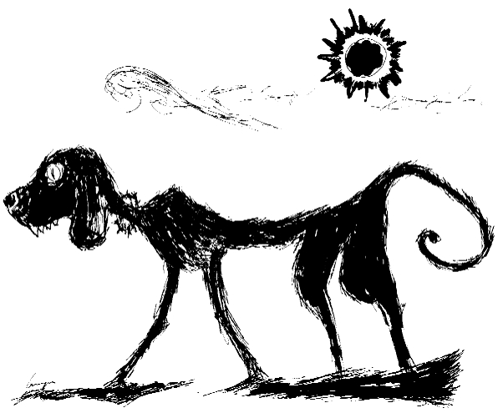
Watch the insightful and moving video which is part of an ad campaign against depression and answer the following questions.
1 Is the Black Dog of the video a normal domestic animal, a pet with all the beneficial effects on its owner?
2 Name a few of the effects the Black Dog had on the man of the video.
3 What made the man concerned about owning a Black Dog as regards the people around him, and why was he afraid to present it to them?
4 What was it like waking up in the morning having a Black Dog?
5 What happened as the man got older and older?
6 What was his first step towards recovery and at the same time the turning point in his life?
7 Name a few things the man learnt which contributed to his dealing with his so called “Black Dog” friend.
8 What was it that triggered loud barking by the Dog?
9 In the end how did the man finally come to terms with owning a Black Dog? In what sense did the man actually feel grateful for owning it?
Now here is somebody’s account on depression. Try to fill in the gaps with one word only.

Bad thoughts are part of (1)…………… and they will always sneak in our lives but it’s our job to realize that it is only a small part of the true reality. In(2)……………… , there are many truths to each reality.
For (3)………….. ,I (4)……………… to spend my time comparing (5)………………. with people and identifying all negative things about myself. These things were often true and that’s why I couldn’t disregard them. However, step by (6)…………. I learned to question each thought and open my (7)………….. to other more positive truths. Yes, I am not like that person or the other but I realized that It’s so good to be different. Every single person has something about them that is appealing(8) ………… others because it’s different and personal.
Find this individuality in (9)……….. .and embrace it. Also embrace this in others. This is how humanity can be more united, if we just accept ourselves and others. Avoid judging other people
"Treat others the (10)……………. you want to be treated".
﻿
Read the following and take your stand on the issue stated.

We now live in a nation where doctors destroy health
lawmakers destroy justice,universities
destroy knowledge,governments destroy freedom,the press
destroys information,religion destroys morals and the banks destroy
our economy﻿

----------------------------------------------------------------------------------------------------------------------------------------------------------------------------------------------------------------------------------------------------------------------------------------------------------------------------------------------------------------------------------------------------------------------------------------------------------------------------------------------------------------------------------------------------------------------------------------------------------------------------------------------------------------------

Just cry, baby, cry ...
Cause every tear that flows
Falls into the ocean
And rises to the sky
And then the rain will come
... Right before the sun shines...
Lyrics ft. Joss Stone

Time for a joke
Patient: I have a problem doctor.I feel depressed and worthless.
Doctor: You should cut down on your drinks.
Patient: I don't drink and have never touched a drop in my life.
Doctor: You should cut down on your smoking.
Patient: I don't smoke either doctor.
Doctor: You should cut down on womanizing.
Patient: Good heavens!! Haven't touched a woman in my entire life.
Doctor: Your problem is you have no problems!! Get yourself a drink, learn to smoke, and find a couple of girlfriends and you will be alright.
Lori, the pert and pretty nurse, took her troubles to a resident
psychiatrist in the hospital where she worked.
"Doctor, you must help me," she pleaded. "It has gotten so that every
time I date one of the young doctors here, I end up in bed with him.
And then afterward, I feel guilty and depressed for a week."
"I see," nodded the psychiatrist. "And you, no doubt, want me to
strengthen your willpower and resolve in this matter."
"For God's sake, NO!" exclaimed the Nurse. "I want you to fix it so I
won't feel guilty and depressed afterward."
A psychiatrist was conducting a group therapy session with four young mothers and their small children. "You all have obsessions," he observed.
To the first mother he said, "You are obsessed with eating. You even named your daughter Candy."
He turned to the second mom. "Your obsession is money. Again, it manifests itself in your child's name, Penny."
He turned to the third mom. "Your obsession is alcohol and your child's name is Brandy."
At this point, the fourth mother got up, took her little boy by the hand and whispered, "Come on, Dick, let's go home."

