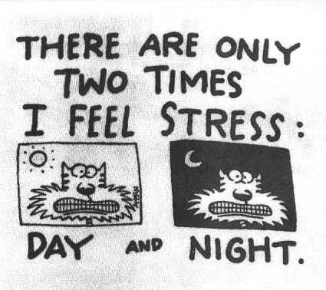
- All stress is bad.
----------------------------------------------------------------------------------------------------------------------------------------------------------------------------------------------------------------------------------------------------
2.There is nothing you can do about stress, it happens and you endure it.
----------------------------------------------------------------------------------------------------------------------------------------------------------------------------------------------------------------------------------------------------------------------------
3.No one else has as much stress as I do, that’s why I’m overloaded.
----------------------------------------------------------------------------------------------------------------------------------------------------------------------------------------------------------------------------------------------------------------
4. Nothing bad can happen to me from too much stress.
----------------------------------------------------------------------------------------------------------------------------------------------------------------------------------------------------------------------------------------------------------------

Stress is a state (1)………..tension related (2)………your body attempting to cope (3)……..its environment. It’s the body’s way of preparing to meet a tough (4)……….. Anxiety is a sense of apprehension, dread and uneasiness. We tend to perceive anxiety and stress (5)………
negative, but in fact both are normal and can (6)……..adaptive. The stress response involves
the nervous system and specific hormones in the body, and it enhances the ability to
perform (7)……..pressure as well as avoid danger. It is when stress is excessive or ongoing
and interfering with functioning (8)………anxiety and stress become a problem. This can lead
(9)……. wearing out the body’s reserves and leaving a person feeling depleted or overwhelmed, thus weakening the immune (10)…………. and making it harder to cope with daily demands. There are effective treatments available for anxiety and stress management. The first step is to learn to recognize when you are stressed and the next is to find a way to deal with stress.
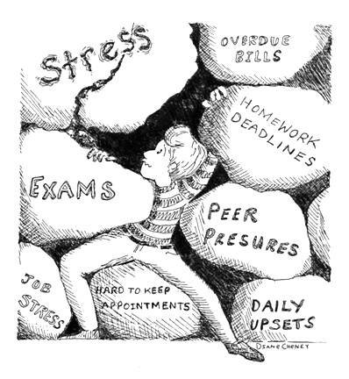

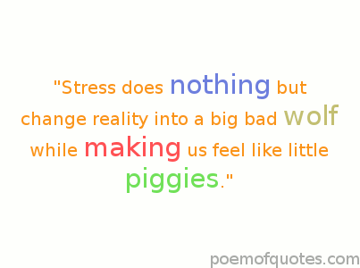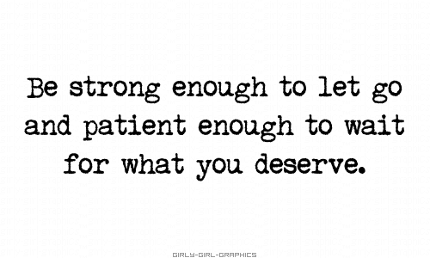
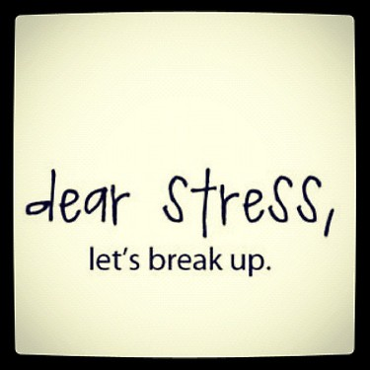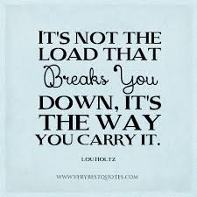
Identify a situation where you felt stressed or anxious this past week:
What did you feel like?
What were your thoughts?
What did you do about it?
What would you do differently in the future?

Identify a situation where you felt stressed or anxious this past week:
What did you feel like?
What were your thoughts?
What did you do about it?
What would you do differently in the future?

