Αντιγράψτε τα ονόματα κάτω από κάθε εικόνα.

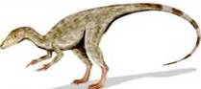

C:\Users\lenovo\AppData\Local\Microsoft\Windows\Temporary Internet Files\Content.Word\Διαφάνεια18.jpg

|  |
| --- |
|  |



|  |
| --- |
|  |



|  |
| --- |
|  |



|  |
| --- |
|  |



|  |
| --- |
|  |

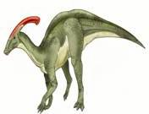

C:\Users\lenovo\AppData\Local\Microsoft\Windows\Temporary Internet Files\Content.Word\Διαφάνεια18.jpg

|  |
| --- |
|  |



|  |
| --- |
|  |



|  |
| --- |
|  |

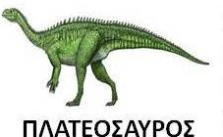

|  |
| --- |
|  |

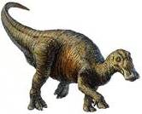

C:\Users\lenovo\AppData\Local\Microsoft\Windows\Temporary Internet Files\Content.Word\Διαφάνεια18.jpg

|  |
| --- |
|  |

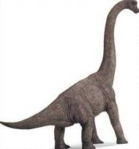

C:\Users\lenovo\AppData\Local\Microsoft\Windows\Temporary Internet Files\Content.Word\Διαφάνεια18.jpg

|  |
| --- |
|  |