**Present Simple: negative & questions:**

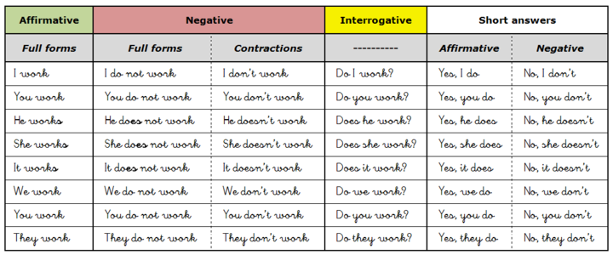

I **eat** bananas. He eat**s** apples.

I **don’t**  eat apples. He do**esn’t** eat bananas.

**Do** you eat cherries? Yes, **I do. (NO:** Yes, I eat)

Do**es** he eat cherries? No, **he doesn’t.**

**do not = don’t**  μεταφράζουμε όλο μαζί **ΔΕΝ**

**does not = doesn’t**

1. **Circle:**
2. Judy gets up / doesn’t get up at 6.
3.  They eat / don’t eat bananas for breakfast.
4. Tim likes / doesn’t like fish. 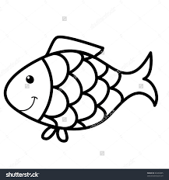
5. You go / don’t go to school early.
6. We have / don’t have lunch at school. 
7. Mary watches / doesn’t watch cartoons. 
8. **Give true answers about you**
9. Do you like tigers? Yes, I do/ No, I don’t.
10. Do you get up early at weekends? Yes, I do / No, I don’t.
11. Does your mum like pizza? Yes, she does/ No, she doesn’t.
12. Does your dad speak English? Yes, he does / No, he doesn’t.
13. Do your friends like dancing? Yes, they do / No, they don’t.
14. Do you walk to school? Yes, I do / No, I don’t.
15. **Complete the questions and answer them.**

**e.g. ………*Do*…………….** they always watch TV? No, **……*they don’t*…………..**

**1. ..............** she have lunch with her parents? Yes, ………………………………..

**2.** ……………………. Mary and John like chess? Yes, ……………………………………

**3.** ………………… you have a shower every day? No, ……………………………………

**4.** ………………… it eat bones? Yes, ………………………………………………

**5.** …………………. George play computer games? No, ………………………………….

1. **Write questions. Then answer them**

**e.g. Loggerhead sea turtles / eat / sausages**

***Do loggerhead sea turtles eat sausages? No, they don’t***

1. teachers/ work / in August
2. you / learn English / at school
3. an elephant / jump
4. monkeys / live / in the sea
5. babies / love their mum
6. **Complete the table with negative sentences and questions**

|  |
| --- |
| **e.g. She plays football.**  *She doesn’t play football.*  *Does she play football.* |
| 1. **The baby cries all the time.**   **………………………………………………**  **……………………………………………...** |
| 1. **They walk to school every day.**   **……………………………………………………..**  **……………………………………………………….** |
| 1. **Mary and Tim always watch tv together.**   **…………………………………………………………….**  **………………………………………………………….** |
| 1. **I finish my homework early.**   **…………………………………………………………….**  **……………………………………………………………..** |

1. **Correct the mistakes**
2. She go to school by bike. …………………………………………………………………………….
3. They do not like Christmas. …………………………………………………………………………..
4. Mary she dosn’t play football. ……………………………………………………………………..
5. You like pizza? ………………………………………………………………………………………………………..
6. Does Maria and Tom play the violin? ……………………………………………………………………..
7. Do I know him? Yes, he does. ………………………………………………………………………………….
8. We not have lunch at school. ………………………………………………………………………………..
9. She isn’t go to bed late.