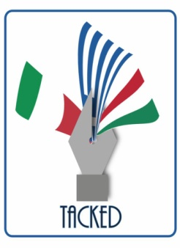

A methodological note
This project has been funded with support from the European Commission.
This publication reflects the views of its authors only, and the Commission or the National Agencies cannot be held responsible for any use which may be made of the information contained therein.
These Guide is not meant to be as rich as the National Reports, where national issues are covered in depth. It aims to represent the intersection, rather than the sum of different experiences, what they have in common (trends, causes, contexts, policies, practices, possible solutions), as well as at highlighting interesting and original solutions, which have proved successful and which might be easily be employed in other countries.
This publication is disseminated free of charge.

Main authors (in alphabetical order):
Barresi Albino
Strati Massimiliano

Contributing authors (in alphabetical order):
Fillocamo Giovanna, Lammendola Enrico, Russo Giuseppina.

Although Calabria is a region overlooking two seas, which belong to a single large sea, the Mediterranean, it is also partly a mountainous land. A particular landscape variety, diversity and multiculturalism: these are the terms to which we must refer when talking about Calabria and the Mediterranean. Because after all, the Mediterranean is the duality of its own name, it finds its most true and intimate elements in plurality. It is characteristic of the entire Mediterranean area to group together, and bring together, in combination and contrast, many aspects of reality. And this is even more true in a land like Calabria which represents a paradigm or rather a sort of microcosm of the Mediterranean, since it contains in itself a mixture of cultures, traditions and plurality of thoughts, in which it seems difficult, if not impossible, to distinguish the individual contributions of the various cultures that belong to it (Greece, Romans, Byzantines, Arabs, Normans, Spaniards, French, Bourbon kingdom).
Calabria, like the Mediterranean, is not one-dimensional, it is many things together, many elements of the complex intertwining of civilizations, cultures, religions, traditions and arts that have characterized its shores and its internal lands. And this variety, this diversity and this multiculturalism can also be found in food and wine, in agricultural products and in typical and traditional products.
Popular traditions reflect the historical, cultural and spiritual traits of an ethnic community and their knowledge contributes to solving the problems connected with the socio-economic development process of the communities concerned. This study intends to enhance the recovery of local traditions and therefore encourage a rediscovery of our roots and culture. To understand life, history and tradition of people, it is necessary to examine their rites, their daily life and to enter the villages of peasant work, where customs come from afar and contain characters of tradition and territoriality. Over the centuries, these old customs have transformed rites of life into what we can now call cultural resources.
Cultural itinerary of Calabria for the recovery of historical memory thus proves to be a fundamental tool for the knowledge of local culture by the younger generations and a tool to contribute to achieving the awareness of belonging to a universal community albeit with its own diversity. Knowledge of cultural diversity can be a keystone for the development of territory of Calabria and for the support of local arts and crafts as a career prospect.
It is our wish to help young people to rediscover their territory, to inspire them to love their origins and to guide them to traditional arts and crafts for individual, cultural, social and financial growth.

The Calabrian marine tradition
Calabria with its 780 kilometers of coasts is the Italian region with the largest coastal line, representing about ten percent of the entire coastal peninsular Italy. Its coasts, renowned since classical antiquity for their flourishing fish have favored the birth of strong maritime traditions. Nevertheless, most of the Calabrian population was held for many centuries strongly perched on mountains, also because of the presence of endemic malaria and Saracen raids coming from the sea, which had the effect of speeding up the process of withdrawal of populations from the coasts towards the interior of the region. As a result of this phenomenon, many coastal centers, such as Locri, Temesa and Turio, disappeared. On the other hand, the new settlements as Catanzaro, Stilo, Gerace and Nicastro acquired great importance through history. On the Tyrrhenian coast, where malaria was scarcely present, flourishing commercial exchanges developed thanks also to the presence of the Amalfi merchants first, Genoese and Pisans after: Reggio Calabria, Tropea and Amantea were the main centers of traffic during this period. Cetraro became the largest shipbuilding center in the region, with orders for shipbuilding also coming from abroad and, in particular, from the Spanish government. Pizzo, Tropea and Bagnara however were places where, following ancient traditions, fishing was the most important activity. Besides the swordfish fishing, typical of the Bagnara seafaring, historical documents mention the tuna fishing practiced in the Gulf of S. Eufemia. The historian Alberti says that in that area, especially in the month of May, a large number of tuna were caught, even a thousand in a single day, which were salted and sold throughout Italy.
For almost three thousand years, fishermen have developed a great capacity to enter into assonance with natural phenomena, making possible a daily relationship of interaction with an element foreign, treacherous, and dangerous as the sea. Operating in such an unpredictable environment, there was a need to know places, currents, winds, storms, and, last but not least, the habits of prey. The numerous magic-ritual rules with which fishing operations are permeated act as a reassuring strategy in unknown or particularly risky situations, as well as an incentive factor for successful fishing. The description of the ancient boats and the changes made over time, initially imperceptible, then increasingly drastic, can allow us to identify the relationships that fishermen have established with nature. It is very probable that in the course of history, the different technical fishing systems have combined, perfecting, adapting, overlapping, or, conversely, remaining in competition with each other, to homogenize only in recent periods.

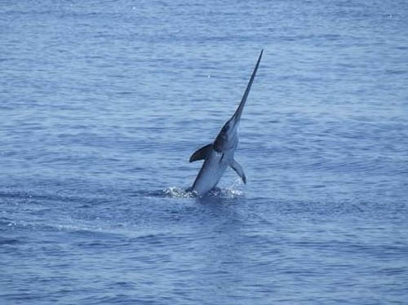
THE SWORDFISH
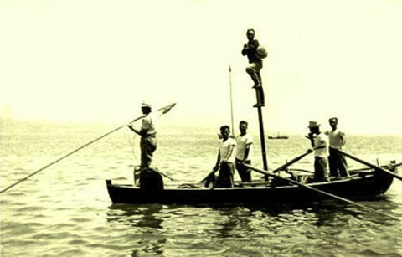
Swordfish is a typical dish of Calabrian cuisine in the province of Reggio Calabria. It is the most requested fish and the protagonist of the city's gastronomy, not only for the delicacy of its meat, but also for the folkloric ritual that characterizes its fishing. In fact, one of the most attractive shows consists in attending the fishing trips of the "passarelle" or "spatare", the characteristic and rapid boats specialized in hunting swordfish in the blue waters of the Costa Viola. They are led by the helmsman and sighter who balances himself on a high flagpole where there is also the formwork. The metal trellis of the flagpole is from fifteen to twenty-five meters high. There is a metal bridge emerging from the bow of the boat, the gangway, from where the harpoon, warned by the sighter, with his harpoon vibrates the fatal blow to the prey.
The swordfish is a fish up to four meters long and sometimes even three hundred kilos heavy. It has a dark gray color above and silver below. It feeds preferably on cuttlefish and squid. It has a delicate, rosy and very nutritious flesh. The sword that represents the extension of the upper jaw is a long and flattened appendage which the fish uses as a weapon of attack and defense. Swordfish is also a fast swimmer, easily reaching speeds of over seventy kilometers per hour.
At the Strait of Messina, in spring time, during swordfish migration, it travels the stretch of sea between Villa San Giovanni, Scilla, Bagnara, and Palmi for reproduction. When the summer begins, the fish changes course along the strait on the side of Sicily. Research on DNA has shown how the various strains present in the seas and oceans tend to mate mainly with specimens of the same origin and that sporadic reproductions occur between fish from different areas.

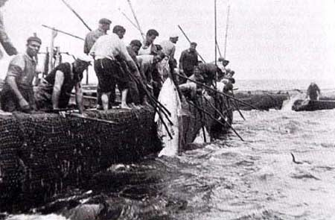
THE TUNA
In Calabria, the Tyrrhenian coasts, and those of Pizzo have always been theater of the slaughter and have experienced moments of triumph of the tuna hunt. This type of fishing took place in a characteristic way: the tuna, in fact, were sighted and signaled from the mainland by towers specially built in strategic positions. In a document of 1577 the tonnarari are referred to stay away from home from mid-March to mid-October because of tuna fishing. The naturalist Minasi da Scilla, noting the course of the schools of tuna, swordfish and dolphins had carefully noticed that in particular the tuna, often chased by the dolphins who try to prey on them, migrate upstream to more easily catch the plankton, preparing themselves to wedge, according to the greater hydrodynamic resistance profile. While waiting for the fish, the tuna chants were typical accompanying fishermen work. They stood with a very thin line that vibrated with the passage of tuna. It was the Arabs who invented the tonnara and they inherited not only the fishing technique, also the jargon, the songs, the traditions. The history of Calabria is closely intertwined with that of tuna fishing; tradition tells that the biggest tuna was offered to San Giorgio, protector of the tonnaroti, for the danger that escaped during the slaughter.
There are stories of masters and poor people, with women in the background weaving nets and all waiting for tuna, which came from the deepest depths of the Mediterranean. They were also called “racing tuna”, because they were more delicious and because they came fat and ready for the mating season. And it was precisely in the pursuit of the females that the tuna ended up finding death; the fishermen knew that the fish followed and still follow the warmest currents, so the love escapes were transformed into death escapes. For each slaughter, new tuna traps were lowered into the water: it was not foreseen to recover a net from the previous slaughter because the fishing violence of the past year did not allow the reuse of the same traps in the following years.

The ancient crafts

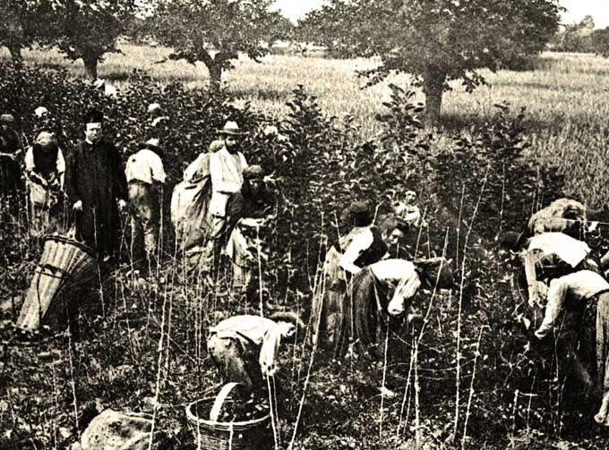
Calabrian craftsmanship has its roots in the Mediterranean civilization and, above all, in that of Magna Grecia from which it descends. The art of weaving is perhaps among those that have more ancient origins and, in the villages of the interior, it is still possible to admire a weaver at work. Of great value are the production of tapestries, embroidery, bobbin lace, silks and damasks. The vancali (silk and wool shawls) of Tiriolo and the pezze (colorful fabrics) of Samo are very famous. The work of wrought iron and copper continues in Serra San Bruno, gold and silver in Crotone, glass in Bagnara, wicker and straw in San Giorgio Morgeto, Cosenza and Soriano Calabro. One of the most original forms of wood production is called "shepherds' art". The workmanship has always remained the same and still today people prefer to use the hand carving technique not using modern machinery. Characteristic is the production of musical instruments of the highest quality, in particular that of violin makers in Bisignano and the construction of cane reed in San Luca and Platì.

SILK
The art of weaving in Calabria has ancient origins. It belongs to the history of each family as the loom has been a symbol of female patience and industriousness. There was no house that did not own one and even today, in many counties it is possible to see old looms, often worm-eaten, which have taken on the color of the hearth where they stayed for years and years. The Calabrian poet Vincenzo Padula exalted this industrious instrument, comparing its sound to a musical instrument, such is the feeling of sweetness that emanates from it. The loom has a great importance not only because it has perpetuated the ancient traditions up to the present day, but also because it was an effective means of communication. Already used by the Greeks, large, made of beech wood, located on the ground floor of the house, or more often in the bedroom, the loom served as an aggregation: the young women gathered here to dream of the future, the old women who remembered the past.
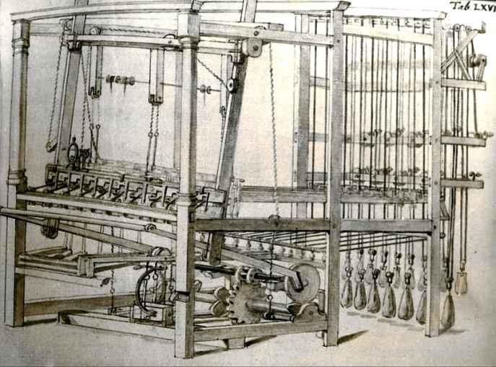
The discovery of silk is due, according to an ancient legend to the Chinese empress Xi Ling-Shi. The empress was walking when she noticed bugs. She touched one with a finger and miraculously a silk thread came out of the caterpillar. As the thread came out of the worm, the empress wrapped it around her finger, obtaining a feeling of warmth. Eventually, she saw a small cocoon, and suddenly understood the connection between the worm and the silk thread. She taught what she had discovered to the people and the news spread. The production of silk from China slowly spread to the west, arriving in Italy, in Calabria and in the southern regions around the tenth century. There were many legends that followed one another around the birth of silk in Calabria. The only certain document is a notarial deed cited, as a certain testimony, by the French historian and scholar Andrè Guillon, dating back to 1050 in which we read, that among the assets of the metropolitan Curia of Reggio Emilia, there is a field of thousands of mulberries.
The development of silk culture began with the introduction of the white mulberry by the Byzantines who brought it to Calabria; before then only the black mulberry was known which was not suitable for the breeding of silkworms. The cultivation of mulberry, in the sixteenth century, involved almost a third of the Calabrian territory. The breeding of the silkworm and the production of the cocoons had a family character: the breeders purchased the eggs of the worm and kept them warm waiting for the worms to come out of the shell, thus beginning their short existence. Others bought the newborn worms and fed them with shredded mulberry leaves, then placed them in the so-called “cannizzi”. The caterpillars ate three times a day for five days and then fell asleep. Upon awakening they lost their skin which was quickly replaced with another four times. This operation is called "undress", the penultimate one was called "tritu" and the last "casarru". When the worm was no longer hungry and refused food, it closed in the cocoon and began to build its dwelling with the drool, producing a kilometer long silk thread. It was then transferred to the “cunocchia”, made up of bunches of dried broom, and here the worm carried on its work until the cocoon became hard; then the weaver began the work of chipping. It consisted in suffocating the worm by introducing hot air (80 ° -90 °) into the environment then immersing it in basins of hot water where the cocoon was beaten with the so-called “manganeddi” (wooden tools that softened it by letting out the silk thread). The skeins were then prepared and sold to the spinning mills or weavers to prepare the kits for the daughters.
In the province of Reggio Calabria, the first impulse to silk was given by the Jews, but soon they were accused by the Genoese and the Lucchesi of monopolizing the market, and in 1511 an order of King Ferdinand of Aragon, forced them to abandon the country. The silk business had a good recovery in 1790, when the first long-stretch spinning mill was built at Villa S. Giovanni and later eight more mills rose. In 1863 there were one hundred and twenty spinning mills distributed along the area. Damask silk was woven while silk and cotton velvets were produced in various colors. This wealth did not last long: in 1879 just eight looms operated in Reggio and four in Scilla, until they completely disappeared. In Cosenza, silk spread to the Crati valley, where the cultivation of the silkworm was the main livelihood of the poor people. Catanzaro was the main center of the region where this art spread, giving the city wealth and prestige. There was a considerable quantity of damask fabric spread from Syria (Damascus), hence the name of damask itself. The maximum development of silk occurred in the eighteenth century. In Catanzaro there were seven thousand silk workers and a thousand looms. Drapes, damasks and brocades were produced, appreciated all over Europe. But in the eighteenth century, the fate of silk began to change and a slow but inexorable decline began.
The decline of the art of silk in Calabria was determined above all by the vexatious monopoly that the government had begun to exercise over it which prevented any progress. While in Northern Italy silk was increasingly valued, in the South it remained in its primitive state and with old-fashioned manufacturing methods, for which the Calabrian silks lost all merit. Other factors, such as the increasingly difficult breeding of the worm due to the shortage of manpower, various epidemics and earthquakes led to the decline, so that the beautiful art of silk became a distant memory.
Tradition observes that the most precious damasks are hung on the balconies of the manor houses during the procession of the patron saint. Of great historical and artistic value are the ancient damasks owned by the Basilica of the Immaculate Conception in Catanzaro. Other lighter damask fabrics, of Calabrian tradition were: the armosino (smooth or worked with flowers of the same color) which once was used for long women's dresses (candusce). The organzine (silk to make the warp), the tabi (tissue similar to the fault that the black color was used for dresses and robes of lawyers) and silk ribbons of all colors. The organzino and the ribbons are still in production.
The production of raw silk (from silkworm to fabric) in the town of Catanzaro is particularly refined, where expert hands work and weave rare silk preciousness in natural color. The damasks are silk fabrics with flowers and various designs, often inspired by the friezes of the eighteenth century in which the motif with the acanthus, olive or laurel leaf mixed with other decorative elements according to the Louis XIV and XV style predominated. Particularly precious, these high quality fabrics are made with the best quality silk. The colors of the Calabrian tradition are red, green, blue and yellow-gold.
In the Reggio area, around the 14th century, the market linked to the production of silk became extremely rapid, so much so that, in a very short time, it became, almost, the only exchange product of its economy and so it remained for another four centuries. While in the twentieth century, just as quickly silk tradition disappeared within a single decade, with almost no trace left. Today there are only a few ruins of spinning mill and some memories in the mind of the elderly. Today silk products are used to make blankets, furnishing fabrics, ornaments and sacred vestments, shawls and linen (tablecloths, sheets, towels).

BROOM
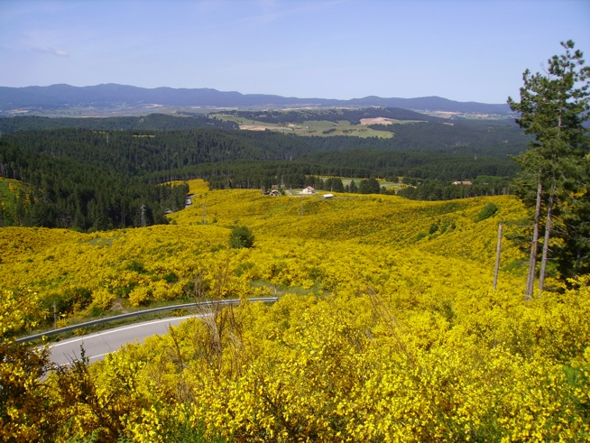
Up to a few years ago in Calabria the processing of the broom was very popular. It was done in almost all counties, given the need to create an economic yarn and the great abundance of broom that colored and perfumed the hills of the region. The broom belongs to the Leguminose family, it is also called with dialectal names, depending on its geographical location in Calabria. The broom is a shrub from 50 to 105 cm tall which has very resistant and erect cylindrical green stems with a few leaves. The stem is very branchy and bald and hard enough, it is difficult to break it with your hands. The leaves are simple, resistant and dark green in color. The petals form a yellow and fragrant flower. The broom prefers the heat and it is flourishing on different types of soil. In fact, it grows in sunny areas from 0 to 1200 meters above sea level. It is used as a consolidation plant for landslides, mainly used in the embankments of highways and railways.
A typical form of poor craftsmanship, the broom was made at the family level and was the task most entrusted to the woman. The broom was the symbol of love, because it was used to make the brides outfit. The broom was mowed and harvested in the mountains and hilly areas in the months of July to August after the feast of Carmine (July 16). Small bundles were prepared which were tied and folded in two and carried to the river. They were boiled in a cauldron (a cardara), turning it over so that the fibers cooked homogeneously. Then they took off the heat and the fibers were left on the ground. Later the fibers were immersed in the river, holding them still with large stones and left inside the water for about eight to ten days. After this time, broom bundles were out of the water and the men beat them with a wooden club, after having covered them with river sand. At this point the women washed the broom which turned white. The women extracted the internal part, leaving a piece still attached; at this point the threads of the broom, called the stamen, wound around it. Then, broom was put it in the sun to dry for a few days. The next step was carding and while combing the fiber, it was divided into two parts: one thinner, better and the other coarser, less valuable, used to make bags. Once spun, the skein was formed.
The quality thread was colored before the loom. Today, only the flower of this precious fiber is used, from which an essence destined for the perfume industries is obtained
The broom has been known since ancient times for its use as a fiber plant. It was, in fact, already used by the Phoenicians, Carthaginians, Greeks and Romans, for the production of mats, ropes and various artifacts. The same etymology of the Greek word "spagos", which means rope, confirms the traditional use of fiber for the creation of coarse fabrics. The use of the broom for textile use seems to start from the nineteenth century. The moment of greatest attention for this plant as a source of fiber occurred during the Second World War. First as a consequence of availability of alternative raw materials and second due to economic sanctions which prevented, among many other things, the import of fibers such as jute, fundamental for the production of packaging cloths and bags. The choice of the broom was conditioned by its high availability on a spontaneous level (it is estimated that there were about three hundred thousand hectares of broom) and by the characteristics of its fiber that were well suited to replace jute. There were numerous initiatives during those years, aimed at promoting the exploitation of the existing gorse, through attempts at thickening and the creation of new plants.
After the war, with the resumption of the import of vegetable fibers of tropical origin, easier to work, the broom as a textile plant was almost completely abandoned. The importance of broom as a textile plant in Italy is now limited to small local realities, in particular to some counties of Basilicata and Calabria where the settlement in the past years of many families from southern Albania led to the use of its fiber to weave in a very handcrafted way fabrics of particular beauty.

LINEN
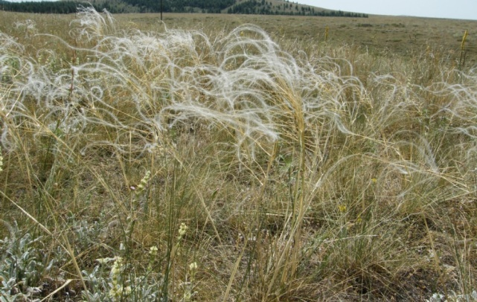
The oldest of the textile fibers is linen. The etymology of the word "linea", from the Latin linum, derives from flax, as the term "filo" derives from the Greek λίνον [linon]. Flax belongs to the Linaceae family and it is an annual herbaceous plant, 30 to 100 cm high. It has a generally simple stem, with linear leaves, the petals are triple the calyx (the internal part of the flower is capsule-shaped and varies from 6 to 9 mm). Flax can grow spontaneously from 0 to 2000 meters and it prefers very sunny areas sheltered from the winds. The Arabs brought the linen to Calabria and after the cultivation the women collected the plant and worked it wisely, drawing a very fine textile fiber that worked on the loom, producing canvas, suitable for tablecloths and sheets supplied.
Today linen is still loom woven by a few elderly women but only in the Calabrian hinterland. Flax fibers are used for fabrics, paper, felts; flax seeds while its oil is used for food, paints and linoleum; other partsof the plant are used for gardening, isolation, bedding or potting soil. Every part of the plant can be used actually.

JASMINE
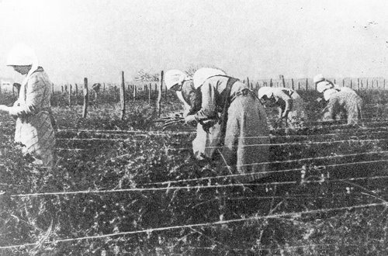
The Costa dei Gelsomini is a coastal area in the province of Reggio Calabria, washed by the Ionian Sea. The Riviera takes its name from the typical cultivation of the jasmine plant, beautiful and delicate, but also robust and climbing. The species cultivated along the coast is the "Jasminum grandiflorum", of Indian origin, one of the most beautiful species. It has large, sweet-smelling flowers that open from June to October. Jasmines were collected by women (called jasmines), sold by weight and exported to France to prepare perfumes. Jasmine work began in the early hours of dawn and ended around eleven in the morning. It was once a good source of income for local families, although the effort was enormous. Three hundred kilos of jasmine flowers were needed for a kilo of essence. A jasmine woman, in one working day, could collect up to four kilos of flowers. The women wore aprons with a large pocket sewn in front which, when filled, was emptied into the cane baskets. The large baskets, after weighing to decide the pay which in fact was by weight, were then transported with carts to the factory, where the men worked. Here the flowers were crushed and ground to form a yellowish and intensely perfumed mush which was then shipped to France, especially in the town of Grasse where distillation was carried out to make perfumes. Jasmine has thin, climbing or hanging stems with 3-5 oval leaves, dark green, shiny and waxy. In spring they form star-shaped flowers, white or pinkish white, intensely scented. They are usually located where it is bright and sunny and sheltered from wind. Jasmine can withstand short periods of intense cold and long periods of drought. They can grow in any soil. In Italy the cultivation of jasmine has been practiced almost exclusively in Calabria, where the mildness of the climate favors the production of essence of excellent quality, used in the manufacture of the highest quality perfumes.
Today, unfortunately, it has been abandoned because, despite Jasmine from Calabria considered the best in the world, it cannot stand the competition with the other producing countries.

SCULPTING
Sculpting is still widespread in the regional territory for everyday objects. The shepherds produce and sell commonly used objects such as the "musulupare" (negative molds for the production of cheese), the stamps for sweets (used to imprint ritual signs), spoons, bowls, cutting boards and cutlery. In addition to these objects, the wonderful “conocchie” (bust slats and loom shuttles) are part of the tradition of the area. Both had a precise meaning: they were a pledge of love from the young shepherd to his beauty. In the conocchia he enclosed a pebble which, when the conocchia turned, produced a noise which was to keep the beloved awake. Alongside the production of traditional objects for everyday use, there is a production of particular artistic value: the sculptures. These are unique pieces, handmade, of great value which are inspired by local, religious, or completely innovative and modern elements: statues and sacred figures, angels, madonnas, cribs, characters, toys.
Particularly important is the faithful and poetic production of sculptures inspired by the animal world. The craftsman's manual ability in carving, engraving and decoration is evident in all his patient ability with significant stylistic differences and expressive specificities, with almost baroque chiaroscuro in the alternation of roundness and recesses, in the softly sculpted drapery of almost scenographic effect: sacred figures, cherubs, leaves, flowers, and animals, both as single or in skillfully composed objects.

WICKER
With the wicker and straw produced in Calabria, traditional "cannistri" are prepared, that is, containers for the collection of fruit, "panari" or "fulazze" for the sun exposure of tomatoes, figs or aubergines. A place of honor in this sector belongs to Soriano where there is a differentiated and relevant production also from a quantitative point of view. Straw chairs, baskets and utensils are produced there, including the beautiful fan to stoke the fire.
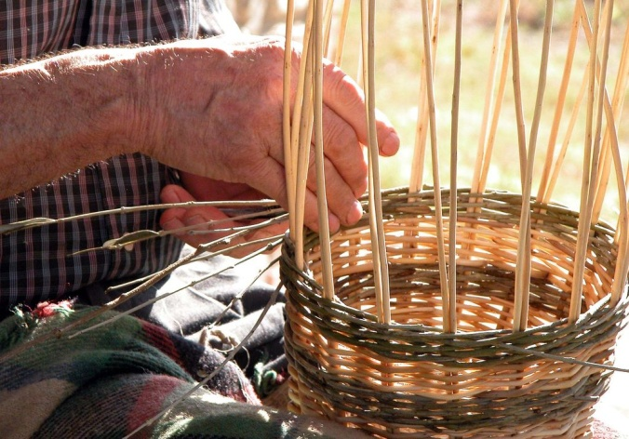
Typical of Soriano is the processing of rattan, bamboo, and wicker furniture, particularly suitable for the creation of both rustic, classic and modern furnishings. The craftsmanship of Soriano has also qualified with a modern design appreciated and introduced on domestic and foreign markets.
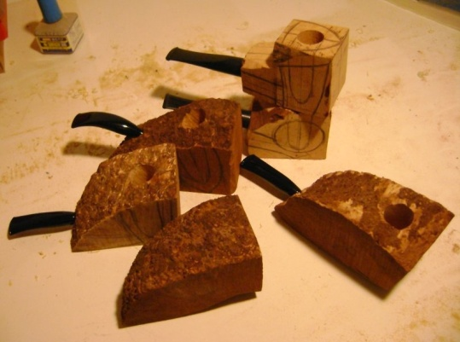
PIPES
When we talk about craftsmanship, recovery and enhancement of ancient crafts, we come across a very particular market, made up of admirers and collectors as in the case of pipes but also of those who love objects of particular value. The rediscovery of crafts, in addition to containing an appeal towards a more human-friendly life system, is closely linked to appreciation of traditional techniques for the creation of artefacts and typical local products. In the case of pipes, tradition has significant value within local communities for centuries.
The raw material produced by the Calabrian woods is very suitable for making excellent quality pipes. Particularly appreciated is the production of extremely valuable pipes made of walnut briar. For the realization of the pipes a protuberance of the root of the Erica Arborea plant called "log" is used. The "log" before being used is left to mature for at least two years. This long seasoning gives the tobacco a particular and unique taste. The working process of the Calabrian pipes is fascinating. The processing is still done by hand in all its stages. Pipe production is a tradition handed down from father to son and is among the oldest and most famous handicraft activities in the region. It is an exciting and delicate job that constitutes one of the most important items for marketing in national and international markets. Calabrian pipes rank first in the collections of the most illustrious amateurs and researchers, both for their functional and aesthetic qualities. In the windows of the most famous shops in the world they are exhibited as an element of great distinction, refinement and elegance.

THE TRADITION OF WOOD
The large amount of wood present in the Aspromonte Mountains has allowed the development of wood craftsmanship since ancient times. The wooden objects are characteristic products of the Greek areas linked to the rural culture of the shepherds of the Ionian side, who during the day spent their time making the plumia or murcari, (stamps for sweets) and the musulupàre, (stamps for cheeses), flutes, candies and other items such as spoons, forks and sticks. The female figure is almost always present in these designs, as is the Greek cross.
The wood craftsmanship in Calabria is one of the oldest and most illustrious, supported by the wealth of wood and the skill of the craftsmen, very good at carving, sculpting, inlaying, and turning. The art of carving, in fact, is an expression of rural culture, where roots and pieces of wood become kitchen utensils, sculptures for everyday life or elegant decoration.

GOLDSMITH
Throughout Calabria there are master goldsmiths and silversmiths who shape the sheets and use the burin to produce earrings, jewelry, necklaces, pendants often referring to ancient styles and new artistic creations known all over the world. This art was grafted onto traditional production which, once, was aimed at embellishing and enriching traditional costumes and decorating sacred images.

CERAMICS
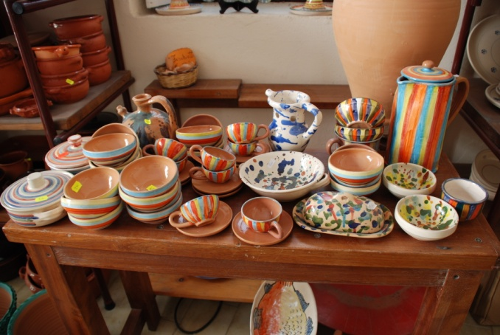
Works of terracotta and the decoration of ceramics were crafts from ancient time. It is no coincidence that there is an excellent craftsmanship of fire-glazed crockery, with milk white and sky blue colors, which are inspired by the chromatic effects of the Magna Grecia pottery. Ceramics is the most important form of craftsmanship in the region as it satisfies both everyday use and art. The production involves furnishings and souvenirs of various kinds where the craftsmen show off the best of their technical and aesthetic skills.
A separate reference must be made for the artisan workshops of Seminara as they prefer the creation of objects that refer to the symbolic forms of popular tradition: from masks to drive away bad luck to the so-called babbaluti, anthropomorphic bottles decorated with faces with an ironic grin and almost wary.

ARTISANS OF THE CHAIRS
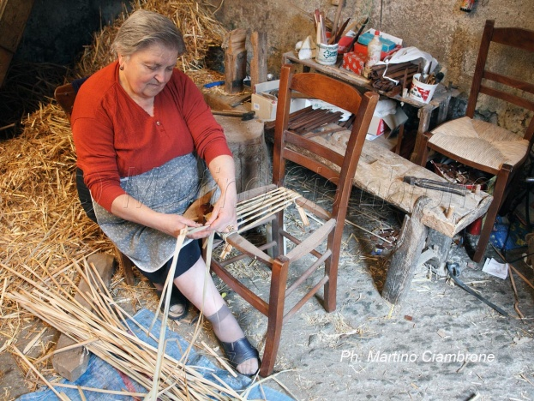
The production of furniture is widespread in the Calabrian territory. The products, in classic or modern style are inspired by popular and peasant tradition. The skillful Calabrian wood craftsman carvers beliefs of the past, simple or richer, perhaps adorned with engraved motifs, wedding chests, decorations of exceptional artistic value, wardrobes, cradles, robust and massive tables often inlaid in the classic style. Different, but equally valuable, the traditional style furnishings: stronger but simpler, solid but gentle furniture, with the rough mark of the mountain in the peasant style of the so-called poor art, which maintains its family-like beauty over time.
In Calabria, the presence of craftsmen who produce chairs is very old. This sector of woodworking is flourishing throughout the region, an example is the characteristic straw chair of Serrastretta. This typical chair so original in materials and shapes, combines the ability in modeling wood with the processing of straw. The module follows the typical one of the chair of common use of the ancient local tradition. The processing is done by hand. One of the most used woods in the production of chairs is beech, of which Calabria is rich. But the new productions are also characterized by the use of chestnut. The Calabrian chairs showcase the precious skills of the master craftsmen who have handed down the secrets of this typical process for generations. In addition to traditional models, there is also a new design which testifies to a continuous search for new and trendy elements with a specific goal: to give a touch of uniqueness to the furnishings of everyday life. The Calabrian chairs for the quality of the materials and the originality have conquered a large space in the national and international market. An inimitable product that combines aesthetic value with strength, stability and durability.

MASTERS OF AX
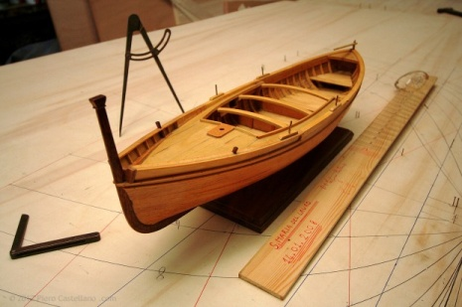
The ancient maritime tradition, together with the industriousness of the population living in the coast is documented by the particular manual and engineering skills of the so-called "ax masters". Among the boat builders, the most famous are those of Scilla and Bagnara, who combine great technical ability with special care, always respecting tradition. The knowledge of the sea, the main stage of adventures, riches, deprivations since Calabria's most remote times, is expressed in the hands of the "ax masters", like a caress of love. So sweet, concave wooden forms are born, light as a nutshell, swinging and fast, more than tuna, more than swordfish, more than the song of the sirens that can still be heard in the Scilla wind.

LUTHEIRS
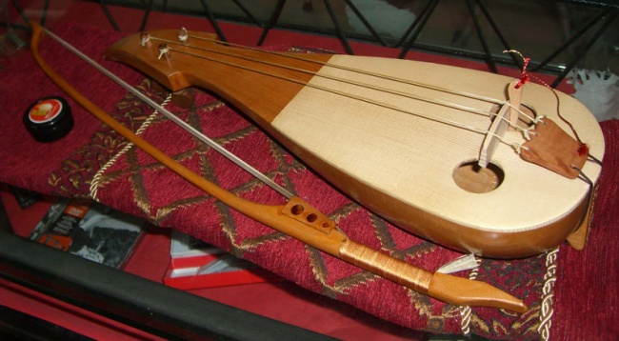
The processing of musical instruments has touched, in small towns such as Bisignano or Delianuova, maximum expressions with the generation of luthiers. Since the eighteenth century, there have been produced guitars, mandolins, harps, and especially violins, one of which is believed to have been purchased by Giuseppe Verdi.
In the sector of musical instruments, Calabria boasts a quality production. In Bisignano there is still a historical factory of lutes, violins and guitars: the workshop of the De Bonis brothers, the last heirs of an ancient family of luthiers, who for centuries have built instruments characterized by a particularly sweet and vibrant sound, due to a combination of elements (choice of woods, proportions, glues used). But the real secret is in the paint, which interferes as little as possible with the vibration of the wood. A specialty of the De Bonis workshop is the harp mandolin, an instrument with an unusual shape and a sweet and persuasive sound. The greatest musicians of all eras have turned to the dynasty of the De Bonis of Bisignano. In order not to lose the values of this ancient art, a Regional School of Violin Making has been established in Bisignano. Also, every year, in May, an international violinmaking event is held, dedicated to the De Bonis family, with exhibitions, concerts and conferences with the presence of numerous artists and renowned experts in the field.

CALABRIAN LIRA
The Calabrian Lira is a traditional musical instrument. Due to its characteristics, the instrument is fully part of a group that can be defined as the "Byzantine lira", a family of arched chordophones, with recurring and very similar characteristics, widespread throughout the area of the former Byzantine Empire. It is played alone or accompanied by the tambourine. It is also used for Calabrian tarantella. In Calabria, the last evidence of the use of the Lira dates back to 1908. Between the two World Wars there are the last public performances. The lira in the late seventies of the last century was in disuse, it seemed to be an instrument intended for museums. Since 1980 thanks to the field research carried out by Association of Catanzaro and the musical group Re Niliu, the last players and builders living in the Locride area were traced, while the presence of craftsmen and players active in Monte Poro was attested until the 1950s. Only two players were found who still used it privately: Peppi i Campu di Fragomeni and Martino di Contrada Camocelli while all the others hadn't played for twenty or thirty years.
Further research by G. Plastino has better clarified the presence of the lyre. The revival of the instrument begins in the early eighties with the first summer courses to learn to play the instrument promoted by the Grecanico Association. In recent years, the ethnic-popular fashion has amplified the number of aspiring players and, consequently, manufacturers, and there are numerous courses, both in Calabria and in the rest of Italy to learn to play or build this instrument. Since 2010, an International Lyra Festival of the Mediterranean has been held in Spilinga.

TAMBURELLI AND TAMMORRE
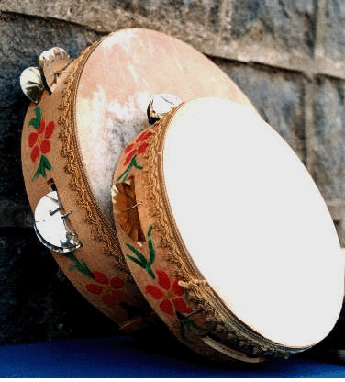
Tambourines and tammorre are framed musical instruments widespread throughout the Mediterranean area. The tamburrello, smaller in shape than the tammorra, is widespread in Calabria where it takes the name of tammurinu or tambureddu. It is present in many Calabrian tourist-commercial iconography and is often used as an emblem of the region. Tamburrelli and tammorre boast ancient origins. Rock graffiti have been found depicting phoenix priestesses with the framed drum in their hand or in the act of playing it. From these depictions, it is believed that tamburrelli and tammorre have always been an essentially female instrument, because it is strictly connected to fertility rituals. Tamburrelli and tammorre are used to accompany tarantella, which requires strong rhythmic support.
The construction of the tambourine starts from the tanning of the leather with salt and rock alum. Still wet, the leather is stretched on a frame obtained from a narrow strip of wood modeled in a circle and fixed around it with glue and nails. Rectangular shapes are open along the frame in which pairs of metal plates are inserted, beaten and tempered, secured by means of iron wire. Some builders are also able to decorate the wooden frames with floral illustrations or representations of chivalrous deeds. Once the leather has been applied to the frame, the tambourine would be ready to be played but it is customary to add (a little to improve the sound, a little by tradition) a metal part made up of cymbals, originally made from Sardinian tin. Cymbals are pairs of beaten and tempered metal saucers applied with iron wires. They are also called rattles. The dimensions of the tambourine vary from 15 to 50 cm in diameter. Even the number of cymbals varies according to the severity of the sound you want to produce. In fact the serious component of the sound produced is the percussion of the goatskin, while the most acute one depends on the metal cymbals.

THE LEGENDS OF SCILLA
Scilla, in the province of Reggio Calabria, is one of the most beautiful and characteristic villages in Italy, destination of artists in every age and of every nationality. The origins are ancient, confused between mythology, history, legend and poetic images fed for millennia by the natural environment. It is said that the beautiful nymph Scilla, daughter of Typhon and Echidna (or according to others of Forco and Crateis) once lived in the present city of Reggio Calabria. Scilla, to whom nature had given an incredible grace, used to go to the rocks of Zancle to walk barefoot on the beach and bathe in the clear waters of the Tyrrhenian Sea. One evening, while lying on the sand, she heard a noise coming from the sea and noticed a wave going towards her. Petrified by fear, she saw a half-man and half-fish with a blue body appear from the waves. He was a marine god who had once been a fisherman named Glauco whom a prodigy had transformed into a being of divine nature. Scilla, terrified at the sight because she could not understood what kind of creature he was, took refugee on the summit of a mountain that stood nearby. The marine god began to scream his love and tell her his dramatic story. In fact, Glaucus was once a fisherman from Boeotia and precisely from Antedone, a man like everyone else, who spent his long days fishing. One day, after a more fortunate fishing than usual, he had spread the nets to dry on a lawn adjacent to the beach and lined up the fish on the grass to count them when, as soon as they were in contact with the grass, they started to move, they took vigor, lined up in packs as if they were in the water and hopping they returned to the sea. Glaucus, stunned by this prodigy, did not know whether to think of a miracle or a strange whim of a god. Since he assumed that a god could not have spent time with a humble fisherman like him, he thought that the phenomenon depended on the grass and tried to swallow some fish. As he had eaten it, he felt a new being born inside him that fought his human nature. This new being was irresistibly attracted to the water. The gods of the sea welcomed him benevolently so much that they prayed to Ocean and Thetis to free him from the last appearances of human and earthly nature and to make him a divine being. Accepted their prayer, Glaucus was transformed into a god and from the waist down he was changed into a fish. Scilla, after listening to the story of Glaucus, regardless of his pain, went away leaving him alone and desperate. Then Glaucus thought of going to palace of the sorceress Circe, hoping that she could make a spell to make Scilla fall in love with him. Circe, after Glaucus had told her about his love for Scilla, admonished him harshly, reminding him that he was a god and therefore he did not need to implore a mortal woman to make himself loved. Circe then suggested to Glaucus to join her, but Glaucus refused to betray his love for Scilla and did it in such a passionate way that Circe, furious at having been refused because of a mortal, decided to take revenge. As soon as Glaucus was gone, she prepared a filter and went to the Zancle beach, where Scilla used to go. She poured the filter into the sea and then returned to her island. When Scilla arrived, warmed by the great heat of the day, she decided to dive into the crystal clear waters. After getting wet, she saw monstrous, angry and growling dog heads around her. Frightened she tried to chase them away but, once out of the water, she noticed that those muzzles were attached to her legs through a long serpentine neck. Then she realized that up to the hips she was still a nymph but from the hips down there were six fierce dog heads, each with three rows of sharp teeth. Such was the horror that Scylla had of herself that she threw herself into the sea and took up residence in the hollow of a rock near the cave where Charybdis lived. Charybdis was the daughter of Forco (or Poseidone) and of Gea and for having stolen the oxen of Gerione from Heracles, Zeus electrocuted her and turned her into a terrible sea monster, destined to swallow and reject the sea water three times a day. Glaucus cried the fate touched to Scylla and was forever in love with the image of grace and sweetness that the nymph once represented.
Scylla and Charybdis, both frightening sea monsters, were therefore close to each other to form what modern people call "The Strait of Messina" and while Charybdis swallows and rejects the sea water three times a day creating gigantic eddies, Scilla attentive to the life of sailors with her six heads tries to catch as many sailors.

