**ΤΟ ΨΗΦΙΑΚΟ ΛΕΞΙΚΟ**

[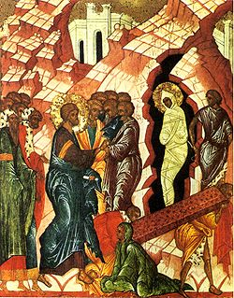](https://el.wikipedia.org/wiki/%CE%A3%CE%AC%CE%B2%CE%B2%CE%B1%CF%84%CE%BF_%CF%84%CE%BF%CF%85_%CE%9B%CE%B1%CE%B6%CE%AC%CF%81%CE%BF%CF%85)

[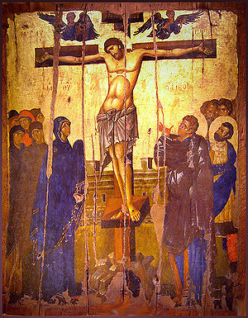](https://el.wikipedia.org/wiki/%CE%A3%CF%84%CE%B1%CF%8D%CF%81%CF%89%CF%83%CE%B7_%CF%84%CE%BF%CF%85_%CE%99%CE%B7%CF%83%CE%BF%CF%8D_%CE%A7%CF%81%CE%B9%CF%83%CF%84%CE%BF%CF%8D)

[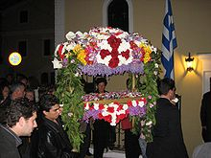](https://el.wiktionary.org/wiki/%CE%95%CF%80%CE%B9%CF%84%CE%AC%CF%86%CE%B9%CE%BF%CF%82)

[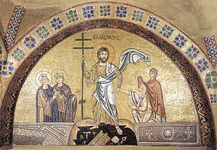](https://el.wikipedia.org/wiki/%CE%91%CE%BD%CE%AC%CF%83%CF%84%CE%B1%CF%83%CE%B7_%CF%84%CE%BF%CF%85_%CE%A7%CF%81%CE%B9%CF%83%CF%84%CE%BF%CF%8D)

[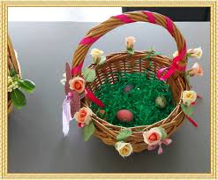](καλαθακι%20για%20το%20λαζαρο%20βικιπαιδεια)

[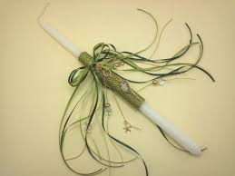](πασχαλινη%20λαμπαδα%20βικιπαιδεια)

[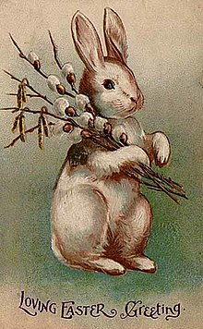](https://el.wikipedia.org/wiki/%CE%9B%CE%B1%CE%B3%CE%BF%CF%85%CE%B4%CE%AC%CE%BA%CE%B9_%CF%84%CE%BF%CF%85_%CE%A0%CE%AC%CF%83%CF%87%CE%B1)

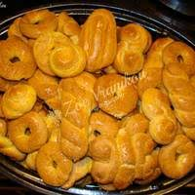

[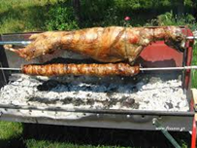](https://www.google.gr/search?rlz=1C1GGRV_enGR750GR753&biw=1366&bih=672&tbm=isch&sa=1&ei=fG-dWuSqBvGCmgXUlaKACw&q=αρνι+πασχαλινο+)