*OLYMP`EA*

*restaurant*

**

*Food*

*fish and seafood*

*trout 10.00$ salmon 10.00$*

*lobster 10.00$ squid 10.00$*

*sardine 10.00$ herring 10.00$*

*prawn 10.00$ swordfish 10.00$*

*mussel 10.00$ crab 10.00$*

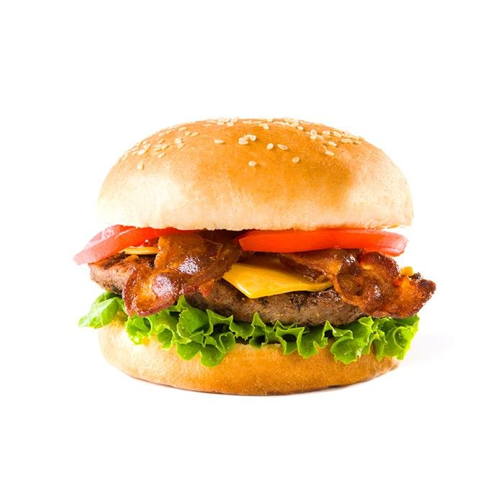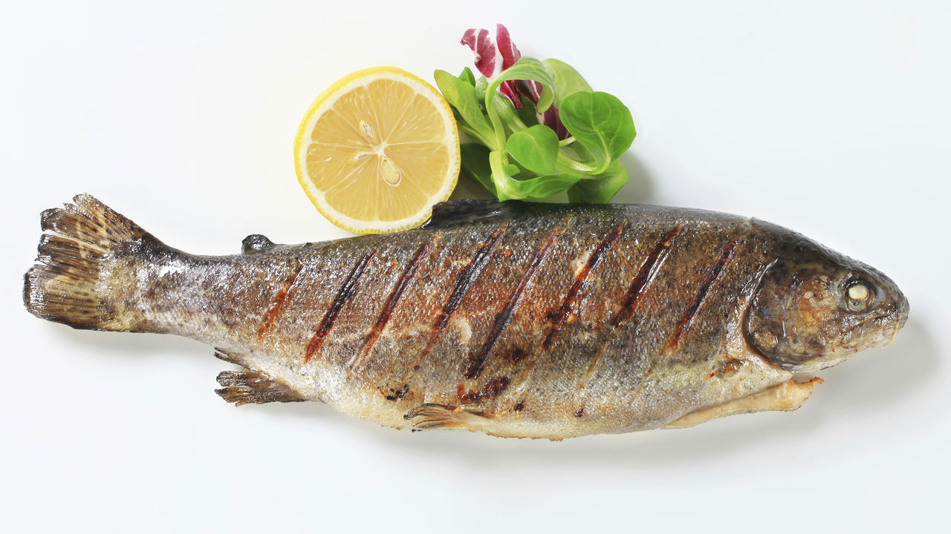 *meat*

*meatball 8.00$ lamb 8.00$*

*steak 8.00$ ribs 8.00$*

*sausage 8.00$ chops 8.00$*

*liver 8.00 $ pork 8.00$*

*beef 8.00$ burger 8.00$*

*vegetarian*

*vegetarian burger 8.00$*

*onion rings 8.00$*

*cheese and onion cake 8.00$*

*pasta with vegetables 8.00$*

*beans 8.00$*

*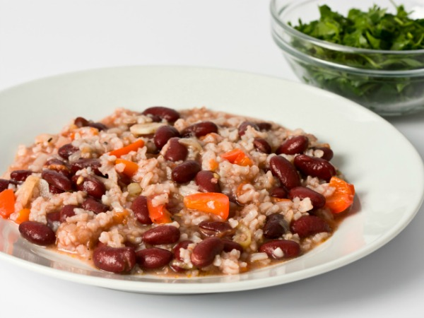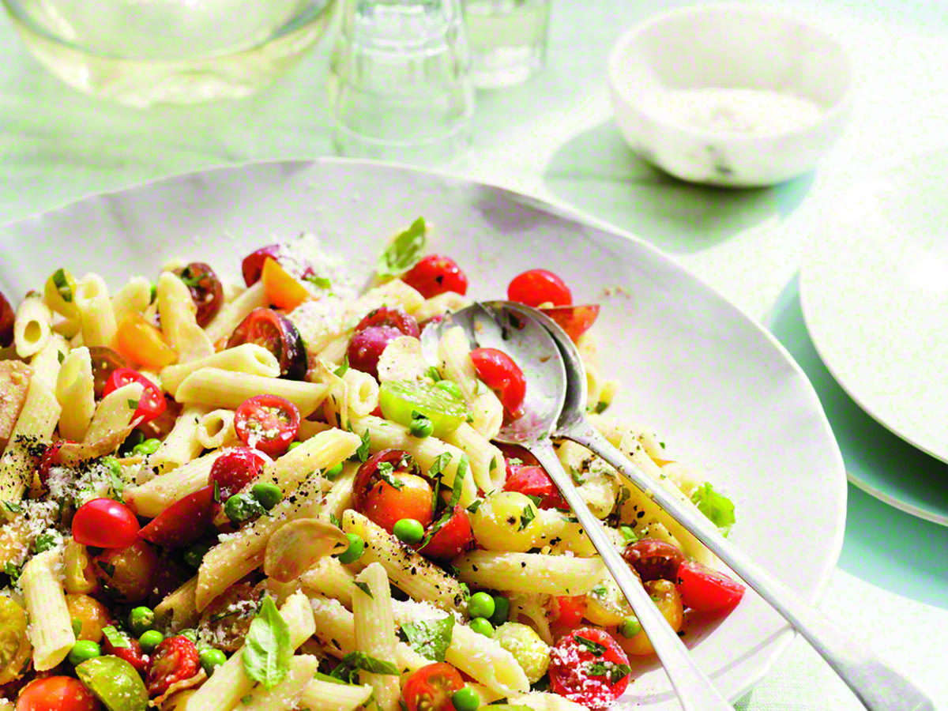*

*salads*

*lettuce 6.00$*

*cabbage 6.00$*

*spinach 6.00$*

*cucumber 6.00$*

*courgette 6.00$*

*tomato 6.00$*

*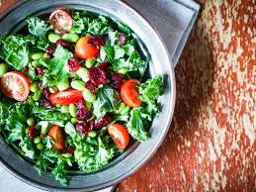*

*dessert*

*brownie 6.00$*

*chocolate cake 6.00$*

*cheesecake 6.00$*

*pancakes 6.00$*

*profiterol 6.00$*

*cupcake 6.00$*

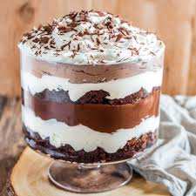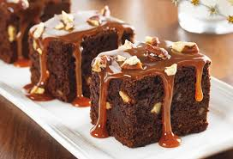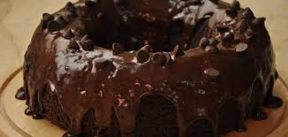

*drinks*

*cola 3.00$*

*soda 3.00$*

*juice 3.00$*

*beer 3.00$*

*wine(red-white) 3.00$*

*water 3.00$*

*a bottle or glass*

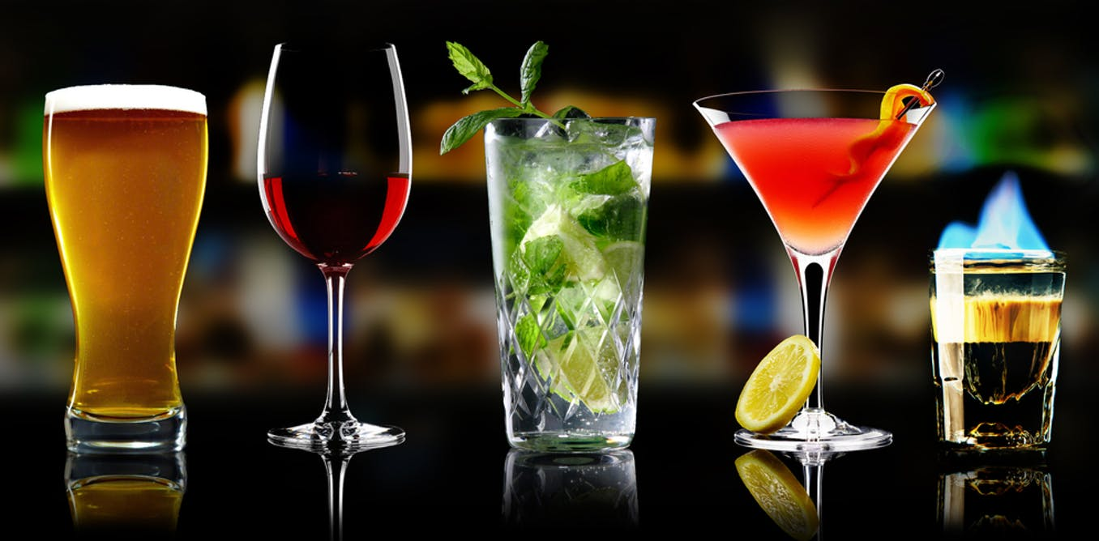

*BON APPETIT*

*by Theodora Papastoitsi*