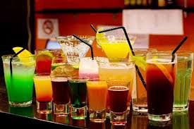
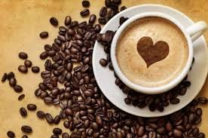
BLACK DIAMOND
Coffee Bar

COFFEE FRESH JUICE
Greek Coffee 1.50€ Orange 2.00€ Espresso 2.00€ Banana 2.00€
Espresso Διπλό 2.50€ Mixed Fruits 2.00€
Espresso Freddo 2.50€ Carrot 2.00€
Cappuccino 3.00€ Strawberry 2.00€
Cappuccino Διπλό 3.50€ Sour Cherry 2.00€

Cappuccino Freddo 3.50€ BEVERAGES
Frappe 1.50€ Chocolate 2.00€
Tea 1.50€
Chamomile 1.50€
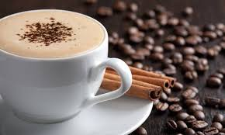

DRINKS
Beer 2.50€
Wine 3.50€
Vodka 7.00€
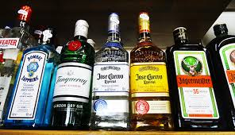
Whiskey 10.00€
Maliby 7.00€
Gkordon 4.50€
Tequila 9.00€
Gin Tonic 10.00€

