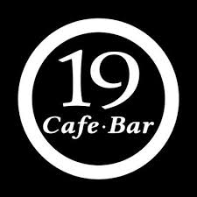

***Menu***

Coffee Alcohol

* **Freddo espresso ...2,50‎€ Black Irish Beer(a glass)...3,50‎€**
* **Freddo cappuccino ...2,50€ Belgian Beer(a bottle) ...4,50‎€**
* **Macchiato ...2,50€ Burgundy Wine(a glass)...3,50‎€**
* **Cafe Latte ...2,50€ Caipiroska (a glass) ...3,50‎€**
* **Espresso ...2,50€ Tequila (a glass) ...3,50‎€**

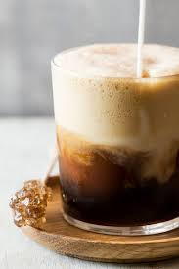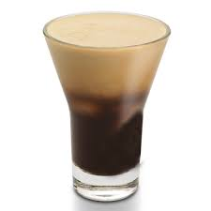 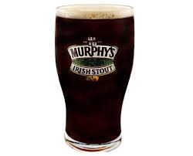 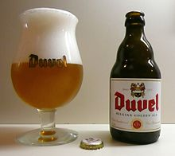

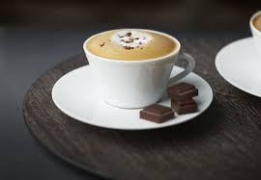 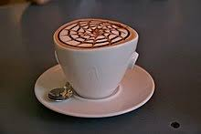 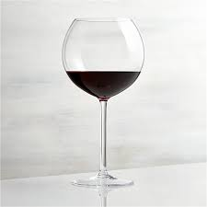 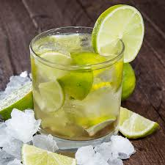

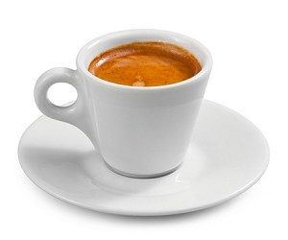 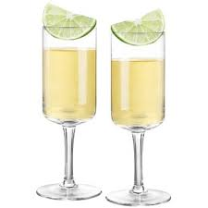

Dessert Soft Drinks

* **Ice Cream(a bowl) 2,50‎€ All Fruit Juice(a glass) 2,50‎€**
* **Croissant(2-3 pieces) 2,50€ Coca-Cola(a bottle) 1,50‎€**
* **Biscuit(2-3 pieces) 2,50€ Chocolate (hot/cold) (a glass) 2,50‎€**
* **Profiterol 2,50€ Ice Tea(a bottle) 2,50‎€**
* **Crepe (sweet) 2,50€ Lemon Soda bottle) 2,50‎€**

