THE MEXICAN
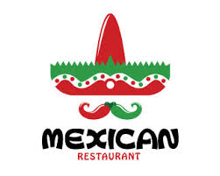

TACOS
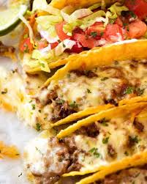
With four different cheeses 4,50$
With pieces of pork 5,50$
With pieces of chicken 5,50$
With different kinds of sausages 6,00$
With different kinds of vegetables 4,50$

BURRITOS
With different kinds of beans 5,00$
With different pieces of meat 6,50$
With different kinds of vegetables 5,50$

PASTA
With red sauce and meatballs 6,00$
Carbonara 6,50$
With a pepper sauce 5,50$
With various seafood and sauce 9,00$

