BREAKFAST - RESTAURANT
“THE TWO COUSINS”

COFFEES

Greek Coffee £ 0.89 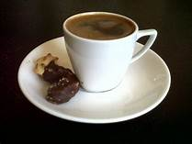
Nes Coffee Frappe £ 1.30 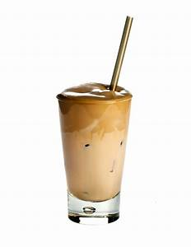
Cappucino £ 2.16 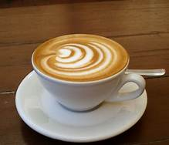
Freddo Espesso £ 1.90 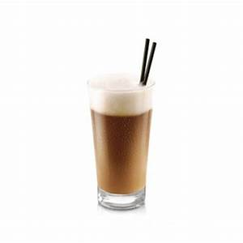
Chocolate £ 2.34 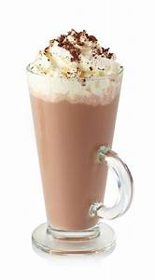

BREAKFAST

Toast With Ham And Cheese £3.63 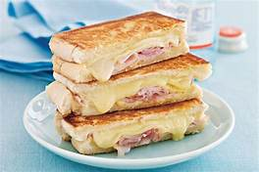
Cereals With Milk £2.94 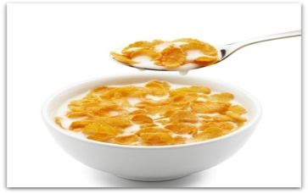
Bacon With Sausages And Eggs £4.33 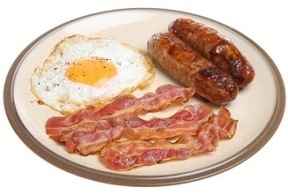

MAIN DISHES

Chicken Schnitzel With Fried Potatoes And Rice £5.80 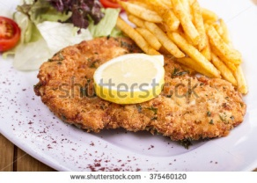
Snickel Pork With Baked Potatoes And Rice £5.19
Pork Dressed With Fried Potatoes £6.49 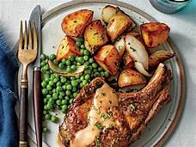
Burgers With Rice £6.92 