MOM’ S COOKING RESTAURANT

MENU

BURGERS

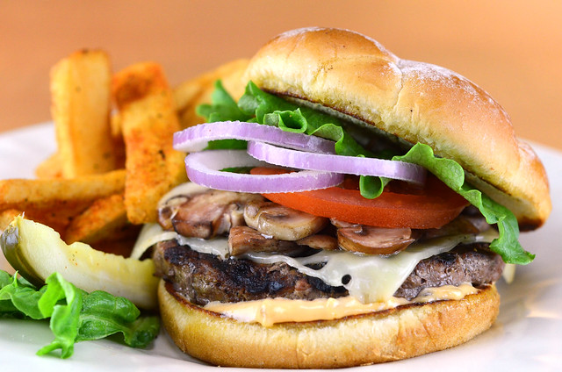

1.BURGER with beef, lettuce, tomato, onions & pickles $ 5.60
2.CHEESE BURGER with beef, cheese, lettuce, tomato, onions $ 5.80
3.VEGGIE BURGER with lettuce, tomato, onions & pickles $ 5.60
4.SPECIAL CHEESE BURGER with beef, double cheese, lettuce, tomato, onions , pickles, mushrooms & potatoes $ 6.50
5.CHICKEN BURGER with chicken breast, bacon, cheese, tomato, lettuce,
onions & pickles $ 6.30
6.SPECIAL CHICKEN BURGER with chicken breast, cheese, red onions, lettuce, red pepper, bacon & pickles $ 6.80

MOM’ S COOKING

RESTAURANT
MENU
SALADS
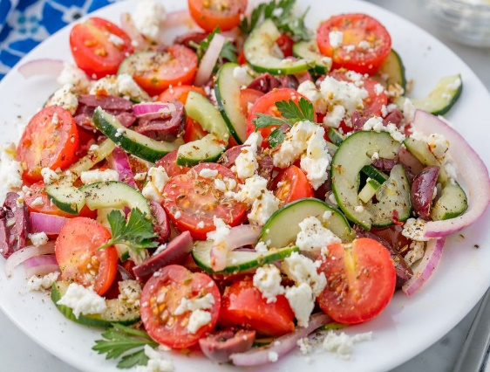
1.GREEK SALAD with onion, lettuce, tomatoes, feta, cucumber, green pepper, black olives & balsamic dressing $ 4.40
2.CAESAR SALAD with grilled chicken, parmesan cheese, croutons & Caesar dressing $ 4.60
3.TUNA & PASTA SALAD with lettuce, pasta, tuna, tomato, broccoli, olives, croutons
and parmesan $ 5.30
4.THE SALAD with spinach, lettuce, grilled chicken, cucumber, tomato, pomegranate, feta, seeds & onions $ 5.60
5.RED SALAD with lettuce, apple, bacon, goat cheese, walnuts & mustard dressing $ 4.00
6.MEXICAN SALAD with tomato, cucumber, sweet corn, mix beans, paprika, lemon mint vinaigrette $ 5.00

MOM’ S COOKING RESTAURANT
MENU
BREAKFAST
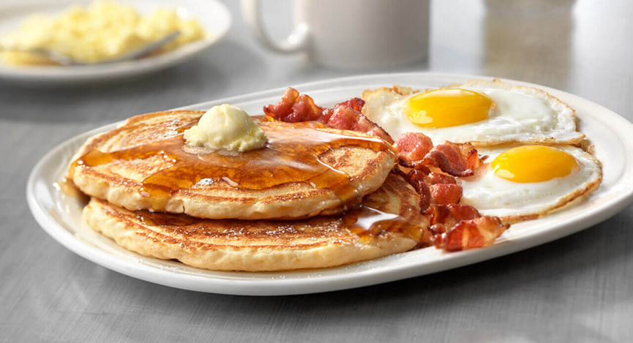
1.PANCAKES & WAFFLES $ 2.50
2.EGG OMELET with mushrooms, bacon, onions, ham, peppers & sausage $ 3.30
3.TOAST with ham & cheese $ 2.00
4.BREAKFAST BURGER with eggs, cheese, potatoes, bacon & mushrooms $ 3.60
5.FRESH FRUITS $ 1.30
6.BUTTERMILK BISCUIT with milk or coffee $ 2.50

