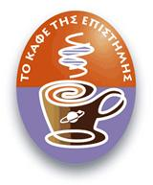
MENOY
COFFEE 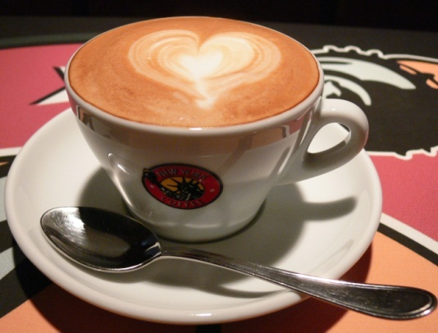
Freddo cappuccino 2,8O
Freddo espresso 2,80
Makiato 2,80
Greek Cafe 1,80
Freddochino 2,80
Cappuccino 2,80
Espresso 2,80
Espresso double 2,80
Ristretto 3,00
Ristretto double 4,00

Juices
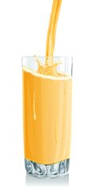
Sour cherry 2.00
Cherry 2.00
Apple 2.00
Orange 2.00
Banana 2.00
Mixed juices 2.00
Natural juices 3.00

Soft Drinks
Coca Cola 2,00 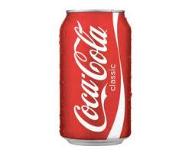
Sprite 2,00
Orange Drink 2,00
Ice Tea 2,00
Soda 2,00

Alcohol Drinks
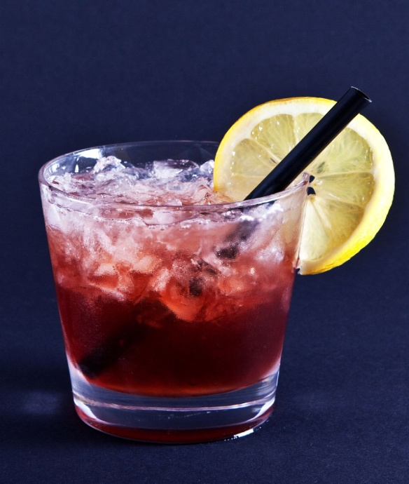
BEER
Vergina 3,00
Amstel 3,00
Amstel Radler 3,00
Amstel Free 3,00
FIX 3,00
Mythos 3,00
Mythos Radler 3,00
Mythos Free 3,00
WHITE WINE RED WINE
Vivlia Hora 30,00 Vivlia Hora 30,00
Malagouzia 14,00 Merlot 14,00
Moshofilero 187ml 3,00 Red wine glass 2,50
WHISKEY TZIN
Johnnie Walker 5,00 Tangeray 6,00
Dewars 5,00 Gordon’s 5,00
Chivas Regal 6,00

Bantouvakis Christos

