menu ( Greek restarunt )
appertizers
- Feta cheese in flaky pastry with honey and sesame 5,00 $
- Spicy “bouyiourdi ” 5,00$
- Pleurotous mushrooms on the grill 5,50 $
- Stuffed mushrooms with blue cheese 6,00 $
- Mediterranean bruschette with tomato,feta cheese,basil pesto and olives 5,50 $
- Potato souffle ( with cream and yellow chesse) 5,00 $
- Stuffed garlic bread with cheese 4,00 $
- Homemade fries 3,00 $
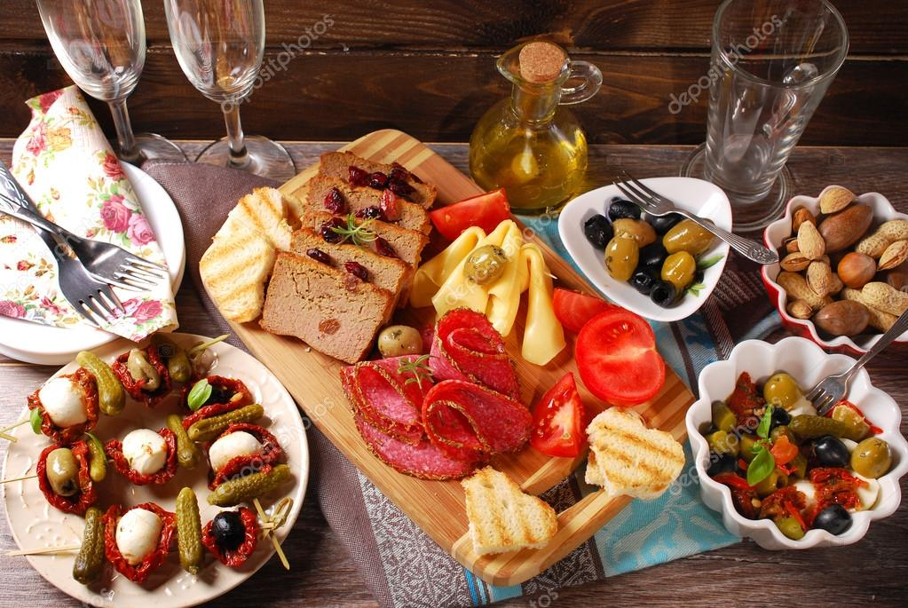

SALADS
- Salad Grecque 5,50 $
- Salade Kesara 6,00 $
- Chop sui salad 5,00 $
- Salad with tuna 6,00 $
- Ceasar’s 4,00 $
- Caprese 4,00 $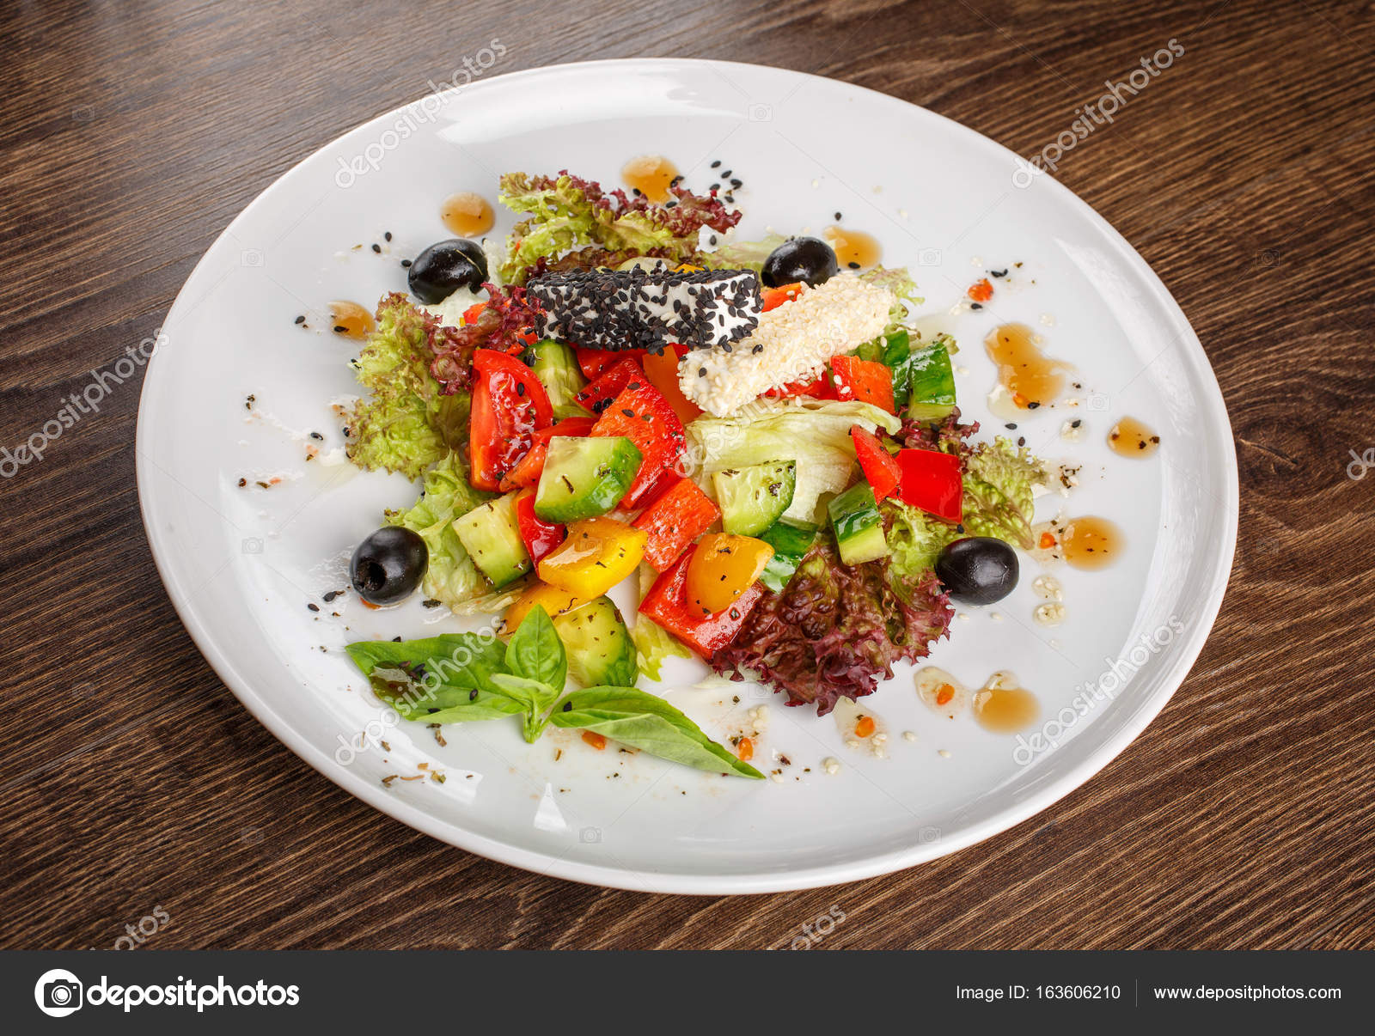
Dinners

- Chicken souvlaki 3,50 $
- Pork souvlaki 3,00 $
- Chicken burger 5,00 $
- Beef burger 7,00 $
- Sauted pork fillet 10,00 $
- Sauted chicken fillet 10,00 $
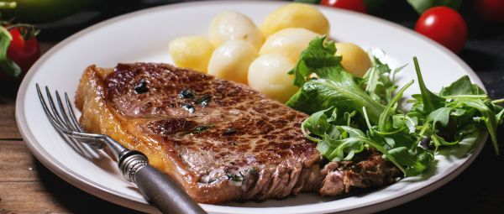

DRINKS

- Coca cola 1,50 $
- Coca cola light 1,50 $
- Orange juice 1,50 $
- Lemonade 1,50 $
- Wine (red,white,pink ) 4,50 $
- Amstel beer 3,00 $
- Kaiser beer 3,50 $
- Fix beer 3,00 $

