*Raw heart compass,Vietnam*

*The Vietnamese worship it! Although it is not commonplace in this part of the world, there is a particular weakness in the heart of the choir. You think that those who eat the heart of the choir have become supernatural.*

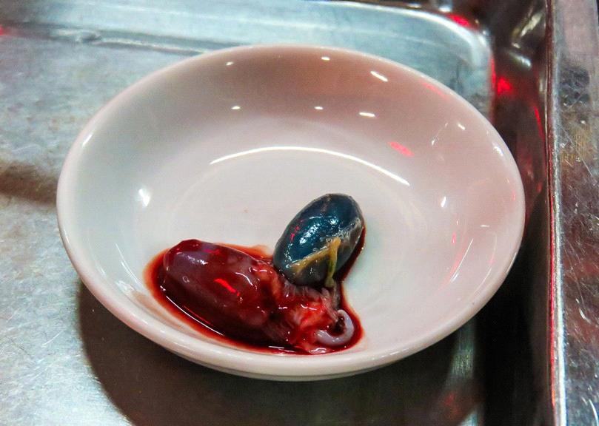

*Eggs of the century,China*

*The egg of the century, known and pidan, is a Chinese delicacy that became famous many years ago. The Chinese call it eggs for hundreds and thousands of years.*

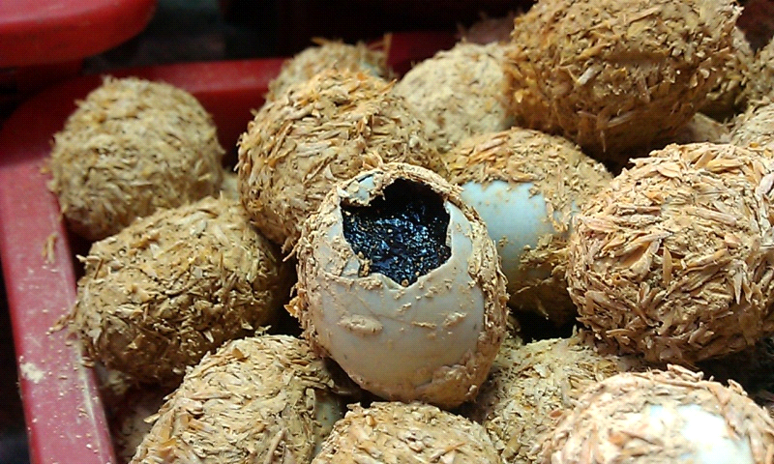

*Frogs, southern US*

*Although this food is also popular in France and China, the Americans of the South have an unusual addiction to frog-poodles, many say they have chicken beef.*

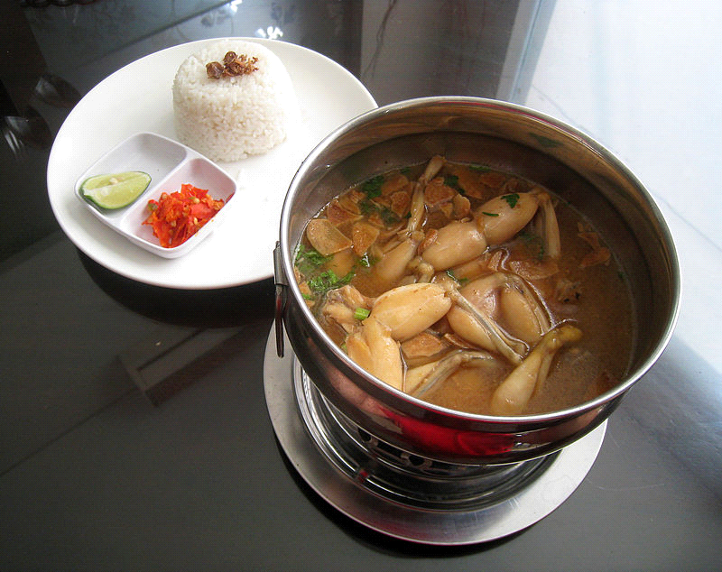

*Biscuits with hazelnuts, japanese*

*Some believe that these pictures are false.We are sorry, but it is real. Hip cookies are a very popular snack in Japan.*

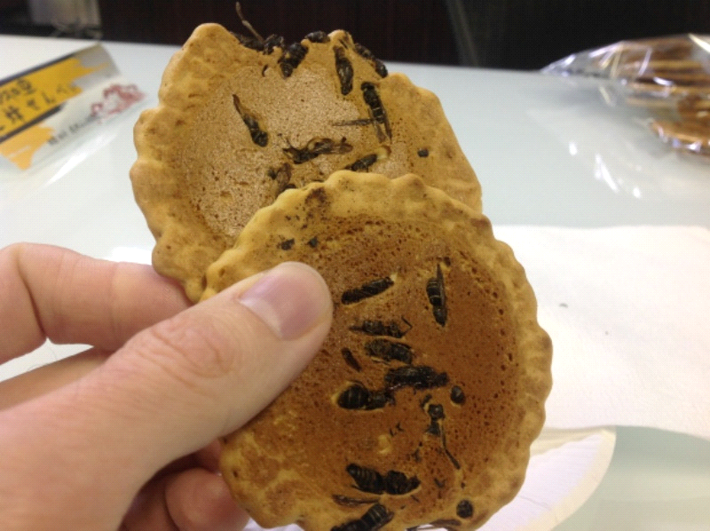

*Haggis,Scotland*

*Haggis is a type of sweetener that contains sheep's heart, liver and pneumonia. It treats the Greek kokoretsi. There is also a haggis for chocolates that has the main bean material*.

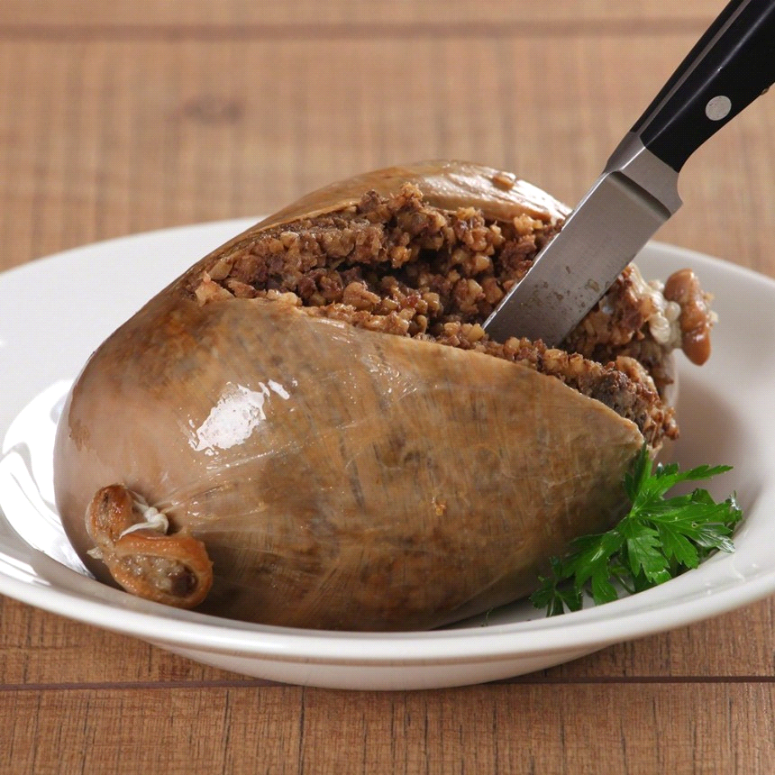

*Sannakji,Korea*

*Would you eat a live octopus? The Koreans worship to keep them as long as their squabbles are still moving!*

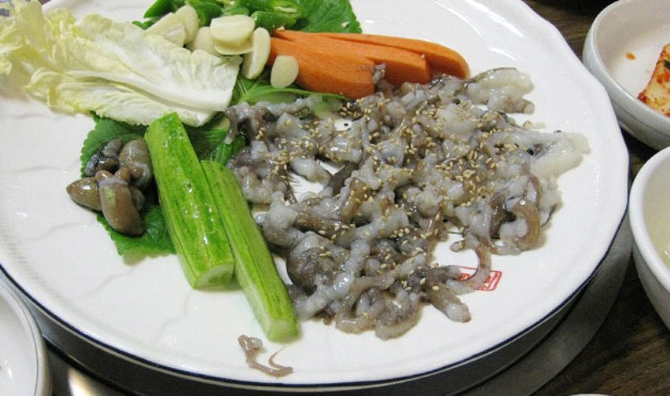

*Asia Minor*

*The sausages are quite popular for consumption in Asia. Serve raw and fresh as soon as the thorns of the Achinus are removed.*

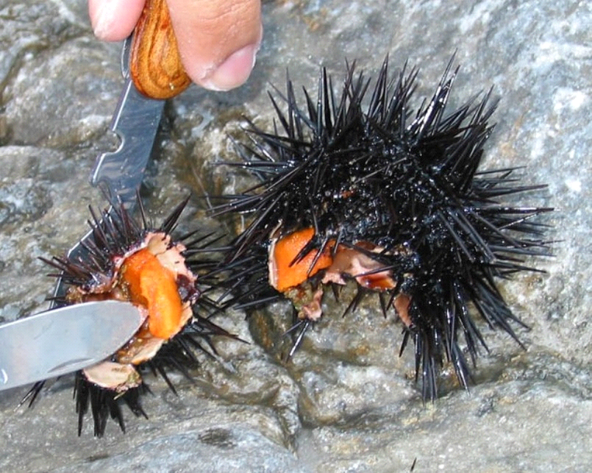

*Grylls,Thailand*

*This insect is a popular snack Thailand.They make a sweet gruel. Some like to eat as long as they are still alive.*

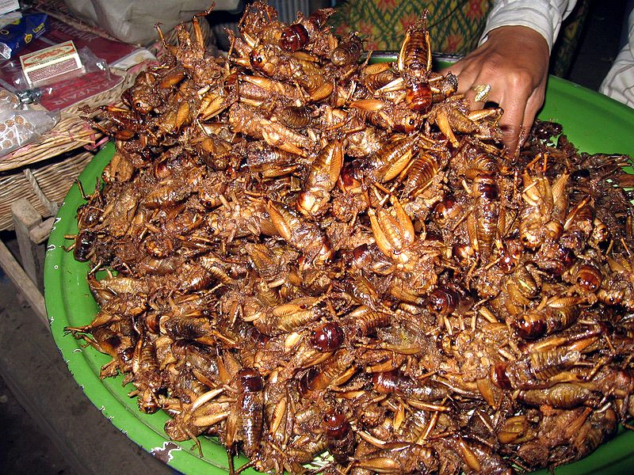

*Fugu*

*The small slices of the fish are so thin that they are barely distinguishable, among the elaborate, colorful dish designs. And yet, behind this "elegant" delight, there is ... death!Thin flies come from frog fish, a creature that hides within it a poison 200 times more lethal than cyanide. The smallest mistake of the chef can send the customer ... to the taurine.*

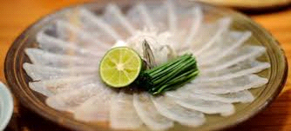

*Fish Yin Yang*

*How strange can a fish be? This fish can be fried in hot oil but remains alive even after cooking. It is particularly popular in China and Taiwan, although many condemn it because of its cruelty.*

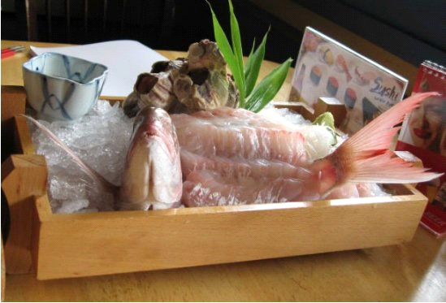

***Δήμητρα Τάντη***

***Παναγιώτα Κέρνα***

***ΒΥΓ2***