Jellied moose nose

The reason for reindeer nose in the form of jelly. This food is in Alaska. After the bulb has been removed, the reindeer's nose is cut into slices, which boil to make it easier to depilate. Then the nose is restored with the addition of onion, garlic and spices, while gaining a gentle texture.
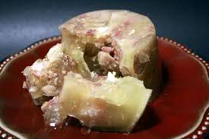
Escamoles
These are ants larvae, harvested from the roots of trees in Mexico and used in local cuisine as a crackling of traditional dishes, such as the vault. They are said to leave a sense of buttered walnut. They call it the "insect caviar".
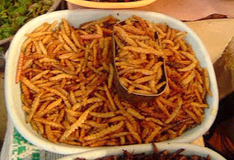

Shirako
This is Japanese food, referring to semen (or seminal fluid) of fish and mollusks. The Japanese prefer to take it out of fish such as cod and skipjack, while it has a fairly creamy texture.
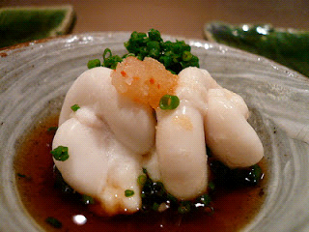

Squirrel Brain
This particular taste is popular with Kentucky residents and more specifically with those who live in the Abalamic Mountains. It is eaten cooked together with eggs, while a variation is to become a stew along with the squirrel meat.
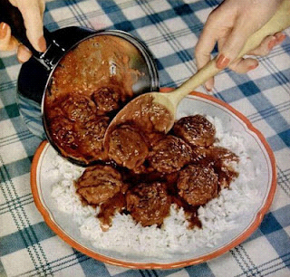
Bird's Blood
In Hungary, when they slaughter a lamb, fry their blood with onion and serve it for breakfast along with hot bread.
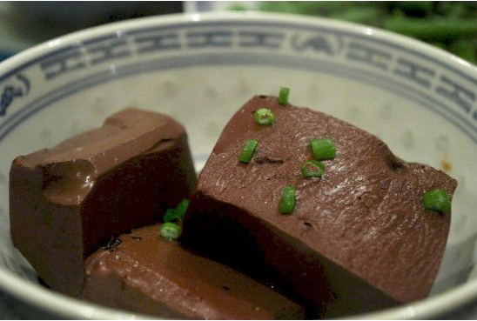
Cocktail of cow blood
The cow's blood is mixed with a little milk and consumed in special rituals in some Ethiopian breeds.
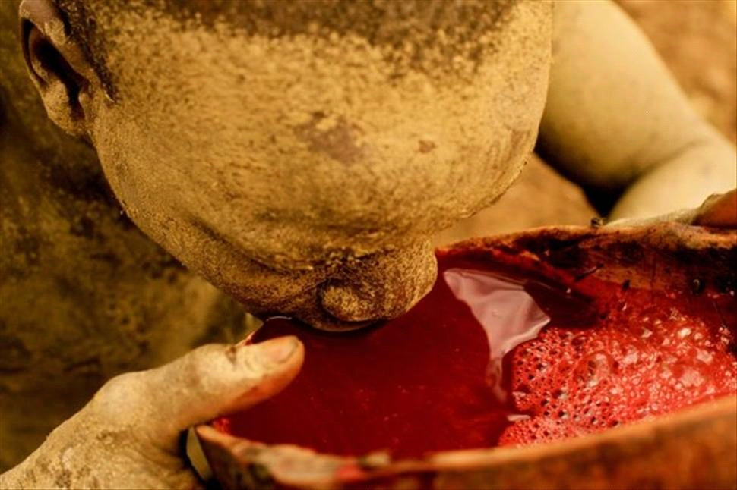
Δήμητρα Τάντη
Παναγιώτα Κέρνα
ΒΥΓ2

