STRANGE FOOD

- Birds Nest Soup—China
Also known as the "caviar of the east," this dish is considered a rare delicacy around the world, but is particularly popular in Asia. The nest is not made of sticks and leaves, but rather the bird's saliva. The soup, comprised of a nest covered in a light chicken broth, is said to be one of the priciest animal products eaten by humans in the world, ringing in at anywhere from $30 to $100 per bowl! 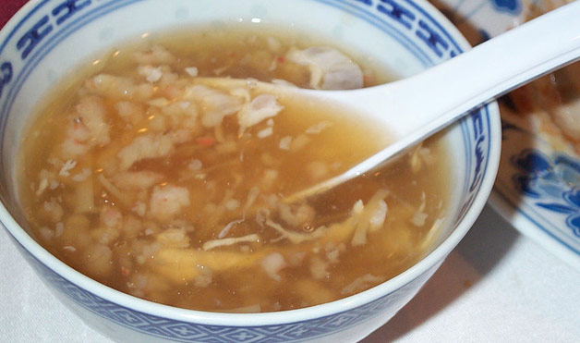

- Fried Tarantulas—Cambodia
Fried spiders? Yep, you read that right. First discovered by impoverished Cambodians during the bloody Khmer Rouge "killing fields" rule, the insects are deep-fried and seasoned with garlic and salt. But this crunchy dish is not just something tourists and natives flock to for a treat; it's also a reminder of the horrible times the country endured. In U.S. dollars the snack costs only about 8 cents per spider, but consider that many poor Cambodians live on the equivalent of $1 a day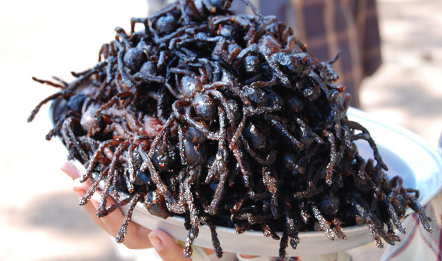

- Balut—Phillipines

If you cringe at the thought of eating a typical egg yolk, you probably won't want to try this Filipino delicacy. Balut is a fertilized egg—usually from a duck or chicken—that has an almost-developed embryo. It's boiled and eaten right out of the shell. The protein-packed snack can be found on street carts and is normally accompanied by a beer. Sellers charge about $12 per dozen. 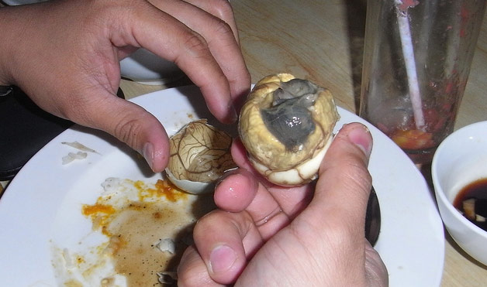

- Sannakji—Korea

Sushi is pretty common in the United States; we even occasionally eat octopus. But live octopus? Not so much. In Korea, fresh baby octopi are cut up, quickly seasoned with sesame oil, and served while the tentacles are still moving. If that's not enough of a dare for you, be aware that the dish can actually be quite dangerous if the suction cups stick to your mouth or throat. 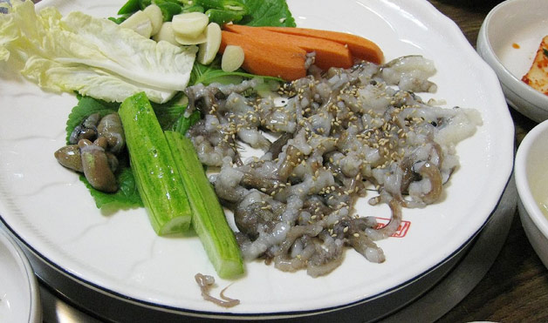

- Snake Wine—Vietnam

This Vietnamese wine is processed by fermenting a dead cobra or scorpion in a bottle filled with rice wine liquor or grain alcohol—the venom is deactivated by the ethanol. Importation of the wine is illegal in many countries because cobras are on the endangered species list, so the best snake wines can only be found online and are priced in the $100 range. 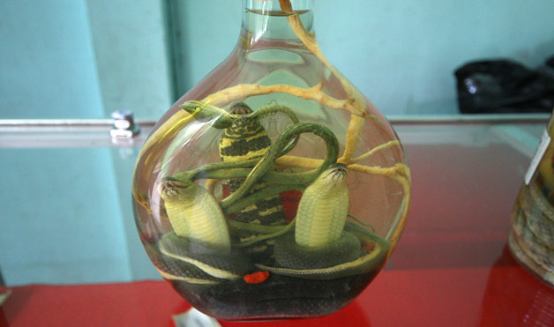

- Stuffed Camel—Dubai

You've probably heard of riding camels, but what about eating them? In the Persian Gulf, a common wedding dish is the stuffed camel, which is made by first packing chicken and lamb with rice and eggs, then stuffing that into a washed and skinned camel. The creation is then broiled using a charcoal pit and topped with nuts. For weddings, as many as 20 chickens are used in addition to the 60 eggs, five pounds of pepper, a whole camel and a whole lamb. The dish typically serves about 90 people. 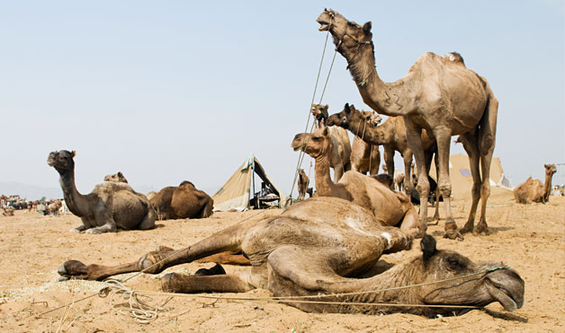

- Kopi Luwak—Indonesia

lso known as civet coffee, kopi luwak is the most expensive coffee in the world, ringing in at $75 per quarter-pound. The coffee is only made on the islands of Sumatra, Java and Sulawesi, and what makes it so special is the processing cycle. A small tree-dwelling animal, the Common Palm Civet, eats the outer layer of the coffee cherry, but does not digest the inner bean. Thus, the droppings contain intact beans mixed with digestive enzymes, which locals collect and sell to vendors, who sun-dry the beans before putting them on the market. 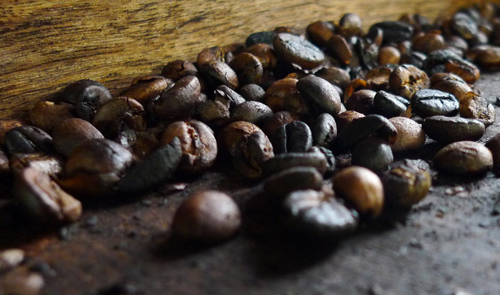

- Haggis—Scotland
The ingredients in Scotland's national dish may sound disturbing, but we have editors here at WD who have tried it—and liked it! Haggis is made with a sheep's lung, stomach, heart and liver. As with many kinds of sausage, the stomach is stuffed with the organ meats, suet, oatmeal, onions and spices, then all the ingredients are boiled together for about three hours. Traditionally, haggis is served with turnips, mashed potatoes and a small amount of whiskey. 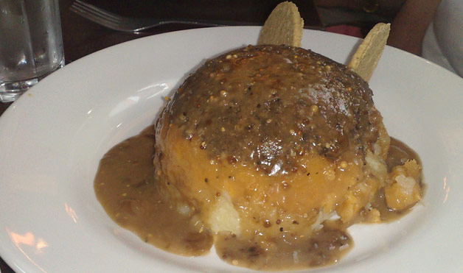

SYROPOULOU KONDYLENIA A2

