Kids and sports
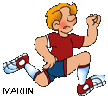

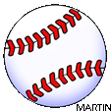
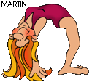
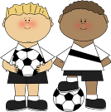
Jack:
I really love soccer. I´m a member of our school soccer team and I play four times a week.
I also quite like cricket and I play it a lot in summer. I don´t like table tennis. I think it´s boring.
Cathlyn:
I don´t like sports at school very
much, but I like going fishing
with my dad. It´s great fun and
it´s very exciting. Sometimes, in the holidays, we go to Scotland and go deep-sea fishing.
Sally:
I absolutely hate gymnastics. Our gym teacher is really horrible. What I like best is swimming because I´m very good at it.
I can swim the hundred metres faster
than the other kids in my class. I also
quite like badminton.

Isabelle:
My favourite sport is karate. I also like tennis very much, but we don´t play it in my school, so I go to a club with my best friend. I´m not very good at swimming
and I really don´t like it very much.
Joe:
I have one favourite sport and that´s cycling. But I don´t like the sports we do at school.
We play football and basketball. I think they´re stupid games and I think they´re boring.
Write about your favourite sports and the sports you don´t like!

My favourite sport is .................. . I think it´s ...................................... . I also like ....................... and ............................ . I´m good at .....................
At school I ........................................................... .
I don´t like .............................. and ................................ . I think they´re ................ .
I´m not good at .................................................. .
........................................................................................................................................................................
Tick off - true or false?
1. Sally´s gym teacher is terrible.
true
false

Fill in: do or play or go

........ golf ........ volleyball
........ skiing ........ karate
........ gymnastics ........ cricket
........ soccer ........ athletics
........ swimming ........ badminton
........ tennis ........ cycling
........ skating ........ tennis
........ basketball ........ jogging
........ judo ........ table tennis
........ hiking ........ sports

Ronnie:
I think basketball is great. I´d like to
be a professional basketball player
when I grow up. It´s a really exciting
and interesting game. My two brothers
are in a basketball team and they teach me a lot. I don´t like volleyball or skating I think they´re are boring.
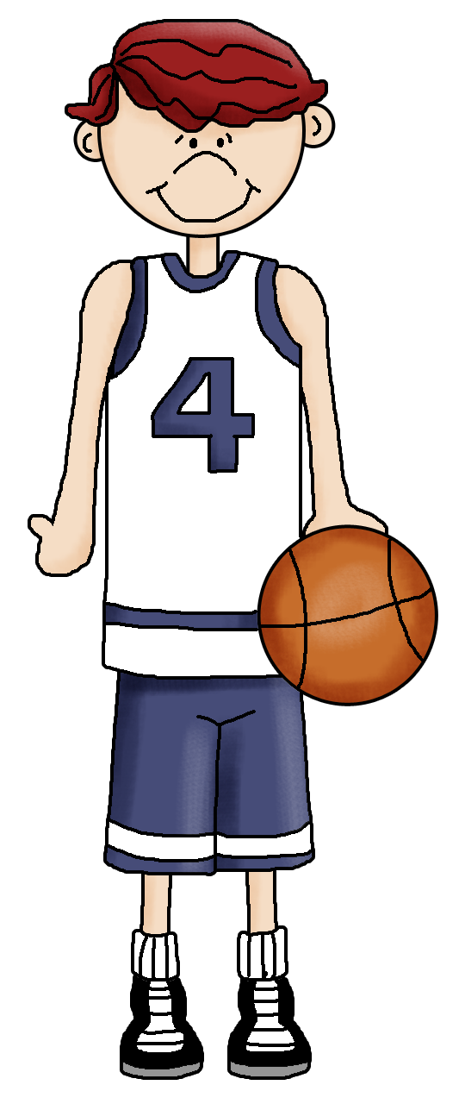
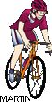
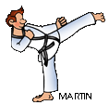
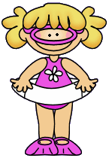
3. Ronnie is a professional basketball player.
true false

2. Cathlyn and her dad go fishing.

true false

4. Isabelle doesn´t play tennis at school.
true false

6. Jack plays cricket in spring.

true
false

5. Joe likes riding a bike.

true false

7. Ronnie thinks skating is boring.

true false

9. Jack plays soccer every day.

true
false

8. Sally can swim 100 m very fast.

true false

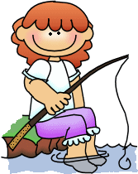
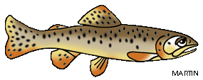


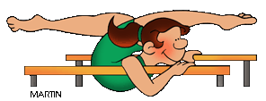
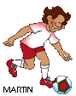
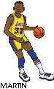

Key
Tick off - true or false?
1. Sally´s gym teacher is terrible.

true false

3. Ronnie is a professional basketball player.
true false

2. Cathlyn and her dad go fishing.

true false

4. Isabelle doesn´t play tennis at school.
true false

6. Jack plays cricket in spring.

true false

5. Joe likes riding a bike.

true false

7. Ronnie thinks skating is boring.

true false

9. Jack plays soccer every day.

true false

8. Sally can swim 100 m very fast.

true false

Fill in: do or play or go

play golf play volleyball
go skiing do karate
do gymnastics play cricket
play soccer do athletics
go swimming play badminton
play tennis go cycling
go skating play tennis
play basketball go jogging
do judo play table tennis
go hiking do sports

