Wall Spiderweb
by Karen on October 24, 2011


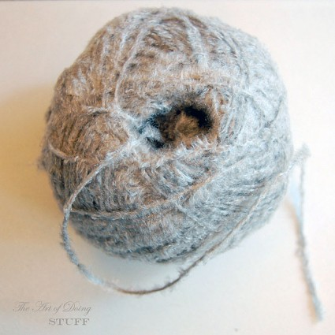

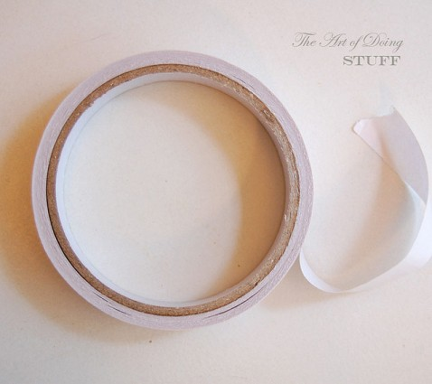

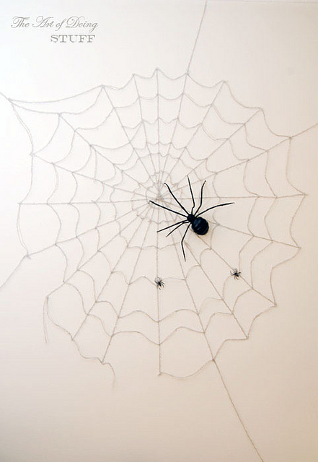
Cute, right? To put it in perspective … here it is in the room.
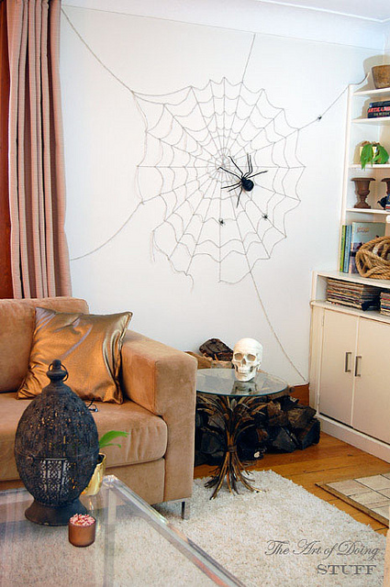
Rather large.
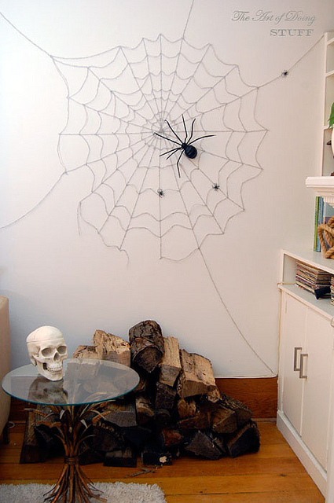
Rather impressive.
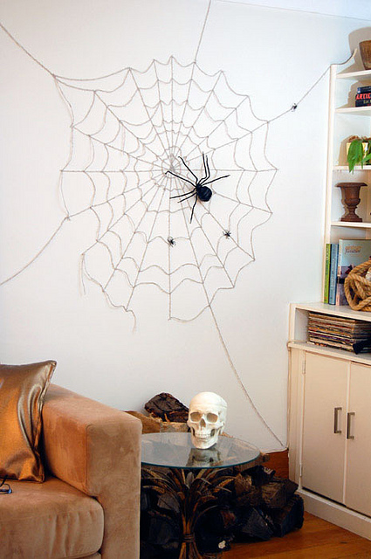
Rather cheap.
$1 for the yarn at the Dollar Store, $1 for the two way tape. If you need to go out and buy the spiders, that’ll set you back another dollar or two. I know. I should really try to keep these crafts within everyone’s budget, but sometimes you just have to go for it. Ya know?
To make your very own spider web all you have to do is cut the two way tape (I used foam tape because it’s easiest to work with) into tiny squares. About a billion of them. In my case, probably closer to 150 or so. A billion just sounds more impressive. The way vahse sounds more impressive than vase. Or eccentric sounds more impressive than nutjob.
Stick the squares onto your wall where you want the spiderweb. As opposed to where you don’t want the spiderweb. Do not stick the squares on your toiletbowl for instance. Or your boyfriend’s butt.
My foam tape was white, which matches my walls. This makes the tape invisible. If your walls aren’t white, use regular, clear, two way tape.
My web is basically 7 circles which get smaller and smaller towards the center. Each circle consists of 20 pieces of tape. I’ve purposely made the web a little off centre so it isn’t too perfect looking.
Once your tape is on the wall, just stick your yarn to it. Do your straight lines first, then finish up with the draping part of the web starting with either the innermost or outermost circle.
For the first while it will look gross. Unattractive. Stupid.
Then as you continue on a magical thing will occur. All of a sudden it will look rather good. Rather large. Rather impressive. Rather than cheap.
http://www.listotic.com/16-awesome-homemade-halloween-decorations/5/

