**Α.** Βρες τα λάθη και γράψε την πρόταση διορθωμένη.

1. I have the heavier bag. --------------------------------------------------

2. Tom is best in our class. ------------------------------------------------

3. Helen is thin than Pam. -------------------------------------------------

4. Betty is happiest than Liz. ----------------------------------------------

5. January is usually the colder month of the year. ------------------------------

6. Your bag is cheapest than mine. --------------------------------------------------

7. My car is most expensive than yours. -------------------------------------------

**B.**Γράψε τον συγκριτικό και υπερθετικό βαθμό των επιθέτων.

1. Careful ----------------------------- -------------------------------------

2. Modern ---------------------------- -------------------------------------

3. Good ------------------------------ ------------------------------------

4. Bad -------------------------------- ------------------------------------

5. Little ------------------------------- -----------------------------------

6. Far --------------------------------- ------------------------------------

7. Expensive -------------------------- --------------------------------------

8. Much --------------------------------- --------------------------------------

9. Young -------------------------------- --------------------------------------

10. Dangerous -------------------------- ----------------------------------------

**C**.Γράψε τον σωστό τύπο του ρήματος στο simple present.

1. The children -------------------------------------- (not like) vegetables.

2. She usually -------------------------------- (get up) at seven.

3. How often -------------------------you (play) ------------------ the guitar?

4. ---------------------------- Ben --------------------- (go) to work at 8:00?

5. ----------------------- your friend ----------------------- (speak) English?

6. My father always ----------------------- (watch) TV at night.

**D.** Βάλε το ρήμα στην παρένθεση στον σωστό τύπο του present continuous.

1. Michael -------------------------- (talk) on the phone at the moment.

2. They ---------------------------- (study English) now.

3. The children --------------------------------- (sit) in the living room now.

4. I -------------------------- (listen) to music at the moment.

5. They -------------------------- (go) to school today.

**Ε**. Δες τις εικόνες και πες τι κάνουν οι άνθρωποι. Χρησιμοποίησε τα ακόλουθα ρήματα ή φράσεις στον Present Continuous. ( ride a bike, dive in a pool, go jogging, bake cookies, have lunch, brush teeth )

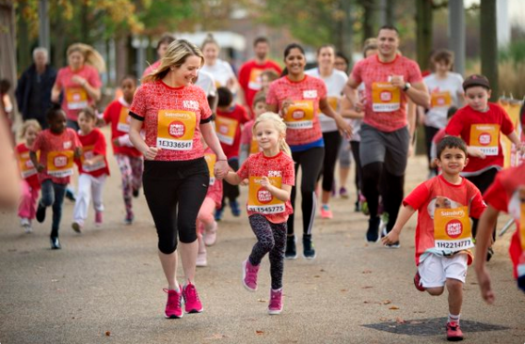

1. ----------------------------------------------------------------------



2. ---------------------------------------------------------------------



3. ----------------------------------------------------------------



4. --------------------------------------------------------------------



5. ----------------------------------------------------------------



6. -------------------------------------------------------------------

**F**.Γράψε τι σκέφτονται οι άνθρωποι βάζοντας τις λέξεις στη σειρά

1. / flower / fantastic / smells /The/

----------------------------------------------------------------



2. / wonderful /The/ looks / landscape /

--------------------------------------------------------------------



3. / tastes / food /The/ great /

-------------------------------------------------------------