**ΑΓΓΛΙΚΑ Γ΄ ΤΑΞΗΣ**

**Α.** Look at the pictures and write what they are doing. Use the phrases from the list below.(Κοίτα τις εικόνες και γράψε τι κάνουν χρησιμοποιώντας τις φράσεις από την παρακάτω λίστα)

The man is swimming , The man is working , The girl is wearing her jacket , The cricket is playing music , The man is walking in the park , The ants are saving food , The boy is reading a book.

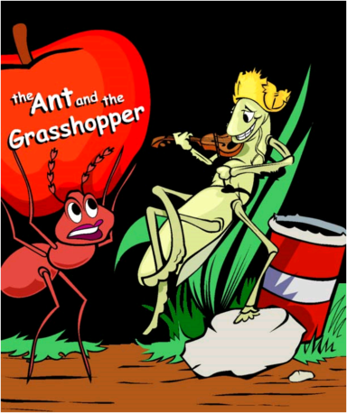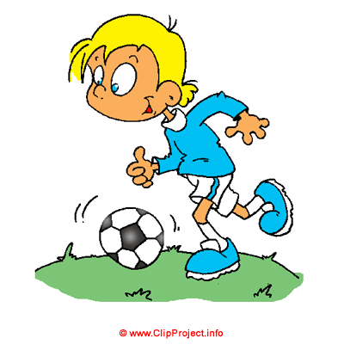

EG . The boy is playing football.

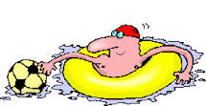

**1.-------------------------------------------- 2.** ----------------------------------------

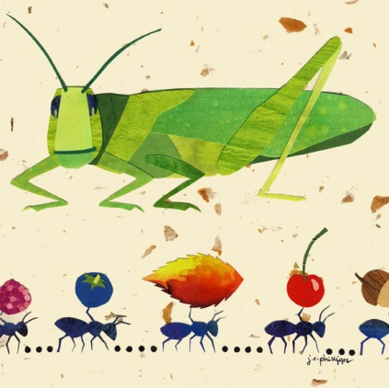

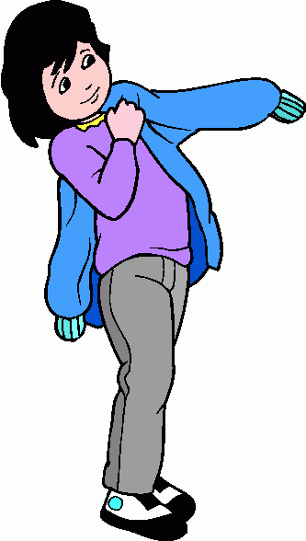**3**.---------------------------------------- **4**.-------------------------------------

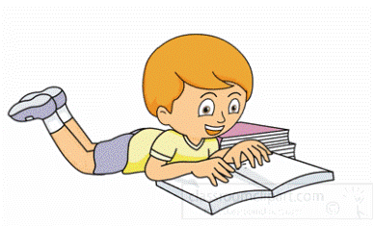

**5**.---------------------------------------------

**6.** -------------------------------------------

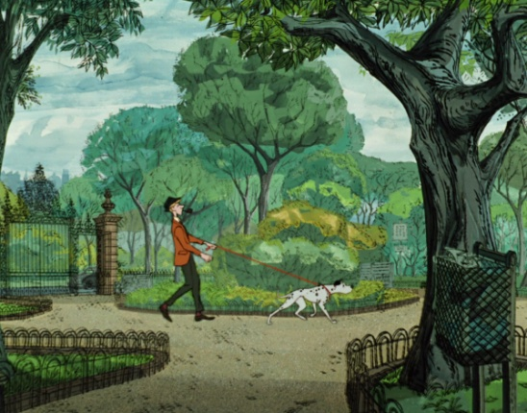

**7. -----------------------------------------**

**Β** .**Find the seasons** (Διάβασε τις προτάσεις και βρες την εποχή)

1. It’s cold and it’s raining. -----------------------------------------

2. It’s hot and we swim in the sea. --------------------------------

3. It’s sunny and warm and there are flowers.----------------------------

4. It’s cool and schools start. ------------------------------------

**C**.

**Fill in the gaps with a word or phrase (Συμπλήρωσε τα κενά με μια λέξη ή φράση)**

**is working , lazy , play , work , is saving ,**

**is coming , near.**

1.The ant ---------------------------- .

2.The ant -----------------------------------food for the winter.

3.The cricket wants to ---------------------and --------------------another day .

4.Winter --------------------------.

5. Autumn is -------------------------.

**D.**

**Find the fruit.(Βρες το φρούτο)**

1. It is sweet yellow and soft. -------------------------

2. It is sweet crunchy and green -------------------------

3. It is sweet red with black spots. -------------------------

4. It is red and small .----------------------------------

**E.**

**Fill in the gaps with the words (Συμπλήρωσε τα κενά με ): saving , playing , raining , wearing , find , sailing , is, am , must , reading , are**

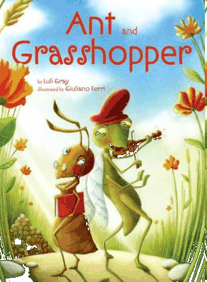

1. ---------------------- you sleeping?

2.----------------------the cricket working?

3.The ant is -------------------------------food.

4.The boat is --------------------------------.

5. The pupils are --------------------------- a book .

6. The boys are -------------------------------football.

7.I -----------------eating a pear.

8. It is ---------------------- now.

9. The girl is -----------------------a jacket.

10. We------------------ study our homework.

11. Let’s ---------------------the magic key.

must = πρέπει

**F.** Look at page 51 of the pupil’s book and answer the questions. Use the phrases

below. (Κοίτα τη σελίδα 51 του student’s και απάντησε στις παρακάτω ερωτήσεις .Χρησιμοποίησε τις παρακάτω φράσεις .

It must wear shoes and socks because it’s cold.

It has got much food.

It’s cold and it’s raining.

It’s autumn.

? -----------------------------

What season is it? ----------------------------

Because the cricket is hungry.

2. How much food has the ant got? ----------------------------------------

3. What is the weather like? ------------------------------------------------

4. What must the cricket wear? ----------------------------------------------

5. Why must the cricket find food? -------------------------------------------

