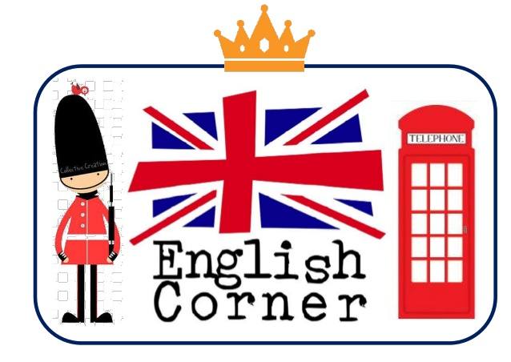

PAST SIMPLE

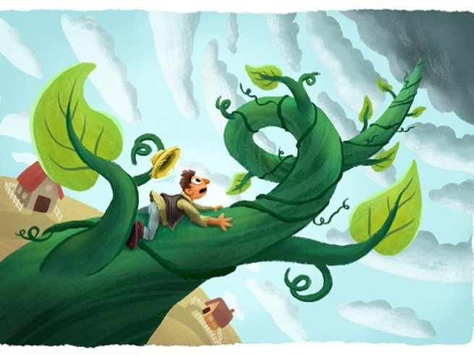
JACK AND THE BEANSTALK
Once upon a time there was a boy called Jack. He lived with his mother. They were very poor. All they had was a cow. One morning, Jack’s mother told him to take the cow to the market and sell her. On the way Jack met a man. He gave Jack some magic beans for the cow. Jack took the beans and went back home. When Jack’s mother saw the beans she was very angry. She threw the beans out of the window. The next morning, Jack looked out of the window. There was a giant beanstalk. He went outside and started to climb the beanstalk. He climbed up to the sky through the clouds. Jack saw a beautiful castle. He went inside. Jack heard a voice “Fee,fi,fo,fum!” and ran into a cupboard. An enormous giant came into the room and sat down. On the table there was a hen and a golden harp.”Lay” said the giant. The hen laid an egg-it was made of gold.”Sing” said the giant. The harp began to sing. Soon the giant was asleep. Jack jumped out of the cupboard. He took the hen and the harp. Suddenly the harp sang “Help, master!”.The giant shouted, “Fee,fi,fo,fum!”.Jack ran and started to climb down the beanstalk. The giant came down after him. Jack shouted “Mother, help!”.Jack’s mother took an axe and chopped down the beanstalk. The giant fell and crashed to the ground. Nobody ever saw him again. With the golden eggs and the magic harp Jack and his mother lived happily ever after.

READ THE FAIRY TALE AND ANSWER THE QUESTIONS
1. What was the boy’s name? ………………………………………………………………………………………………………………………
2. Did he and his mother have a lot of money? ………………………………………………………………………………………………………………………
3. What did Jack do with the cow? ………………………………………………………………………………………………………………………
4. What did the man give Jack? ………………………………………………………………………………………………………………………
5. Was his mother happy when she saw the beans? ………………………………………………………………………………………………………………………
6. What did she do with the beans? ………………………………………………………………………………………………………………………
7. What happened to the beans? ………………………………………………………………………………………………………………………
8. What did Jack see when he looked out of the window? ………………………………………………………………………………………………………………………
9. What did Jack do when he saw the giant plant? ………………………………………………………………………………………………………………………
10. Where did he go? What did he see there? ………………………………………………………………………………………………………………………
11. What did he do when the giant fell asleep? …………………………………………………………………………………………………………………………
12. What did Jack do when the giant suddenly woke up? …………………………………………………………………………………………………………………………..
13. How did he get rid of the giant? …………………………………………………………………………………………………………………………..

READ THE SENTENCES BELOW AND WRITE “TRUE” or “FALSE”
1. Jack and his mother were very wealthy. ( ……… )
2. He shared the house with his mother. ( ……… )
3. Jack’s mother told him to take the cow for a walk. ( ……… )
4. Jack met a man on the way to the market and sold the cow to him.( …… )
5. Jack sold the cow for a hen and a magic harp. ( ……… )
6. When his mother saw the beans, she cooked the dinner with them. ( ……… )
7. Jack woke up and saw a very big beanstalk in front of the window. ( ……… )
8. He went up to the sky and saw a beautiful girl over the clouds. ( ……… )
9. He hid under the table when he heard the voice of giant. ( ……… )
10. The giant had a hen that laid golden eggs. ( ……… )
11. The golden harp could sing. ( ……… )
12. The golden harp warned Jack because the giant woke up. ( ……… )
13. Jack took the hen and the harp with him before he climbed down the beanstalk. ( ……… )
14. The giant didn’t follow Jack.( ……… )
15. Jack’s mother burnt down the beanstalk and killed the giant. ( ……… )

COMPARATIVES AND SUPERLATIVES
READ THE SENTENCES AND FILL IN THE BLANKS WITH THE CORRECT FORM OF THE ADJECTIVES IN THE LIST.
exciting, good, friendly, busy, dangerous, big, expensive, dry, hardworking, bad, happy, old, important, tall, boring, fast , beautiful, intelligent
1. The traffic in city centers is ..................... than the traffic in the country.
2. This is ..................... book I have ever had. I fell asleep as soon as I started reading it.
3. A house in London is ..................... than a house in Sheffield. You can buy a house in Sheffield with this money, but in London you can't.
4. If you ask me, Albert Einstein was ..................... person in the world history.
5. Nowadays unemployment is ..................... problem of the European Union.
6. Frank got A+ from all his exams this semester. He studies really hard. He is ..................... student in the collage.
7. People feed cats and dogs in their houses. They are both friendly, dogs are ..................... than cats.
8. All the whales are big, but blue whales are ..................... animals on earth.
9. Cinderella is ..................... than her stepsisters. In the end she marries the prince.
10. If you want to eat ..................... pizza around here you should visit Pizzarium at the left end of this street.
11. You should be respectful to your aunt and uncle. They are much ..................... than you are.
12. ..................... building in the world is in Dubai. Its name is Burj Khalifa and it was opened on January 4, 2010.
13. I would rather go bungee-jumping. I think it's ..................... than going fishing.
14. A cobra snake is ..................... snake in the world. When it bites an adult, he dies in seconds.
15. ..................... place in the world is Atamaka Desert in South America. The average rainfall there is 1 milliliter per year.
16. It was ..................... dinner I've ever had. I think I won't go to that restaurant again.
17. If we drive ..................... than 50 miles per hour the police will stop us.
18. Susan's father bought her a nice dress and a pair of elegant shoes for her birthday. She must be ..................... girl on earth.

