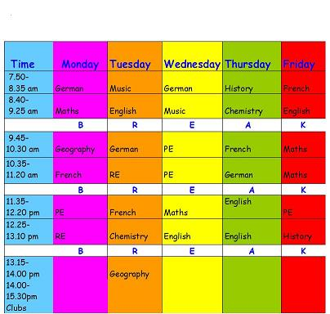
Activity 3: Look at Jack’s school timetable

Answer the following questions:
1/. What Jack got German on Monday?
_________________________________________ ________________________________________________

2/. Has Jack got Maths on Tuesday?
_________________________________________

3/. Which day has Jack got music? __________________
_____________________________

4/. Has Jack got History on Thursday?
____________________________________________

5/. Has Jack got PE on Friday?
_______________________________________________

