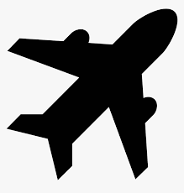
The history of the aeroplane:
a/. Find the hidden words!
aeroplane, inventor, flight, helicopter, simulator, fly, flyers, cockpit, fuselage, fin, wing, landing gear, nose wheel, rudder, nose, tail.
b | a | l | l | o | o | s | a | h | P
a | d | e | m | n | a | l | p | a | h
e | f | a | r | b | y | y | s | l | e
r | w | l | a | e | y | l | r | a | l
o | w | h | i | a | a | f | e | n | i
p | P | s | e | g | a | a | y | d | c
l | w | d | a | l | h | a | l | i | o
a | f | s | g | g | i | t | f | n | p
n | e | u | j | h | d | c | g | g | t
e | i | g | s | n | v | h | o | g | e
r | e | n | n | e | m | l | k | e | r
f | e | g | v | j | l | k | l | a | t
g | g | j | n | e | j | a | p | r | l
n | h | i | h | j | n | n | g | n | e
i | f | h | k | j | k | t | i | e | e
w | r | r | l | r | h | r | o | i | h
f | l | o | w | i | j | e | h | r | w
t | w | k | t | a | a | l | e | h | e
i | e | f | a | a | y | t | y | p | s
p | s | f | f | l | l | y | y | i | o
k | o | c | k | r | y | u | p | l | n
c | n | v | w | h | a | s | m | o | t
o | a | w | h | e | e | a | a | i | k
c | x | z | r | e | d | d | u | r | s
b/. Write at least 5 parts of the plane you know!
_1_________________ _2_____________________
3__________________ _4______________________ _5_________________

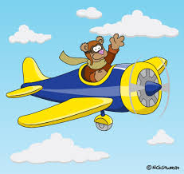
c/. Now make a drawing with aeroplanes!

