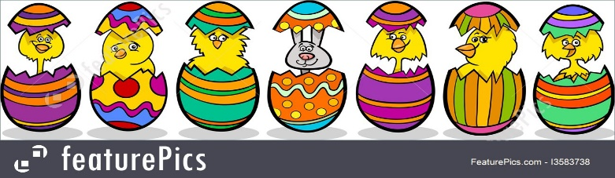
Colour the Easter Eggs

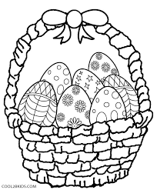
Happy Easter

