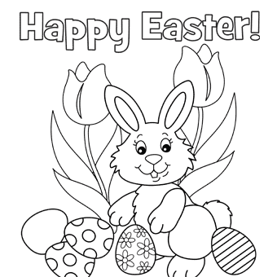
Colour the Easter Bunny! Happy Easter to everyone!!!!

