D Class

Date:_____________________
Name:__________________________________

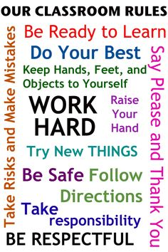
Activity 1: Name the objects in the classroom:

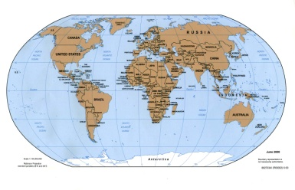
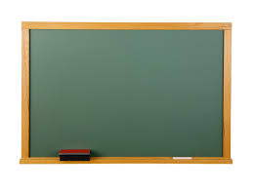
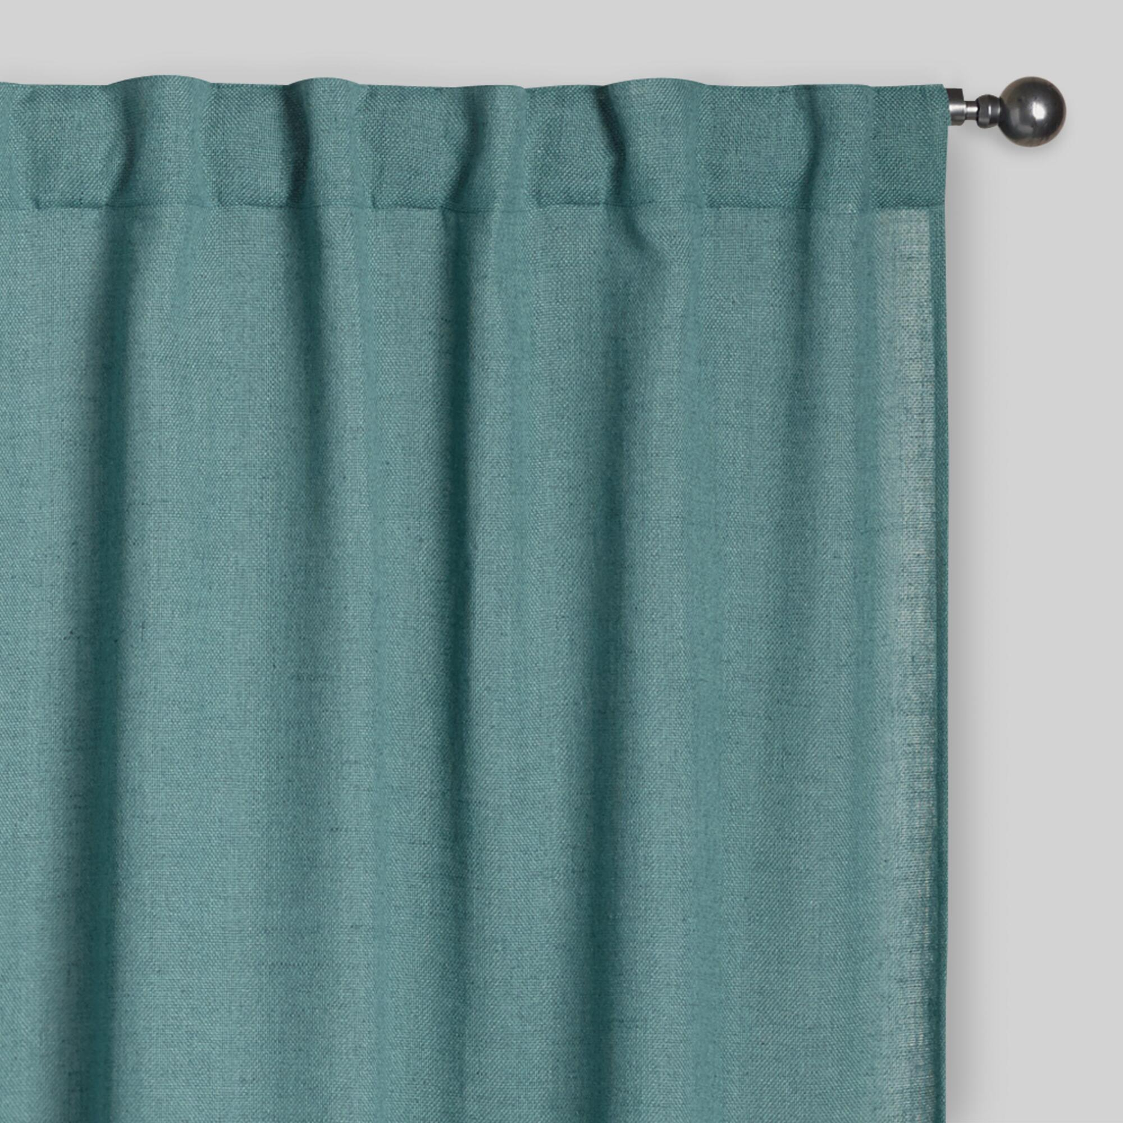

a) _____________ b) _____________ c) _______________ d) ____________

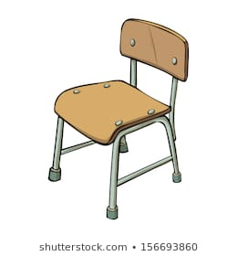
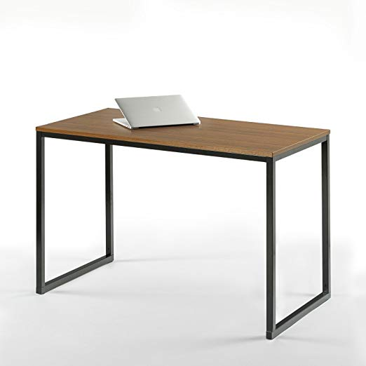



e_______________ f) ___________ g)_____________ h) ________________

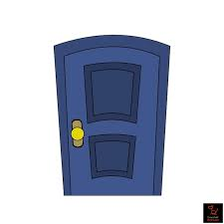

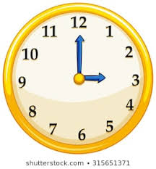



- ______ j) ________ k)_________ l) _________

Activity 2: Write the correct numbers:

11+22= __________________________________________

23+33= __________________________________________

56+10= ______________________________

78+3= __________________________________________

32+5= __________________________________________

12+8= ____________________________________________

15+3=______________________________

8+2=_______________________________________________

81+8___________________________________________

47+3=__________________________________

11+ 18=_______________________________________

12+9=_________________________________________________

15-5=_____________________________________________

8-2=______________________________________

20-13=__________________________________________

18-5=_______________________________

40-25=___________________________________________

