Has COVID 19 managed to steal Christmas?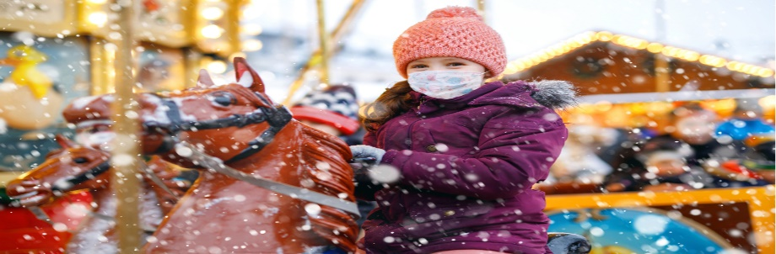
I believe it hasn’t …and it won’t …as restraint this festive season increases the chance that Christmas time this year will once again be spent with family and close friends in decorated houses with warmth, affection and empathy. In the meantime, we should bear in mind that in our great traditions, hardship and its lessons amplify our celebrations. Through enduring difficulty, we build faith and hope in a better future.

