Colour the Christmas tree
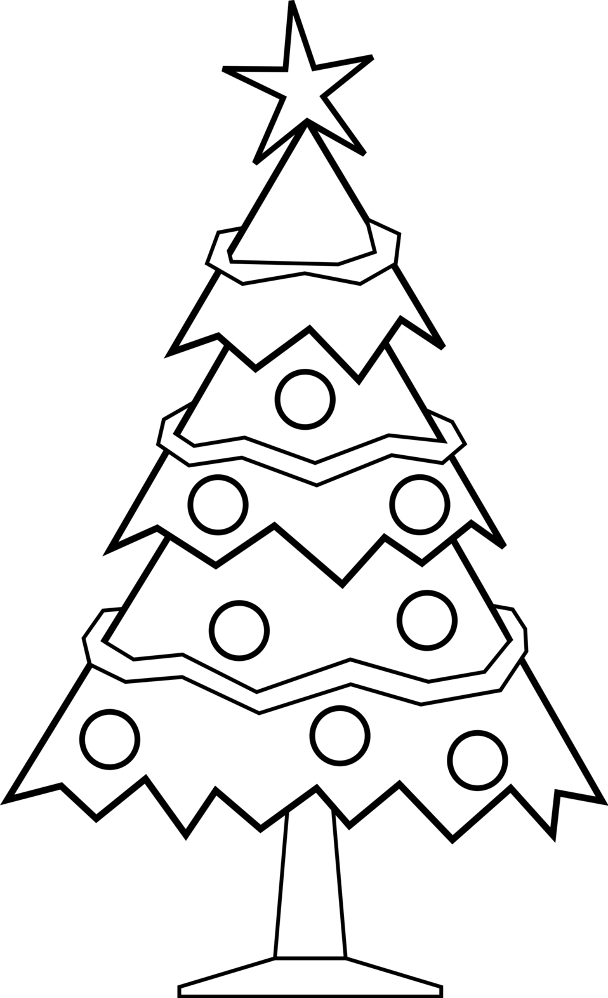

MERRY CHRISTMAS

