**Ψηφιακό λεξικό με θέμα: «Φρούτα και λαχανικά της Άνοιξης»**

|  |
| --- |
| **Μπρόκολο** |

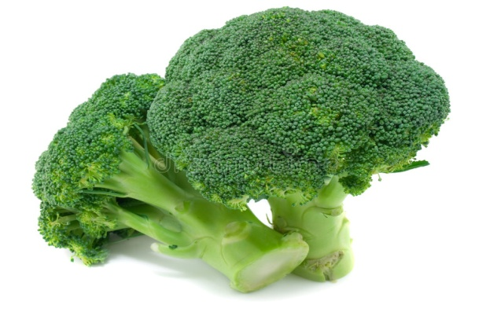

|  |
| --- |
|  |

|  |
| --- |
| **Αρακάς** |

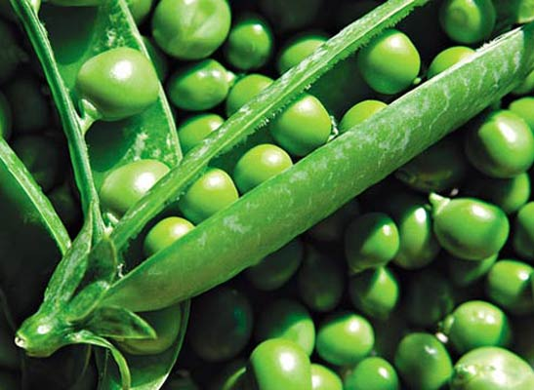

|  |
| --- |
|  |

|  |
| --- |
| **Αγκινάρες** |

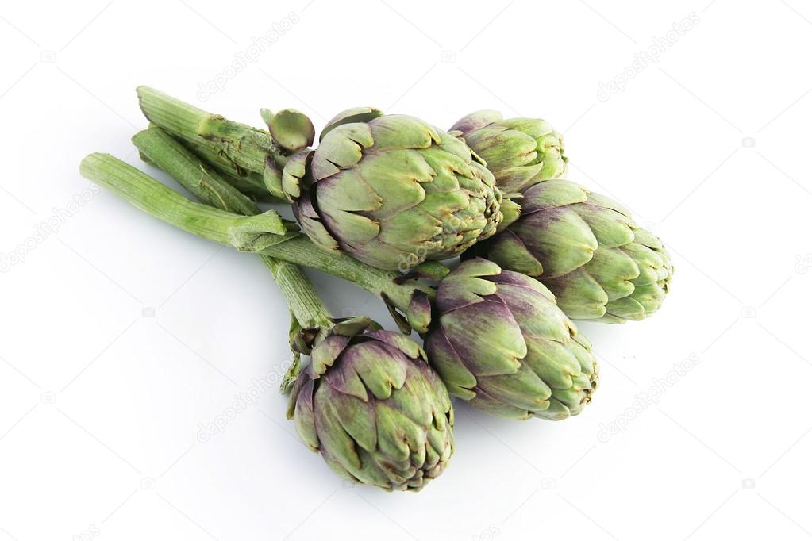

|  |
| --- |
|  |

|  |
| --- |
| **Παντζάρια** |

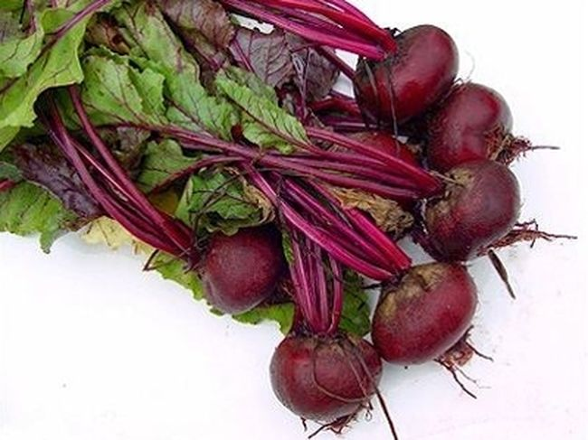

|  |
| --- |
|  |

|  |
| --- |
| **Ρόκα** |

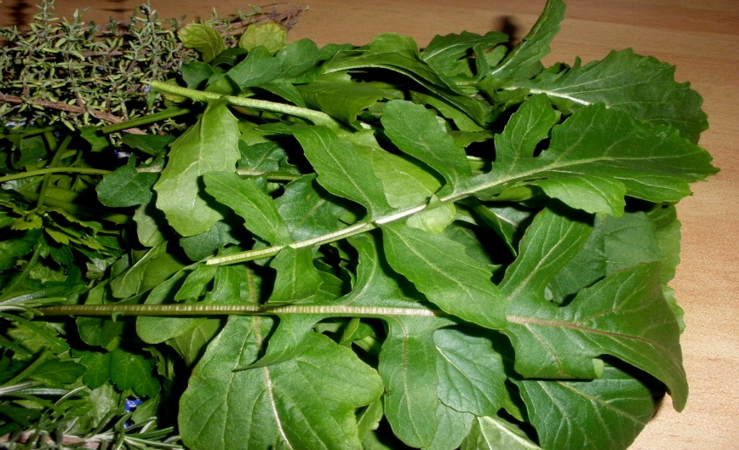

|  |
| --- |
|  |

|  |
| --- |
| **Φράουλες** |

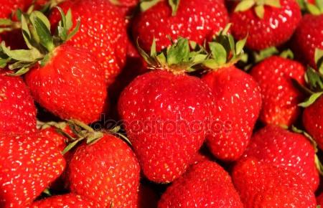

|  |
| --- |
|  |

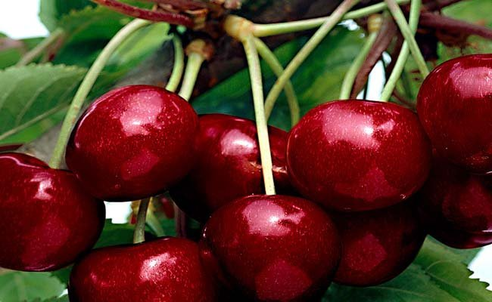

|  |
| --- |
|  |

|  |
| --- |
| **Δαμάσκηνα** |

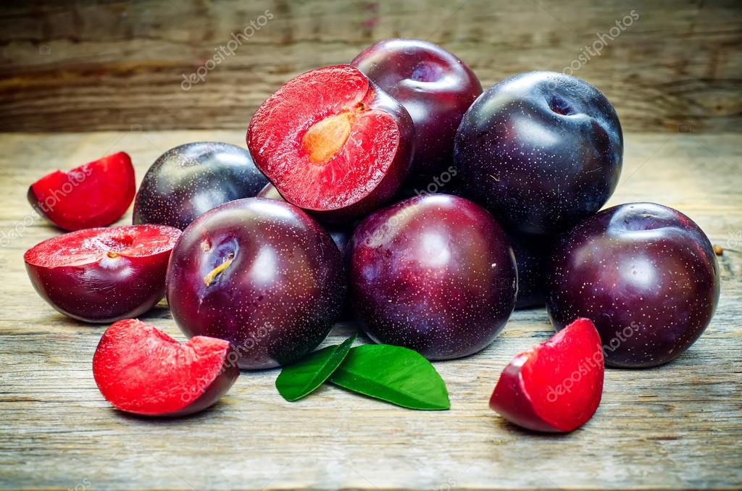

|  |
| --- |
|  |

|  |
| --- |
| **Ραπανάκια** |

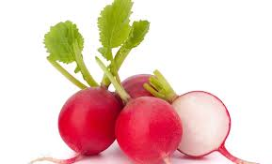

|  |
| --- |
|  |

|  |
| --- |
| **Πράσο** |

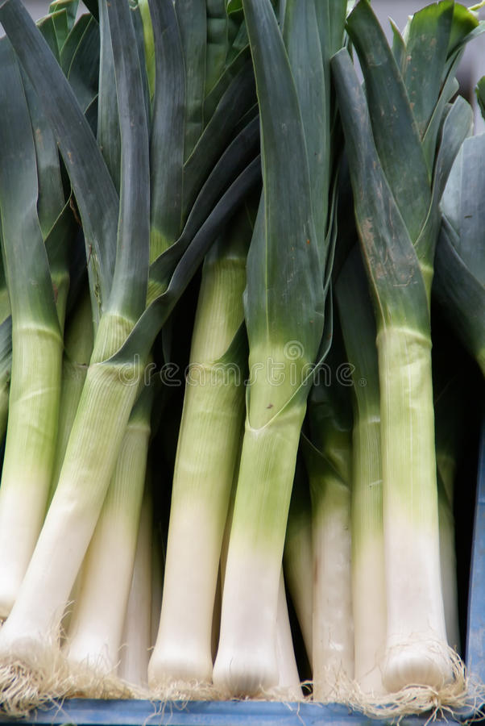

|  |
| --- |
|  |

|  |
| --- |
| **Σπαράγγια** |



  
  
  