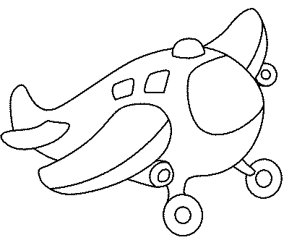

**www.kidsactivities.gr**

