Lesson 1: It’s only a dream!
(Bratsoli & Diamantidou, 2009)
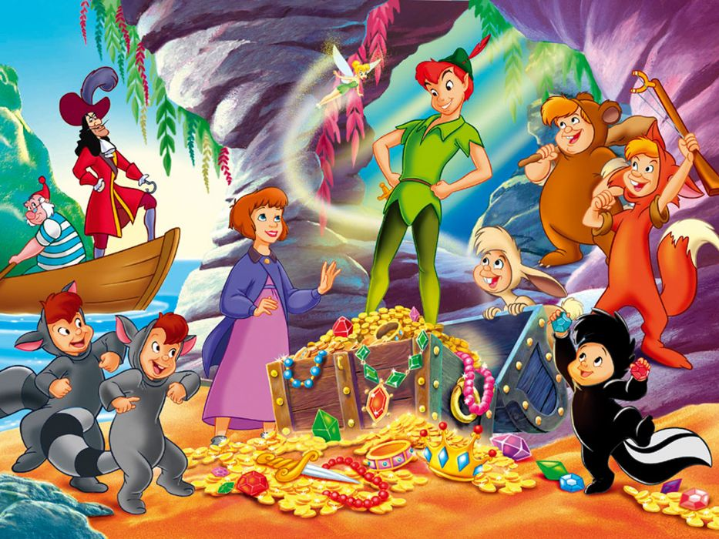
wallpaperup.com
Δρατηριότητα 1: Betty and Sophia are talking. Betty is telling Sophia about a dream she sometimes has.

Read and find out:
“What’s Betty’s favourite story?”
…………………………………………………………………………………………………………………………………………………………………………………………………………………………………………………..

Betty: ... and I sometimes have this dream! In my dream I live in Neverland, Peter Pan’s island. There, I always wake up at 10 o’clock in the morning and I never go to school and, of course, I never do any homework. | 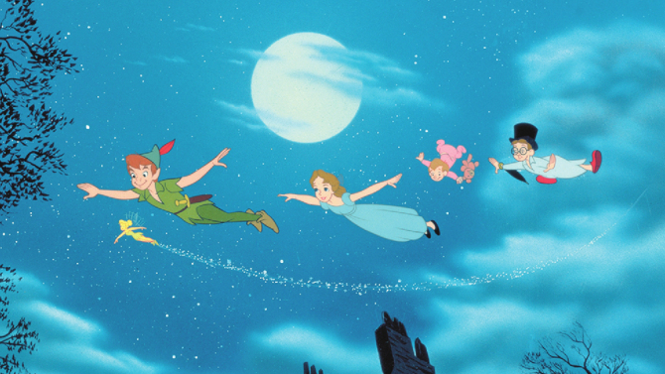  https://pmcvariety.files.wordpress.com/2013/12/peter-pan.jpg?w=670&h=377&crop=1
….

Every morning I fly over Captain Hook’s ship with Peter Pan and Tinker Bell and in the afternoon I often play games with the Lost Boys, Peter Pan’s friends. My favourite game is cake war. The Lost Boys are so funny! | https://www.wallpapers13.com/wp-content/uploads/2017/12/Peter-Pan-and-Captain-Hook-fighter-fencing-  pirate-ship-cartoon-Walt-Disney-Picture-1920x1200-915x515.jpg
We sometimes explore the island together and come back to our cave late at night. So, I always go to bed late and I never brush my teeth.  Sophia: Wow! I really like this life!  Betty: Yes, I like it, too, but then I wake up and I realize it’s only a dream.... | 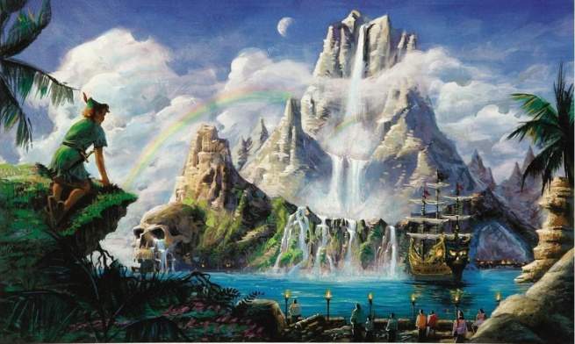  https://lh4.googleusercontent.com/proxy/UqflmDsK3VmP-hHSMo--DTV9m7y5B1BYqgW-9GSohshCvSxGqUU8AeOSVTlPMO9Xu8ULxO7P63rJpIvy_YUaTFYtArE0OPo-_Iq_NwlJLx6Y6fudj4qcYqnBvxKA0Bc=s0-d
Καινούριες λέξεις
tell about | =μιλώ για | have a dream =ονειρεύομαι
Neverland | =η Χώρα του Ποτέ | island (άηλαντ) | =νησί
do my homework | =κάνω τις ασκήσεις μου | over | =πάνω από
ship | =πλοίο | the Lost Boys =τα Χαμένα Αγόρια
war | =πόλεμος | funny | =αστείος
explore | =εξερευνώ | together | =μαζί
come back to | =γυρίζω πίσω σε | cave | =σπηλιά
early | =νωρίς | late | =αργά
at night | =τη νύχτα | go to the bed =πηγαίνω για ύπνο
brush my teeth | =βουρτσίζω τα δόντια μου | life=ζωή
wake up | =ξυπνώ | realize | =αντιλαμβάνομαι
of course | =φυσικά | really | =πραγματικά
….
Δραστηριότητα 2: Να απαντήσεις στις παρακάτω ερωτήσεις:
- Where does Betty live in her dream?  __________________________________________  - What time does she wake up in the morning?  __________________________________________  - Does she do any homework?  __________________________________________  - What does she do every day?  __________________________________________  - Who are the Lost Boys?  __________________________________________ | 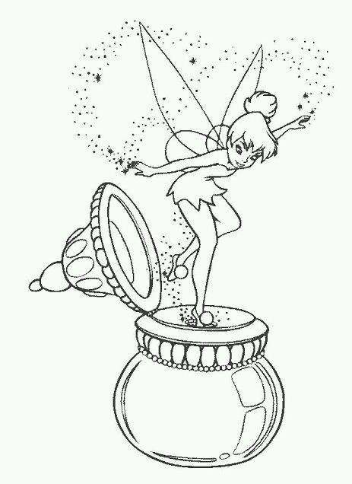
- What does she do with them?  __________________________________________  - What’s her favourite game?  __________________________________________  - When does she go to bed?  __________________________________________  9. Does she brush her teeth?  __________________________ | 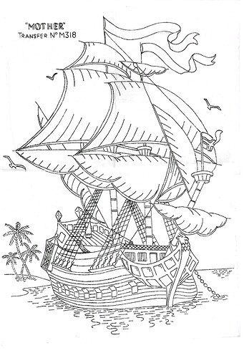
Δραστηριότητα 3: Να αντιστοιχίσεις τις λέξεις με τις εικόνες!

1 | 2 | 3 | 4 | 5 | 6 | 7 | 8 | 9
g

Τελείωσες τις δραστηριότητες;
ΜΠΡΑΒΟ ΣΟΥ!!
Τώρα μπορείς να επισκεφτείς με έναν από τους γονείς σου την ιστοσελίδα
https://www.jigsawplanet.com/?rc=play&pid=1a449194eaef και να κάνεις το παζλ με τον Peter Pan που έφτιαξα για σένα!
Enjoy!

