Bonfire Night = Guy Fawkes Night

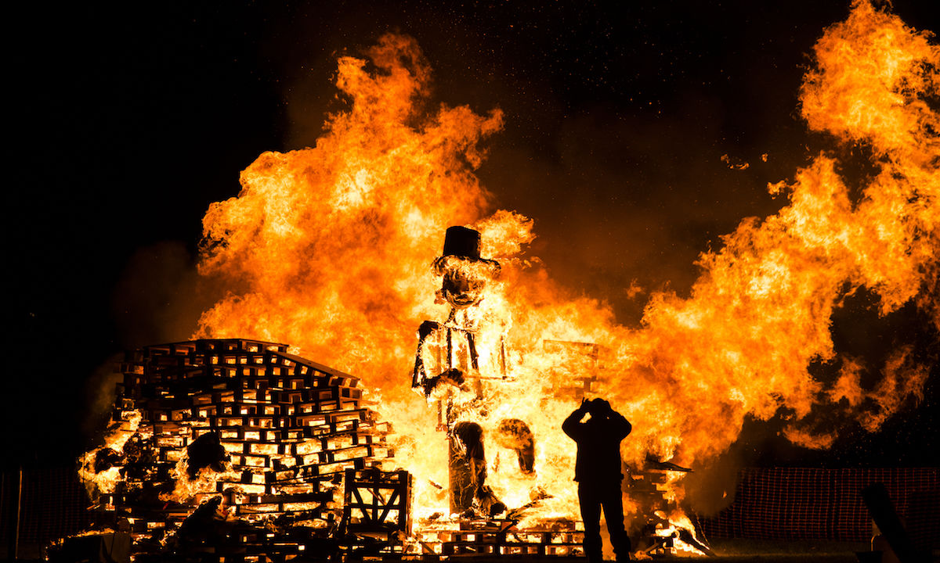
https://d36tnp772eyphs.cloudfront.net/blogs/1/2018/11/Man-takes-a-picture-during-a-bonfire-the-night-of-the-fifth-of-November-1200x720.jpg
Αφού μελετήσεις τις λέξεις, να διαβάσεις το κείμενο!
celebrate | =γιορτάζω | in memory of | =στη μνήμη του
event | =γεγονός | conspiracy | =συνωμοσία
gunpowder | =μπαρούτι | Roman Catholics | =Ρωμαιοκαθολικοί
conspirators | =συνομώτες | planned | =σχεδίαζω
blow up | =ανατινάζω | the Houses of Parliament. | =τα κτίρια του Κοινοβουλίου
stuffed with | =παραγεμισμένος με | straw | =άχυρo
represent | =συμβολίζω | sight | =θέαμα
bonfire | =πυρά | figure | =μορφή, φιγούρα
clothes | =ρούχα | guy | =ανδρείκελο, κούκλα
burn | =καίω | on top of | =πάνω από
penny pence (πληθ.)  =πένα, (αγγλ. νόμισμα) |  | fireworks | =πυροτεχνήματα

Bonfire Night is a special night in Britain. The English celebrate it on November the 5th the famous event in British History, the Gunpowder Plot. When in 1605 Guy Fawkes and a group of Roman Catholics conspirators planned to blow up the Houses of Parliament.
Some children make a guy, a figure of a man made of clothes stuffed with newspaper or straw to represent Guy Fawkes. They take their guy into the street and ask for a penny for the guy. They burn their guy on top of a bonfire on Bonfire Night. Some people have bon fire parties in their gardens. They light and watch fireworks and eat hotdogs and burgers. It’s a beautiful sight!

Δραστηριότητα 1: Να απαντήσεις στις ερωτήσεις που ακολουθούν!
When do the English celebrate Bonfire night?
What is the Gunpowder Plot?
What is a “guy”?
What do the children do with it?
Why is the Bonfire Night a beautiful sight?

Time for fun!
Click here to do the Guy Fawkes puzzle I made for you!

