***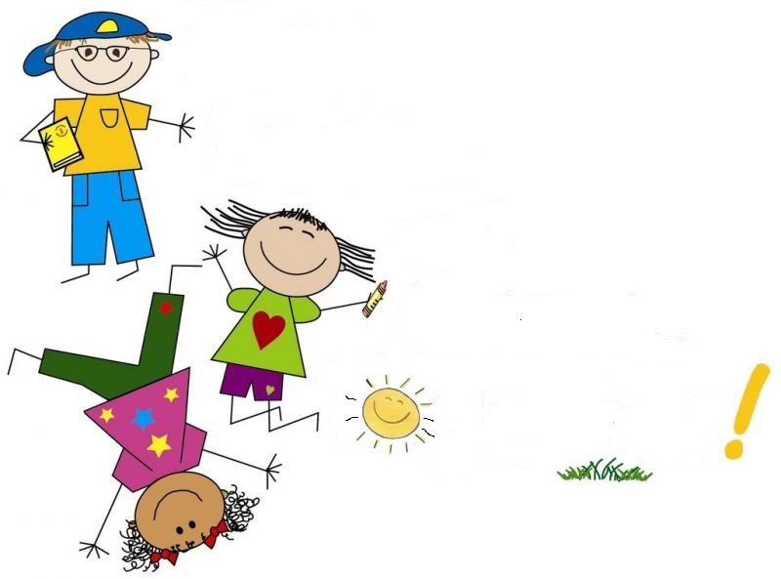***

**μου**

**λεξικό**

**Πρώτο**

# Το

Πάτα το αρχικό γράμμα που θες!

|  |  |  |  |
| --- | --- | --- | --- |
| [**Α**](#Α) | [**Β**](#B) | [**Γ**](#Γ) | [**Δ**](#Δ) |
| [**Ε**](#Ε) | [**Ζ**](#Ζ) | [**Η**](#Η) | [**Θ**](#Θ) |
| [**Ι**](#Ι) | [**Κ**](#Κ) | [**Λ**](#Λ) | [**Μ**](#Μ) |
| [**Ν**](#Ν) | [**Ξ**](#Ξ) | [**Ο**](#Ο) | [**Π**](#Π) |
| [**Ρ**](#Ρ) | [**Σ**](#Σ) | [**Τ**](#Τ) | [**Υ**](#Υ) |
| [**Φ**](#Φ) | [**Χ**](#Χ) | [**Ψ**](#Ψ) | [**Ω**](#Ω) |

**Αα**

|  |  |
| --- | --- |
| **C:\Users\SONY\Desktop\Λεξικό\gg63645550.jpg** | **Αγάπη** |
|  |  |

**Bβ**

|  |  |
| --- | --- |
| **C:\Users\SONY\Desktop\Λεξικό\TN_boy-diving-into-pool-summer-clipart2.jpg** | **Βουτιά** |
|  |  |

****

**Γγ**

|  |  |
| --- | --- |
| **C:\Users\SONY\Desktop\Λεξικό\DP_Girl-Laughing-x500-249x300.png** | **Γέλιο** |
|  |  |

**Δδ**

|  |  |
| --- | --- |
| **C:\Users\SONY\Desktop\Λεξικό\boy-giving-present-girl_1308-242.jpg** | **Δώρο** |
|  |  |

**Eε**

|  |  |
| --- | --- |
| **C:\Users\SONY\Desktop\Λεξικό\ee18a44fb3dde6c4b921c48341804946--elephant-ride.jpg** | **Ελέφαντας** |
|  |  |

**Zζ**

|  |  |
| --- | --- |
| **C:\Users\SONY\Desktop\Λεξικό\istockphoto-496573506-612x612.jpg** | **Ζαχαρωτά** |
|  |  |

**Hη**

|  |  |
| --- | --- |
| **C:\Users\SONY\Desktop\Λεξικό\th.jpg** | **Ήλιος** |
|  |  |

**Θθ**

|  |  |
| --- | --- |
| **C:\Users\SONY\Desktop\Λεξικό\θάλασσα.jpg** | **Θάλασσα** |
|  |  |

**Ιι**

|  |  |
| --- | --- |
| **C:\Users\SONY\Desktop\Λεξικό\cartoon-couple-native-indian-american-traditional-costume-illustration-88358756.jpg** | **Ινδιάνοι** |
|  |  |

**Κκ**

|  |  |
| --- | --- |
| **C:\Users\SONY\Desktop\Connie_Carrot_giant7_2_large.png** | **Καρότο** |
|  |  |

**Λλ**

|  |  |
| --- | --- |
| **C:\Users\SONY\Desktop\Λεξικό\1461218.png** | **Λουλούδι** |
|  |  |

**Μμ**

|  |  |
| --- | --- |
| https://i.pinimg.com/originals/84/1d/a0/841da045bc94ad95beea6f37642ffd69.jpg | **Μαγιό** |
|  |  |

**Νν**

|  |  |
| --- | --- |
| http://famouscutouts.com/images/detailed/0/677-Seven-Dwarves.jpg | **Νάνοι** |
|  |  |

**Ξξ**

|  |  |
| --- | --- |
| https://tse3.mm.bing.net/th?id=OIP.22Od13c09L6hYYhit9ftHwHaIz&pid=Api&P=0&w=300&h=300 | **Ξύστρα** |
|  |  |

**Οο**

|  |  |
| --- | --- |
| https://tse3.mm.bing.net/th?id=OIP.S3Z2guwrrLSeYWyHONenJwHaLX&pid=Api&P=0&w=300&h=300 | **Ομπρέλα** |
|  |  |

**Ππ**

|  |  |
| --- | --- |
| **C:\Users\SONY\Desktop\th.jpg** | **Παγωτό** |
|  |  |

**Ρρ**

|  |  |
| --- | --- |
| https://tse2.mm.bing.net/th?id=OIP.mzWbIFwcghxZQbdoWGKD4gHaHl&pid=Api&P=0&w=300&h=300 | **Ρακέτα** |
|  |  |

**Σσ**

|  |  |
| --- | --- |
| https://content.mycutegraphics.com/graphics/kids/boy-pet-dog.png | **Σκύλος** |
|  |  |

**Tτ**

|  |  |
| --- | --- |
| https://clipground.com/images/train-ride-clipart-1.jpg | **Τρένο** |
|  |  |

**Υυ**

|  |  |
| --- | --- |
| https://image.freepik.com/free-vector/kids-ride-submarine-cartoon-illustration_1465-217.jpg | **Υποβρύχιο** |
|  |  |

**Φφ**

|  |  |
| --- | --- |
| http://clipart-library.com/image_gallery/n1586713.jpg | **Φράουλα** |
|  |  |

**Χχ**

|  |  |
| --- | --- |
| http://suwaneemagazine.com/wp-content/uploads/2016/04/SuwMagMayJune16-Feature-article-pictures10.jpg | **Χαρταετός** |
|  |  |

**Ψψ**

|  |  |
| --- | --- |
| http://moziru.com/images/fisherman-clipart-kid-fishing-4.jpg | **Ψάρι** |
|  |  |

**Ωω**

|  |  |
| --- | --- |
| https://png.pngtree.com/element_origin_min_pic/16/12/26/c5ff9c3b901a9d30720bc48ef0fcd962.jpg | **Ώρα** |
|  |  |