Πίνακες Ζωγραφικής με θέμα τη μητέρα ! .
Όσο δύσκολο και εάν είναι να αποτυπώσεις – εκφράσεις τα συναισθήματα που δημιουργεί η Μητρότητα και η έννοια της «Μητέρας», ο καλός ζωγράφος συχνά πετυχαίνει τον στόχο του.
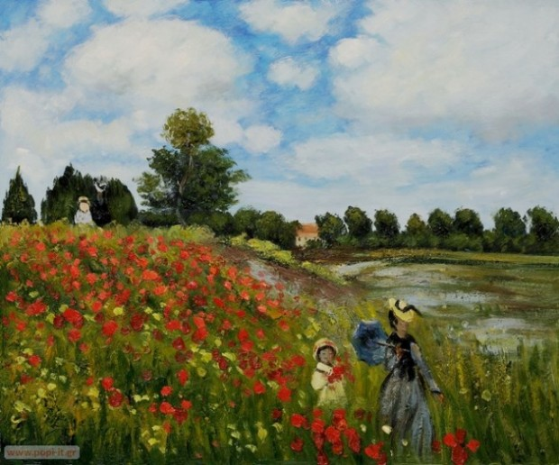.”Poppy Field in Argenteuil,” Claude Monet – In this colorful oil painting, originally created in 1873, Claude Monet painted his wife and son strolling together among the poppies.
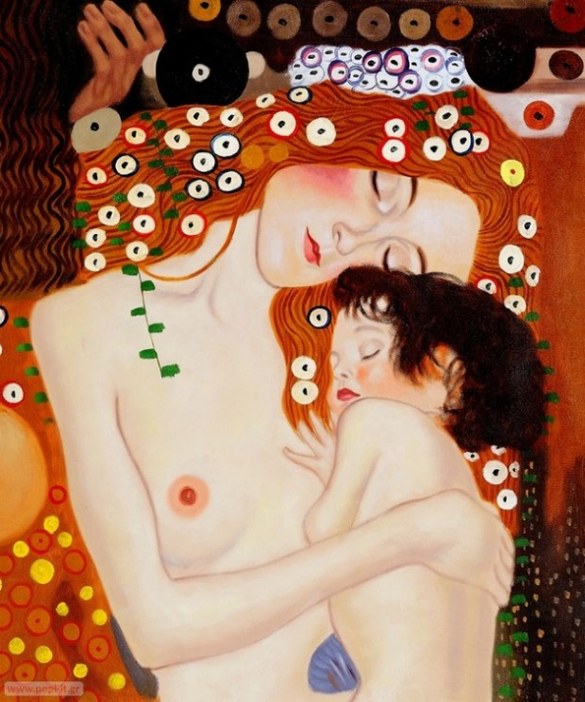“Le tre eta della donna (Mother and Child),” Gustav Klimt – Mother and Child is part of Klimt’s famous oil painting Three Ages of Woman. The painting depicts an image of a mother cradling her young son. The original was created in 1905, three years after the death of Klimt’s baby son, Otto.
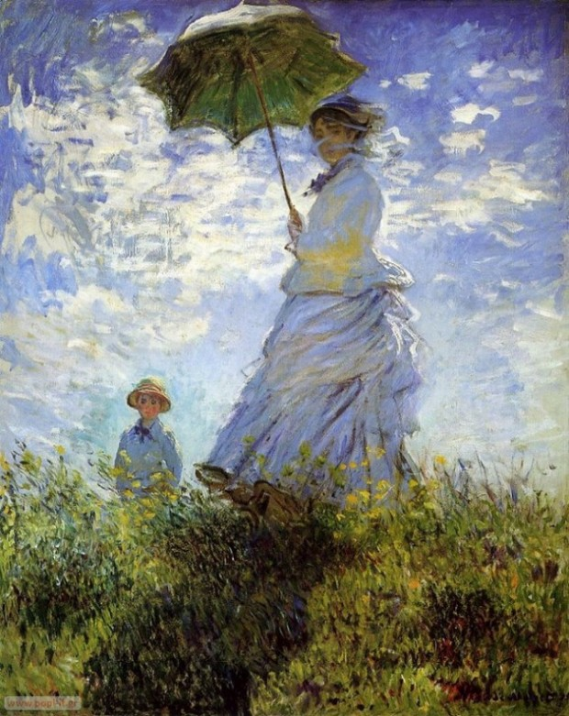Madame Monet and Her Son, by Claude Monet. 1875
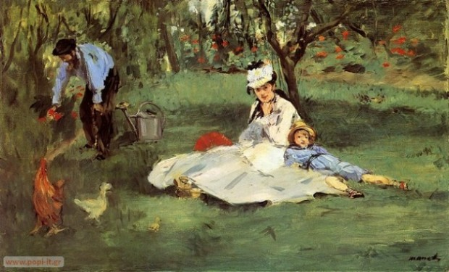The Monet Family in Their Garden, by Edouard Manet. 1874
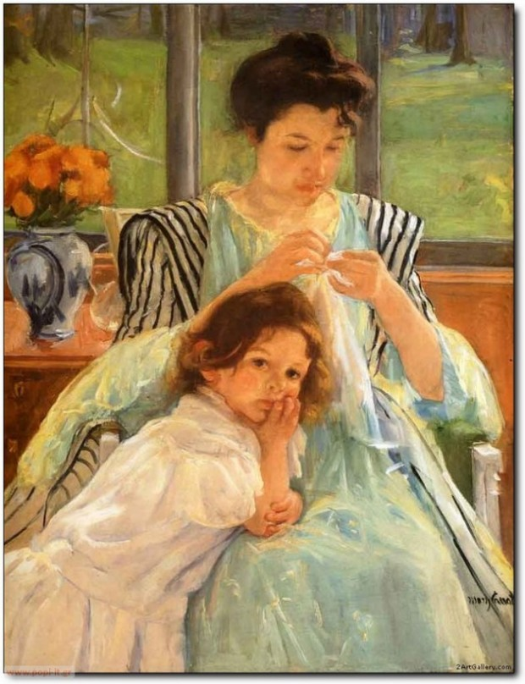Young Mother Sewing, by Mary Cassatt. 1900
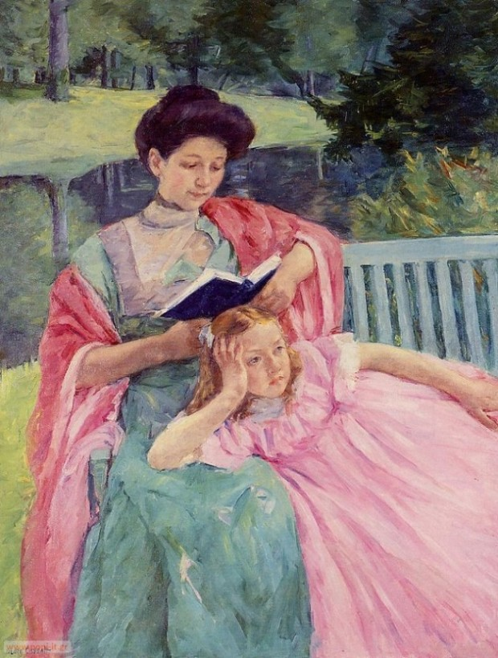Auguste Reading to Her Daughter, by Mary Cassatt. 1910
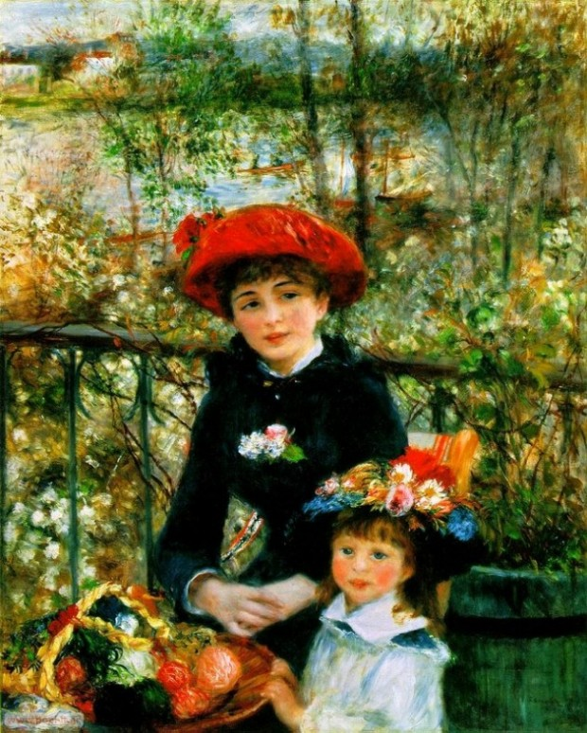On the Terrace, by Pierre Auguste Renoir. 1881
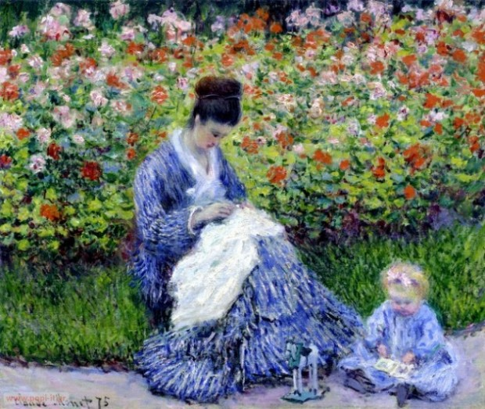Camille Monet and Child, by Claude Monet. 1875
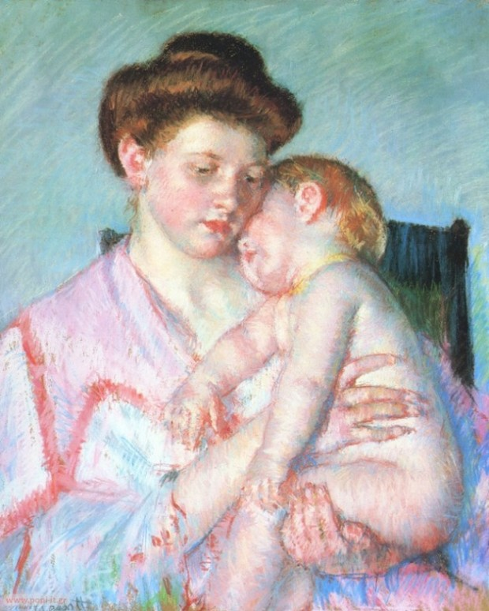Sleeping Baby, by Mary Cassatt. 1910
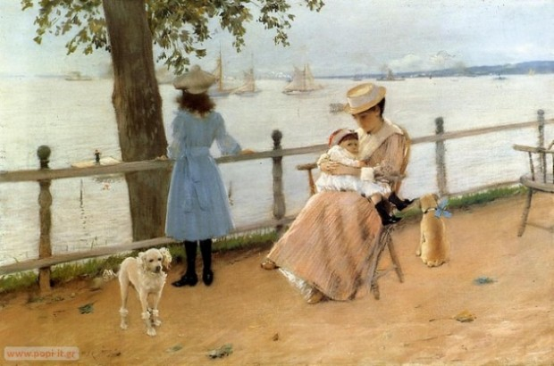Gravesend Bay, by William Merritt Chase. 1888
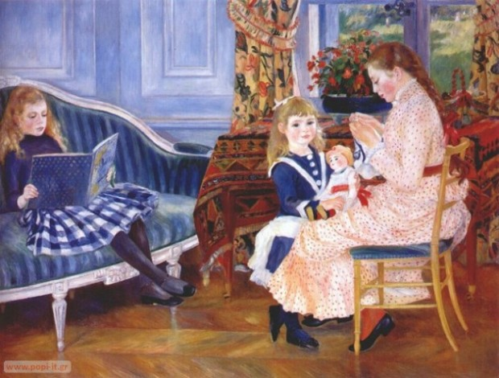Children’s Afternoon At Wargemont, by Pierre Auguste Renoir. 1884
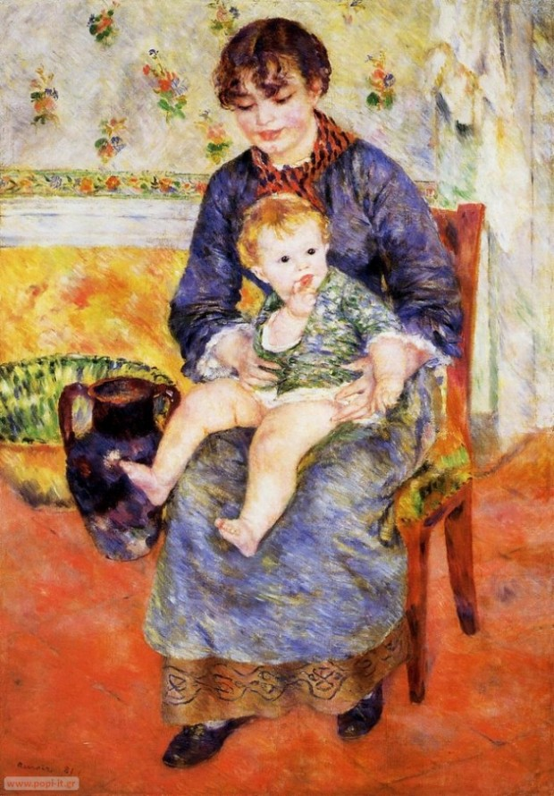Mother and Child, by Pierre Auguste Renoir. 1881
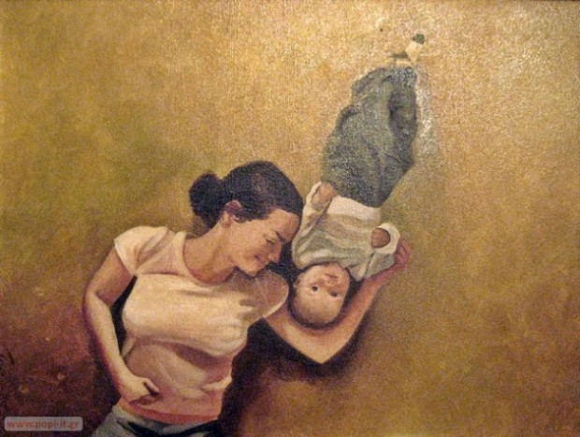Łukasz Ciaciuch, paintings – Mother with child

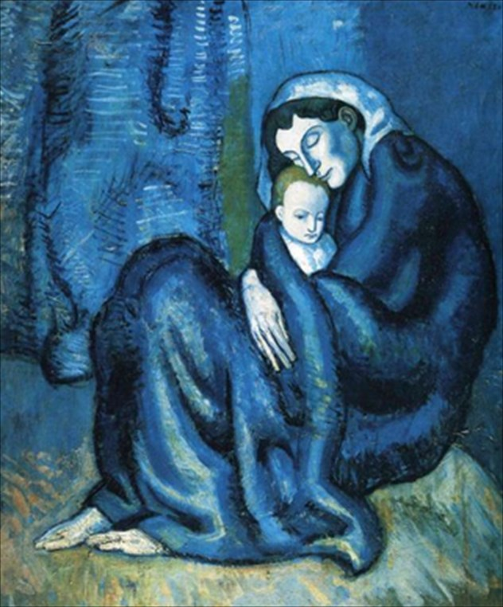
Pablo Picasso

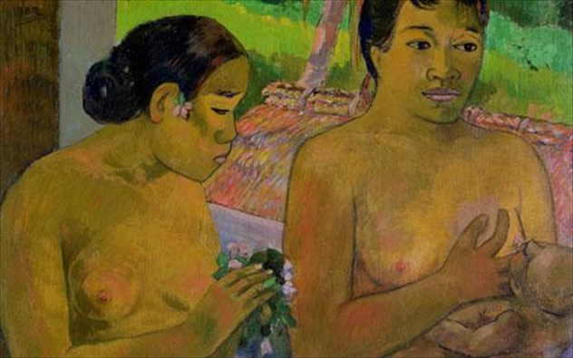
Paul Gaugin

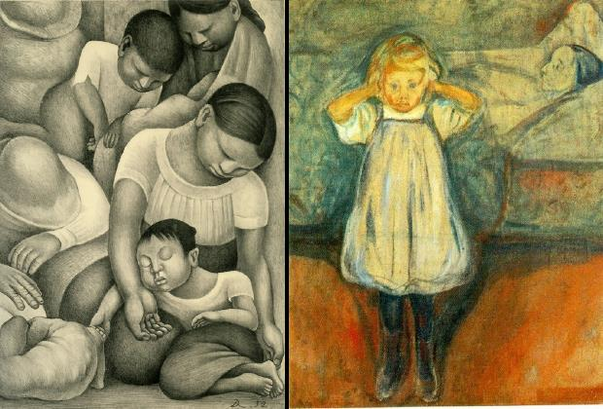

ΑΡΙΣΤΕΡΑ: Diego Rivera, Οικογένεια που κοιμάται (1932). ΔΕΞΙΑ: Edvard Much, Η νεκρή μητέρα (η μητέρα του καλλιτέχνη πέθανε στα 5 του), 1899

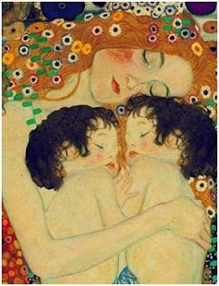
Gustav Klimt

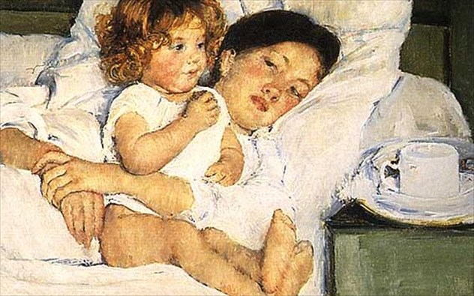
Mary Cassat

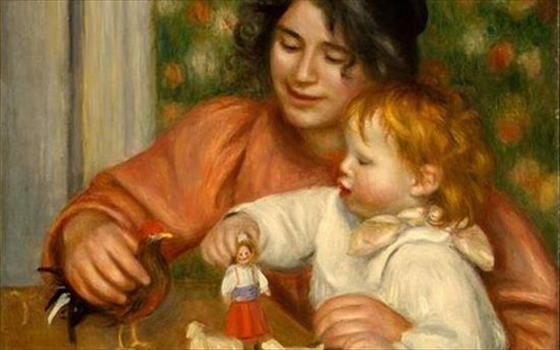
Pierre-Auguste Renoir

