**Ανασκόπηση Μαρτίου 2015 μέσω γελοιογραφιών**

[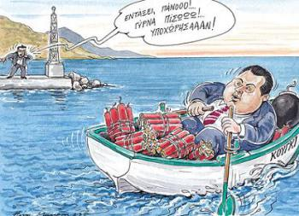](http://i0.wp.com/antikleidi.com/wp-content/uploads/2015/04/kamenos-tsipras-kougki.jpg)

Γελοιογραφίες που ξεχώρισαν τον προηγούμενο μήνα.

[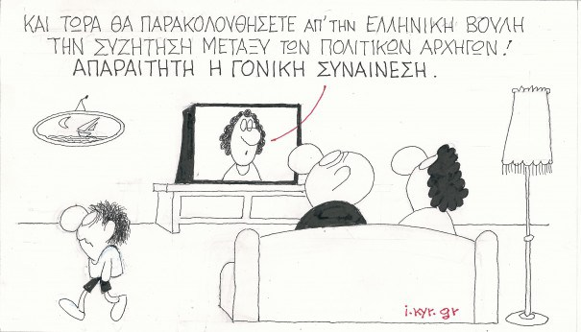](http://i0.wp.com/antikleidi.com/wp-content/uploads/2015/04/01-04-15-605346.jpeg)

[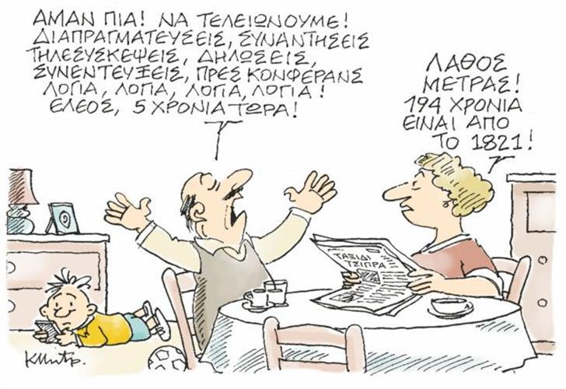](http://i1.wp.com/antikleidi.com/wp-content/uploads/2015/04/21202954_MHTROPOULOS_SKITSO_200215.limghandler.jpg)

[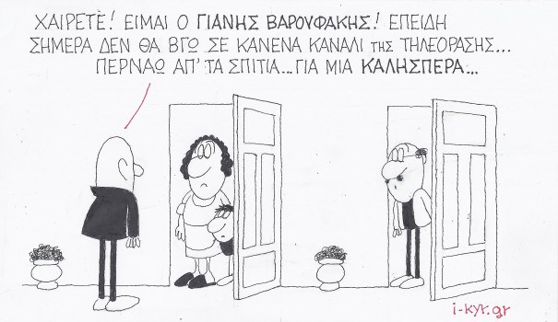](http://i1.wp.com/antikleidi.com/wp-content/uploads/2015/04/04-03-15-605x350.jpeg)

[](http://i1.wp.com/antikleidi.com/wp-content/uploads/2015/04/petr11-thumb-large.jpg)

[](http://i0.wp.com/antikleidi.com/wp-content/uploads/2015/04/21243066_MHTROPOULOS_SKITSO_280315_F3.limghandler.jpg)

[](http://i2.wp.com/antikleidi.com/wp-content/uploads/2015/04/1267164_525_350_w.jpg)

[](http://i0.wp.com/antikleidi.com/wp-content/uploads/2015/04/1264779_525_350_w.jpg)

[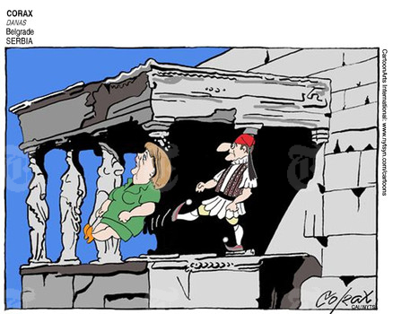](http://i2.wp.com/antikleidi.com/wp-content/uploads/2015/04/1262917_525_350_w.jpg)

[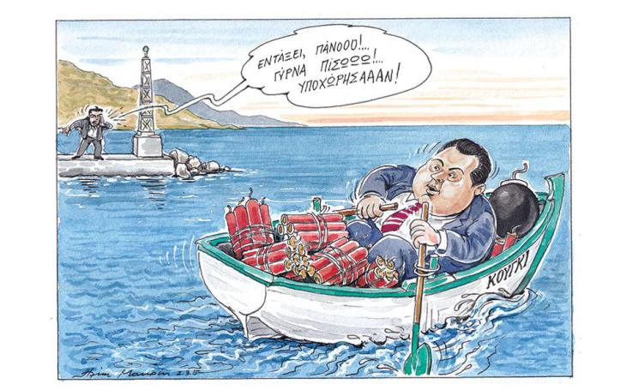](http://i2.wp.com/antikleidi.com/wp-content/uploads/2015/04/skitsomakrrrr-thumb-large.jpg)

[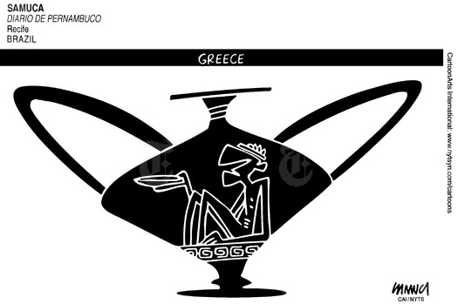](http://i0.wp.com/antikleidi.com/wp-content/uploads/2015/04/1254869_525_350_w.jpg)

[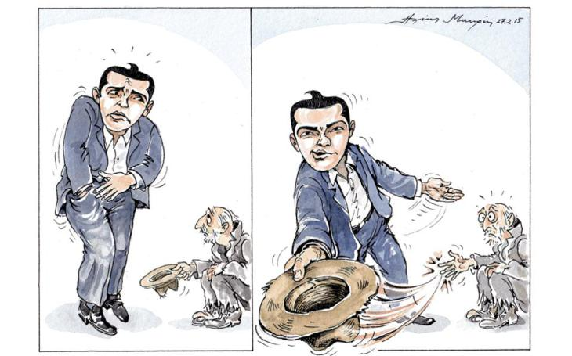](http://i1.wp.com/antikleidi.com/wp-content/uploads/2015/04/mak13-thumb-large.jpg)

[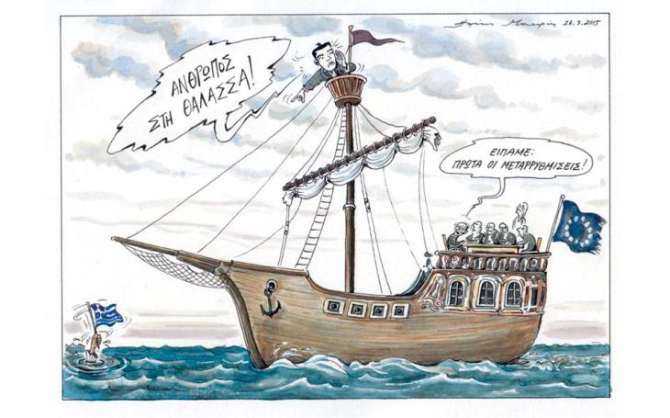](http://i1.wp.com/antikleidi.com/wp-content/uploads/2015/04/mak293-thumb-large.jpg)

[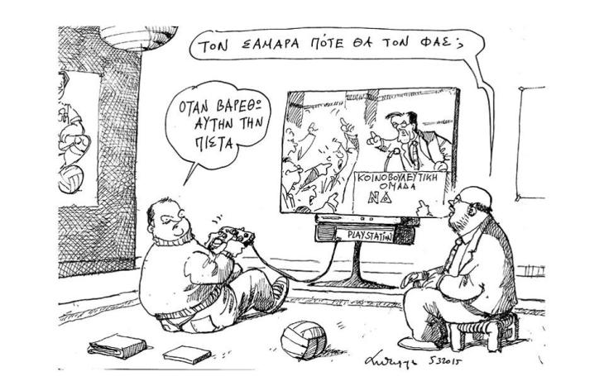](http://i0.wp.com/antikleidi.com/wp-content/uploads/2015/04/skitsopetrrrr-thumb-large.jpg)

[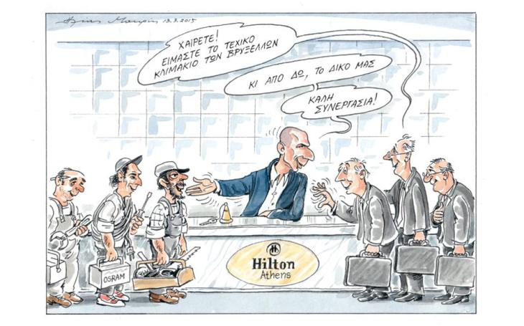](http://i0.wp.com/antikleidi.com/wp-content/uploads/2015/04/s11_skitso-3-thumb-large.jpg)

[](http://i1.wp.com/antikleidi.com/wp-content/uploads/2015/04/petr24-thumb-large.jpg)

[](http://i0.wp.com/antikleidi.com/wp-content/uploads/2015/04/485_78640fefec483bc9bef33c50a09cda8c.jpg)

[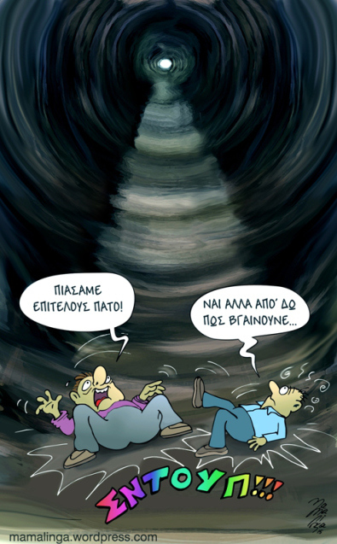](http://i2.wp.com/antikleidi.com/wp-content/uploads/2015/04/epitelous-patos.jpg)

[](http://i1.wp.com/antikleidi.com/wp-content/uploads/2015/04/28-03-15-605346.jpeg)

[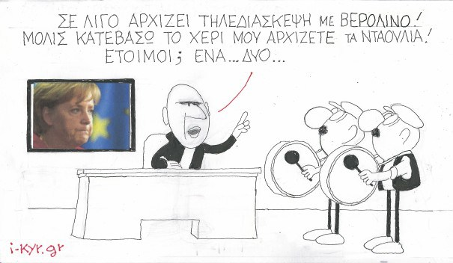](http://i1.wp.com/antikleidi.com/wp-content/uploads/2015/04/13-03-15-605352.jpeg)

______