**Ioannina:**

*A Paradise of Blue and Green*

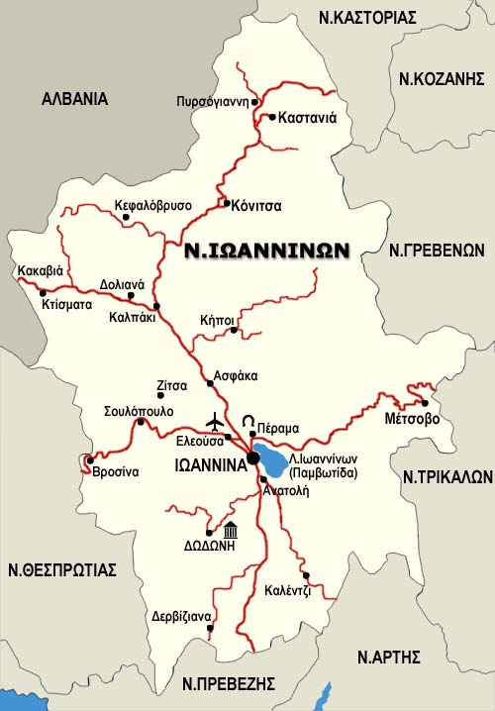

Ioannina city is picturesque.

It has always been a favourite destination with visitors

Because it has magnificent scenery and

The most beautiful lake in Greece.

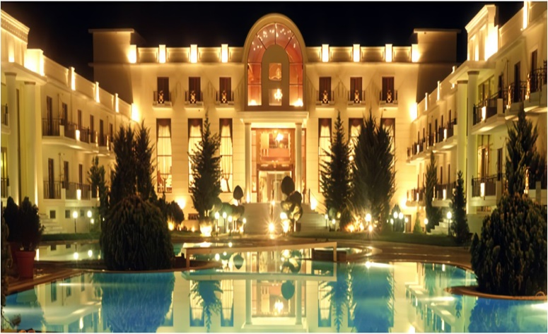**Where to stay**

The city has a lot of

Great hotels but I

Suggest the «Dulac»

**What to see:** I think that the best place you can visit is the island which located inside the lake and is the unique island where located in lake at the Greece.

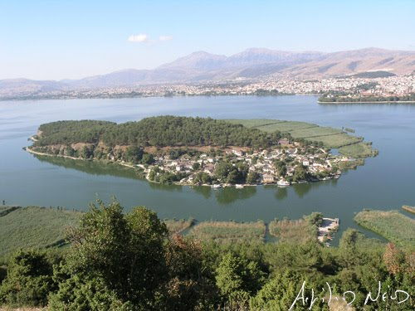

**Where/what to eat**

Ι believe that the best restaurant in Ioannina is «Frontzou politeia» and it has the most delicious food.

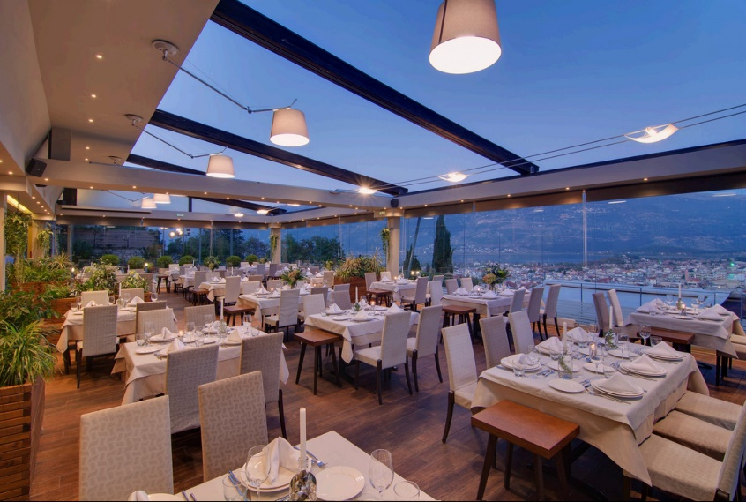

**Where to shop**

Ioannina has a big market with famous fashionable stores and little, local shops.

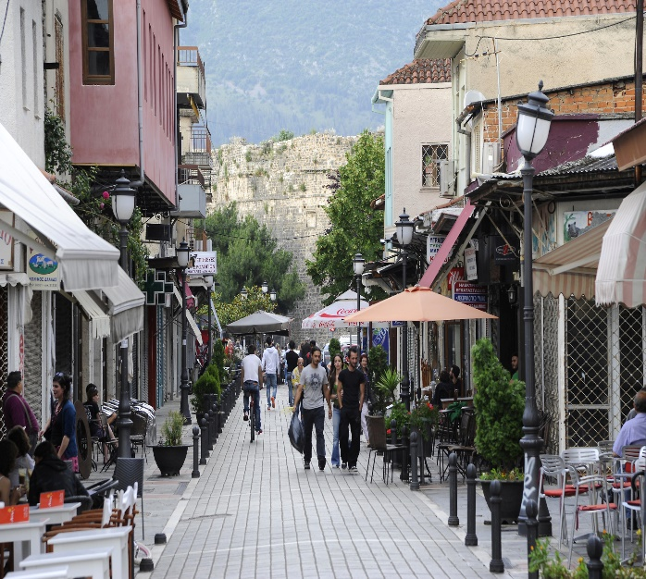

**What to buy**

You can buy a lot of souvenirs for instance magnets and keychains depicting the city also a hat that shows the city or some T-shirts with the sights.

**Where to have fun**

There are a lot of night clubs which you can go with some friends or solo.

