**Gaining sustainable healthy life**

**5th Volos Hihgschool**

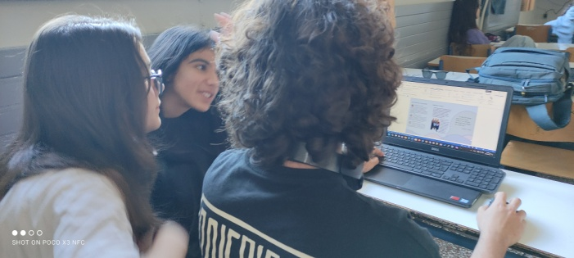**Writing the tips and the leaflet**

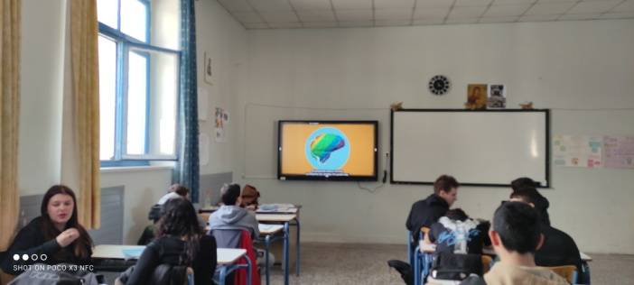 **Tips:**

* Choose plant-based foods
* Eat with the seasons
* Take care of your health with sustainable supplements
* Improve your performance sustainably
* Stay hydrated through tap water
* Planning helps reduce waste and makes life cheaper
* Recycle what you can

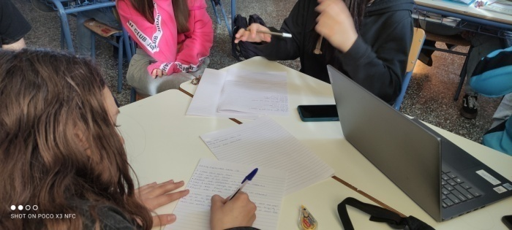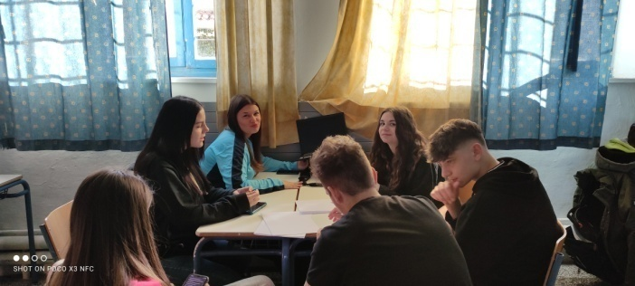

All Erasmus students gathered and discussed about food waste and also what we can do to gain a healthy lifestyle. We learned many things from wikipedia from experts, school lessons and we had a debate. We were given the assignment to prepare a short document about ways of gaining a healthy lifestyle, propose tips and make suggestions. An expert came to our school to inform us about food waste and healthy way of life. We made a leaflet about our meeting in Volos to disseminate project information from our second mobility with students, by sharing them to other schools, parents and neighbours. We made a research that we sent by mail to the whole school community , we shared and gathered to have the results. We made visits trying to choose healthy food and get to know how expensive it is.

We are looking forward, to our trip to Turkey to learn more things about composting and food waste with our European peers. We hope to have a good time and gain new experience, to have a great communication-cooperation. To exchange ideas, to see new places, to make new friends. To go on with our goals and expectations.

