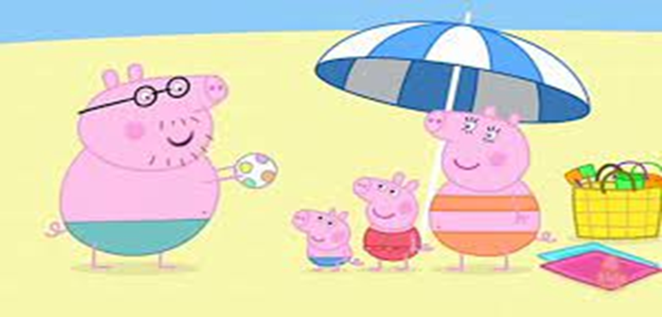

**SUMMER**

Peppa Pig - At the Beach (full episode)

<https://www.youtube.com/watch?v=7OHjX-h0qEY>

Peppa Pig's Rainbow Ice Cream Party

<https://www.youtube.com/watch?v=Zw6Y2tlGqVk>

Summer Song for Kids | The Singing Walrus

<https://www.youtube.com/watch?v=mVhh0oATqBI>

Summer Song for Kids | Easy Monkey Songs

<https://www.youtube.com/watch?v=DyMQk_7NwVw>

Down In The Deep Blue Sea | ft. Finny The Shark! | Super Simple Songs

<https://www.youtube.com/watch?v=7pMEQsk3c5Y>

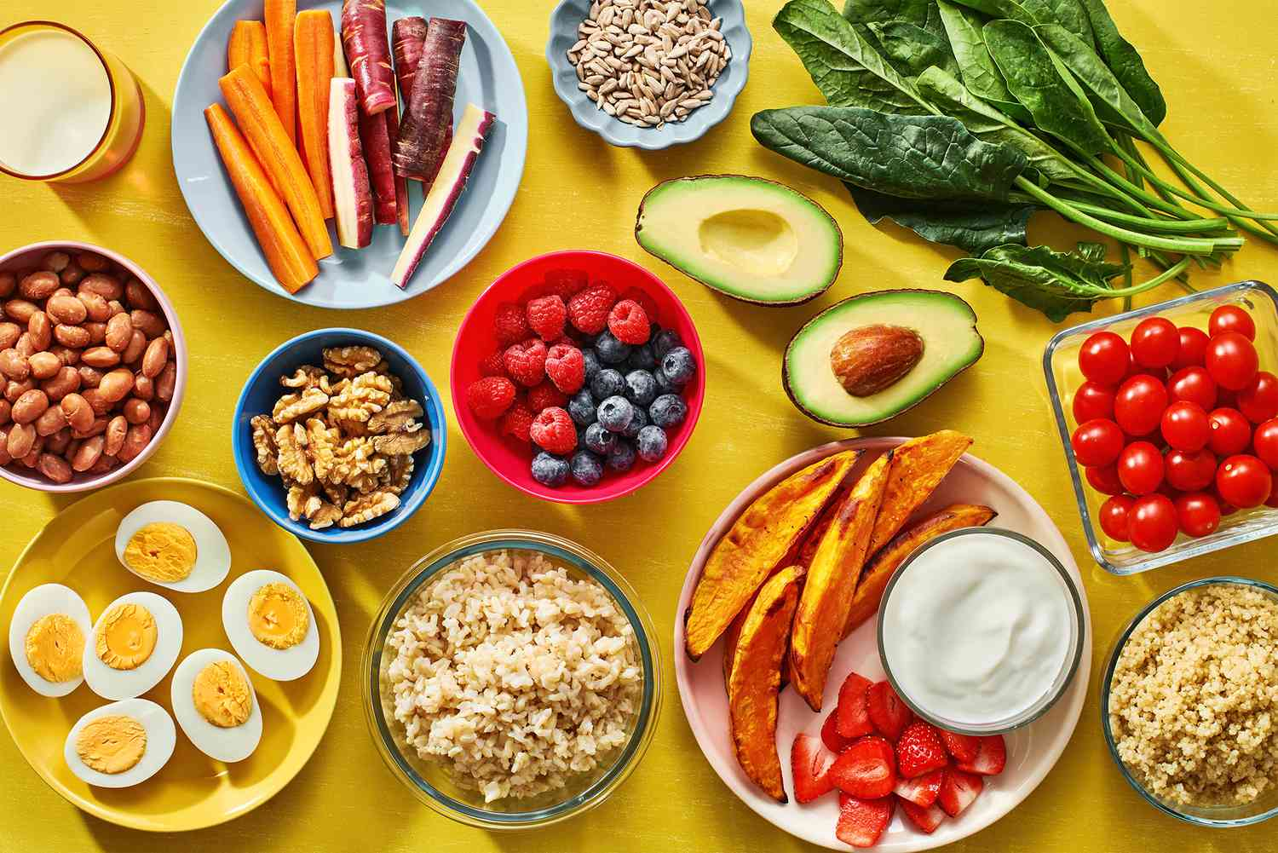

**HEALTHY FOOD**

Peppa Pig - Lunch (full episode)

<https://www.youtube.com/watch?v=Ez0qR3m1G4g>

Fruit day Peppa

<https://www.youtube.com/watch?v=5pM7Bp3Hcfk>

The Very Hungry Caterpillar - Animated Film

<https://www.youtube.com/watch?v=75NQK-Sm1YY>

Healthy Food Vs Junk Food Song!

<https://www.youtube.com/watch?v=fE8lezHs19s>

FRUIT SONG for children with lyrics - original nursery rhymes songs

<https://www.youtube.com/watch?v=oUGsMV-rphw>

Vegetable Song | Songs for kids | The Singing Walrus

<https://www.youtube.com/watch?v=RE5tvaveVak>

Fruit Song for Kids | The Singing Walrus

<https://www.youtube.com/watch?v=mfReSbQ7jzE>

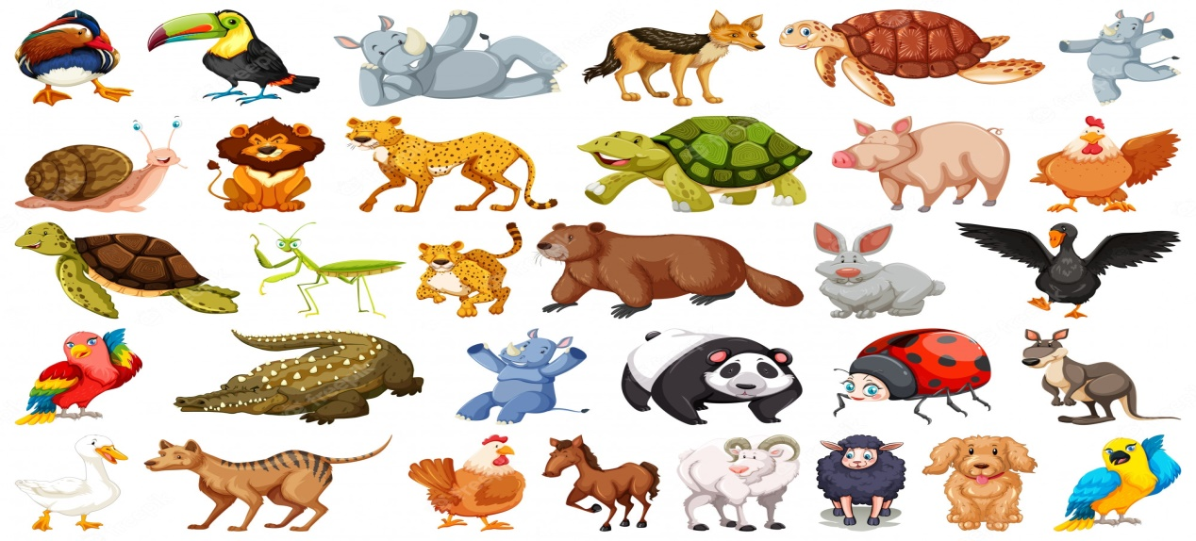

**ANIMALS**

The Animals On The Farm | Super Simple Songs

<https://www.youtube.com/watch?v=zXEq-QO3xTg>

Animal Sounds Song | The Singing Walrus

<https://www.youtube.com/watch?v=zgJle_VO7Gk>

Old MacDonald Had A Farm | Nursery Rhymes | Super Simple Songs

<https://www.youtube.com/watch?v=_6HzoUcx3eo>

The Lion and the Mouse in English | Story | English Fairy Tales

<https://www.youtube.com/watch?v=GxcGVCEEdcU&t=174s>

Peppa Pig at the Petting Farm | Peppa Pig Official | Family Kids Cartoon

<https://www.youtube.com/watch?v=cNQ5MIA0vDk>

We Love Peppa Pig The Zoo #15

<https://www.youtube.com/watch?v=wG79NIO0x7w>

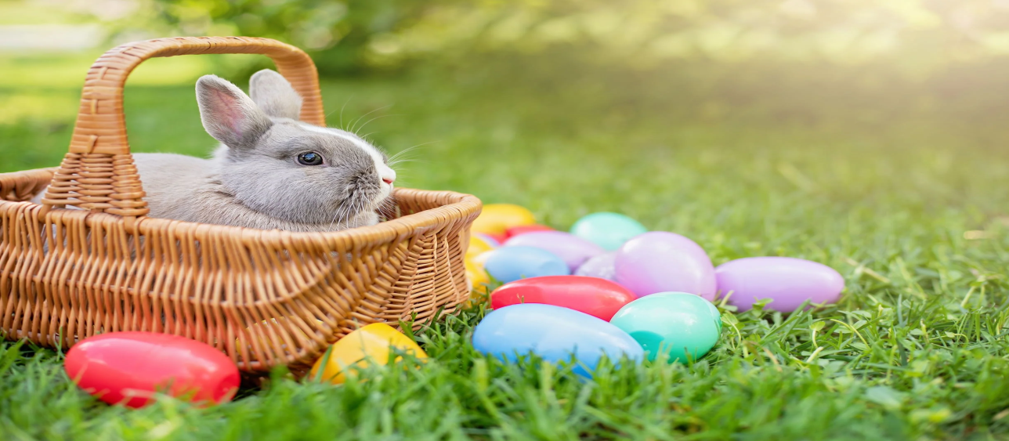

**EASTER**

5 Easter Traditions Around the World

<https://www.youtube.com/watch?v=HMDNCfl4Pxw>

Butterfly Ladybug Bumblebee | Super Simple Songs

<https://www.youtube.com/watch?v=EgiQ6GliTrI>

Happy Easter Song

<https://www.youtube.com/watch?v=-oIphWmyC1A>

Ten Bunnies Counting Song 1-10 | Easter Song | Lyrics | Easter Bunny | Kids Song

<https://www.youtube.com/watch?v=Tyyh8rhwKQ8>

Hop Hop Little Bunny - The Kiboomers Preschool Songs & Nursery Rhymes for Easter

<https://www.youtube.com/watch?app=desktop&v=gPaaDjhVKqk&feature=share&fbclid=IwAR2YZ3gJOA4TNAp0hlV_j8BDTloRVk02EuKln4CFeR3wQtF-ZT-EHA_cY7g>

Hot Cross Buns | Nursery Rhymes | Super Simple Songs

<https://www.youtube.com/watch?app=desktop&v=re3gXNTtwig&feature=share&fbclid=IwAR3m81tLnQCAiS8jFn5IqgKd-09-z0xLOOiH-xja4I1_IUy15h6B51gQ3ps>

Peppa Pig Full Episodes |Easter Bunny #11

<https://www.youtube.com/watch?v=PrNI1m5jBC4>

Peppa Pig And Friends Go On An Easter Egg Hunt!

<https://www.youtube.com/watch?v=SqcMlmqLwAk>

PETE THE CAT BIG EASTER ADVENTURE Read Aloud ~ Easter Stories for Kids ~ Kids Read Along Books

<https://www.youtube.com/watch?app=desktop&v=BakRa62GLbQ&ab_channel=Grandma%27sHouse&fbclid=IwAR0MOhn5Bccoj_meplQ5hi76d15V3C_Y_GS0zM6qKe0SHL92B9YdasGSc-A>

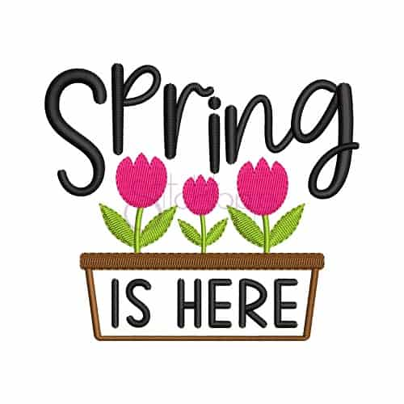

**SPRING IS HERE**

Spring Songs for Children - Spring is Here with Lyrics - Kids Songs by The Learning Station

<https://www.youtube.com/watch?v=DobrRgD5aOU>

Spring is here. Poem/song/gestures

<https://www.youtube.com/watch?v=_SINtuFOqik>

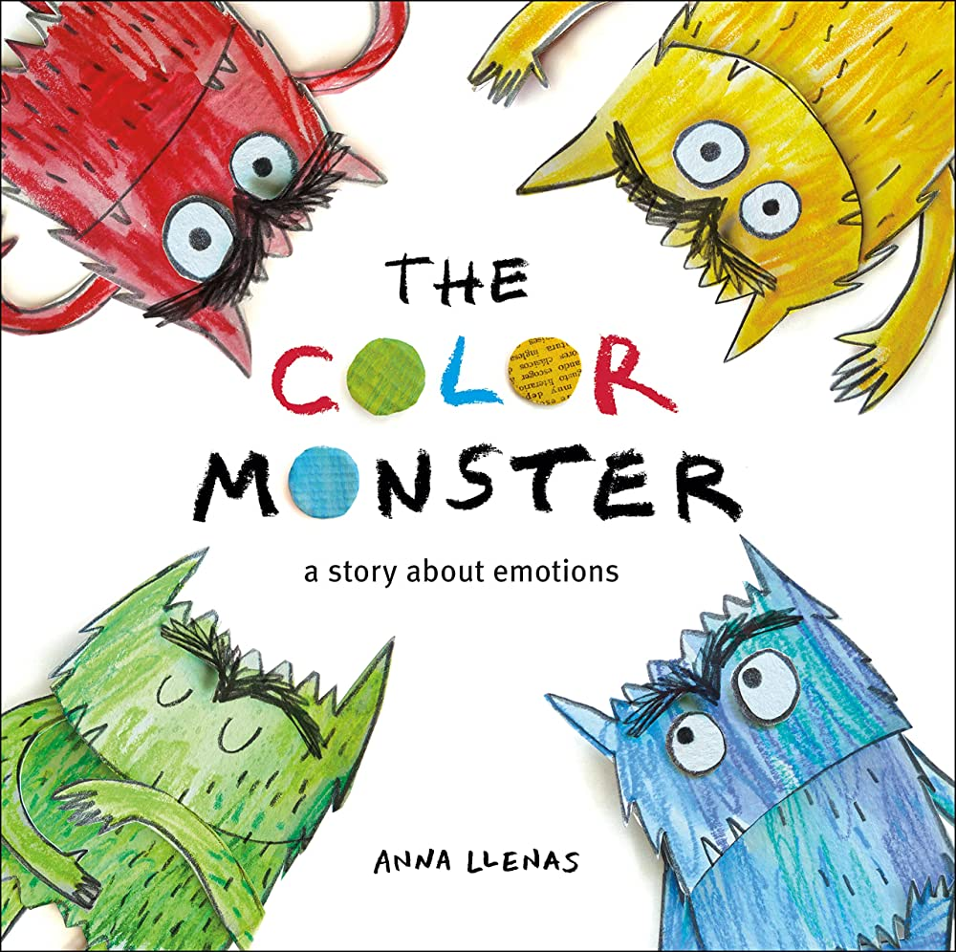

**FEELINGS**

**The colour monster Story**

[**https://www.youtube.com/watch?v=PWujGPb6mgo**](https://www.youtube.com/watch?v=PWujGPb6mgo)

**If you’re happy and you know it Kids Songs | Super Simple Songs**

[**https://www.youtube.com/watch?v=M6LoRZsHMSs**](https://www.youtube.com/watch?v=M6LoRZsHMSs)

[**https://www.youtube.com/watch?v=l4WNrvVjiTw**](https://www.youtube.com/watch?v=l4WNrvVjiTw)

**This Is A Happy Face | Noodle & Pals | Songs For Children**

[**https://www.youtube.com/watch?v=W9rX6ApYqjo**](https://www.youtube.com/watch?v=W9rX6ApYqjo)

**The Emotions Book**

[**https://www.youtube.com/watch?v=jl8G2jiSNA0**](https://www.youtube.com/watch?v=jl8G2jiSNA0)

**VALENTINE'S DAY**

H E A R T - The Kiboomers Preschool Songs & Nursery Rhymes for Kids for Valentine's Day

<https://www.youtube.com/watch?v=kgAx_sQ0mqE>

If You Love Me and You Know It Lyric Video - The Kiboomers Preschool Songs & Nursery Rhymes

<https://www.youtube.com/watch?v=mLdfVgWJ_yk>

You Are My Sunshine Lyric Video - The Kiboomers Preschool Songs & Nursery Rhymes

<https://www.youtube.com/watch?v=SOM6VMkOcqc>

Pete the Cat Valentine's Day is Cool | Animated Book | Read aloud

<https://www.youtube.com/watch?v=rQAYTaFwARI>



**LET’S FLY A KITE**

Peppa Pig - Flying A Kite (full episode)

<https://www.youtube.com/watch?v=5L7bAvXLd3w>

Let's Go Fly A Kite - Mary Poppins (David Tomlinson)

<https://www.youtube.com/watch?v=BA-g8YYPKVo>

Five Little Kites Lyric Video- The Kiboomers Preschool Songs & Nursery Rhymes

<https://www.youtube.com/watch?v=4JBE0co13AA>

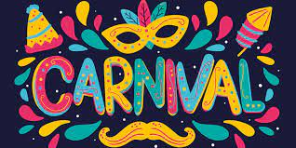

**CARNIVAL**

Pictures & videos: Carnival presentation

<https://sway.office.com/bXbH6BPAVyKQ6uh3?ref=Link&fbclid=IwAR0qQiQKqXrvvInKr91AGVZMtFtxOuWV5u56QRRNNfurgl3BQli0Nc8sRHk>

Peppa Pig - Fancy Dress Party (full episode)

<https://www.youtube.com/watch?v=KM-1WApbEsU>

THE CARNIVAL SONG

<https://www.youtube.com/watch?v=iAd7FQ7VAC0>

I Love Costumes Song | Songs for Kids

<https://www.youtube.com/watch?v=m2MDEjhk4ew>

Conga Line Dance - The Kiboomers Preschool Songs & Circle Time Activity

<https://www.youtube.com/watch?v=8pIxNjE83qI>

Baby Shark Carnival | DADDY SHARK WEEK | Mother Goose Club Kid Songs and Phonics Songs

<https://www.youtube.com/watch?v=tqBEy72vdDo>

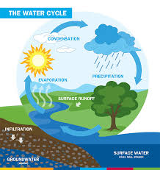

**THE WATER CYCLE**

Water Cycle Song

<https://www.youtube.com/watch?v=TWb4KlM2vts>

The Water Cycle Song

<https://www.youtube.com/watch?v=gBbFxl6Oy94>

Let’s be Scientists (video) & experiments

<https://www.youtube.com/watch?v=uGCexyr4IYw>

Readings and storytelling about water or where water is an important element

Save water for preschoolers | Short Story | Good Habits | Polly Olly

<https://www.youtube.com/watch?v=a9tsMNVfU4E>

Save Water to Help the Earth S4 E3

<https://www.youtube.com/watch?v=rl0YiZjTqpw>



**WINTER**

Cold Winter Day 🐷❄️ @PeppaPigOfficial - Cartoons with Subtitles

<https://www.youtube.com/watch?v=kcflCGNY6o8>

Peppa Pig | Winter Games | Peppa Pig Official | Family Kids Cartoon

<https://www.youtube.com/watch?v=aDNmW43uUIM>

Peppa Pig (Series 1) - Snow (with subtitles)

<https://www.youtube.com/watch?v=_-diBexRvk0>

Pete the Cat Snow Daze | Animated Book | Read aloud

<https://www.youtube.com/watch?v=WQ92ehmuxjs>

Sneezy the Snowman by Maureen Wright and Stephen Gilpin | A Christmas Book Read Aloud for Kids

<https://www.youtube.com/watch?v=LvJ1aePjEfc>

Put On Your Boots | Kids Songs | Super Simple Songs

<https://www.youtube.com/watch?v=AsZwvuUmHGU>

Winter Mittens Song | Song Lyrics Video for Kids | Winter Songs | The Kiboomers

<https://www.youtube.com/watch?v=2Gz9YsL_qJk>

WINTER song for children - English and Preschool students - Easy vocabulary

<https://www.youtube.com/watch?v=Xk2WpcN8IfM>

Froggy gets dressed - Read aloud story time

<https://www.youtube.com/watch?v=g_Aqq5jnDDg>

Winter Hokey Pokey | Winter Songs for Kids | The Kiboomers

<https://www.youtube.com/watch?v=uBYNtMyN_6E>

Wintertime is Here Song | The Kiboomers | Kids Songs | Seasons | Winter Song for Kids

<https://www.youtube.com/watch?v=vpaBH2PbWkc>

Snow Man Freeze Song ⛄️ Freeze Dance ⛄️ Winter Song for Kids ⛄️ Brain Breaks by The Learning Station

<https://www.youtube.com/watch?v=C0tVmABwMPs>

If You Know All the Seasons - The Kiboomers Preschool Learning Videos for Circle Time

<https://www.youtube.com/watch?v=_BkkzF9z4-g>

The Seasons Song

<https://www.youtube.com/watch?v=VS9qBeInJ0U>