1. 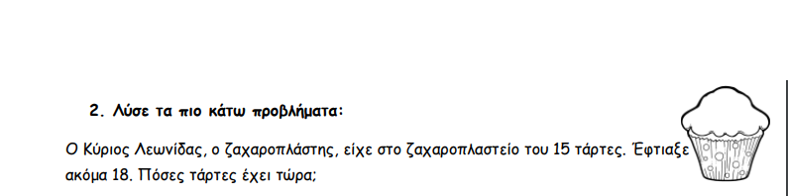
2. ­­­­­­­­­­­­­

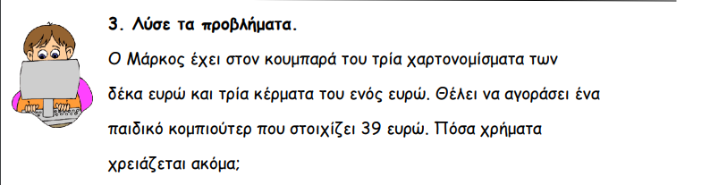

4