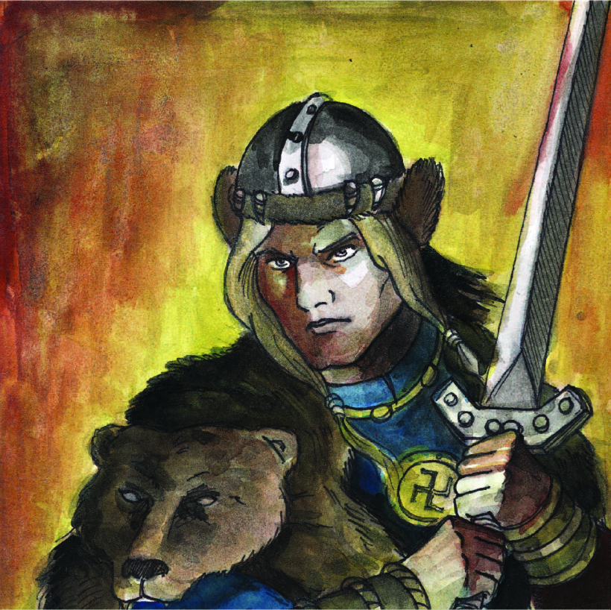
“Lāčplēsis”

Lāčplēsis is an epic poem by Andrejs Pumpurs, a Latvian poet, who wrote it between 1872–1887 based on local legends. Lāčplēsis is regarded as the Latvian national epic.
The poem recounts the life of the legendary hero Lāčplēsis, chosen by the gods to become a hero of his people. His name means "Bear-slayer", because as a young man, living as the adopted son of the Lord of Lielvārde, he kills a bear by ripping its jaws apart with his hands. At the castle of Lord Aizkrauklis, he spies on the activities of the witch Spīdala, who is under the control of the Devil, and the holy man Kangars, who is in reality a traitor plotting with crusaders to replace the old gods with Christianity. Spīdala tries to drown Lāčplēsis by throwing him into the whirlpool of Staburags in the Daugava, but he is rescued by the goddess Staburadze and taken to her underwater crystal castle. There Lāčplēsis meets and falls in love with the maiden Laimdota. Shortly afterwards, Lāčplēsis becomes friends with another hero, Koknesis ("Wood-bearer"), and they study together at the Castle of Burtnieks, Laimdota's father.
Kangars provokes a war with the Estonians, and Lāčplēsis sets out to fight the giant Kalapuisis to win the hand of Laimdota. He defeats the giant, and the two make peace and decide to join forces to fight their common enemy, the German missionaries, led by the priest Dietrich (Dītrihs). Lāčplēsis performs another heroic deed by spending the night in a sunken castle, breaking the curse and allowing the castle to rise into the air again. Laimdota and Lāčplēsis are engaged. In the following episodes, Laimdota reads from the old books about the Creation and ancient Latvian teachings.
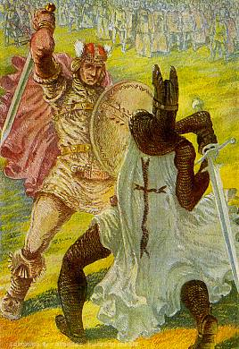
Laimdota and Koknesis are kidnapped and imprisoned in Germany. Spīdala convinces Lāčplēsis that Laimdota and Koknesis are lovers. Lāčplēsis returns home to Lielvārde, then sets sail for Germany. His ship becomes lost in the Northern Sea, and he is welcomed by the daughter of the North Wind. In the meantime, Dietrich and the Livonian prince Caupo of Turaida meet with the Pope in Rome to plan the Christianization of Latvia. Lāčplēsis begins his dangerous journey home from the Northern Sea. He fights monsters with three, six, and nine heads on the Enchanted Island. Finally, he encounters Spīdala on the island, and frees her from her contract with the Devil. Lāčplēsis is reunited with Laimdota and Koknesis, who escaped from Germany but were then trapped on the Enchanted Island. Koknesis declares his love for Spīdala, and the four friends return to Latvia.
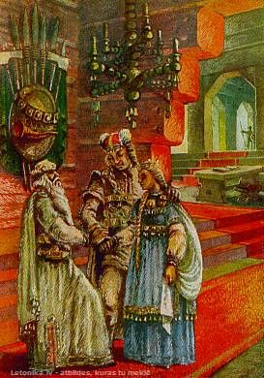
A double wedding is celebrated during the Jāņi (Midsummer festivities), but the heroes soon set off to fight the German crusaders. After several battles, the Germans are pushed back, and their leader, Bishop Albert, brings reinforcements from Germany, including the Black Knight. At Dietrich's bidding, Kangars finds out the secret of Lāčplēsis' strength and treacherously reveals it to the Germans: Lāčplēsis' mother was a she-bear, and his superhuman strength resides in his bear ears. The German knights come to Lielvārde offering to make peace. Lāčplēsis organizes a friendly tournament, during which he is goaded into fighting the Black Knight. The knight cuts off Lāčplēsis' ears. Lāčplēsis, still, having not yet completely lost his strength, explodes in anger and lifts the Knight, to throw him in the river from a cliff. But the two combatants fall into Daugava river, because the Knight, when thrown, grabs Lāčplēsis, and they both disappear into the water. In the same moment Laimdota's life ends.

