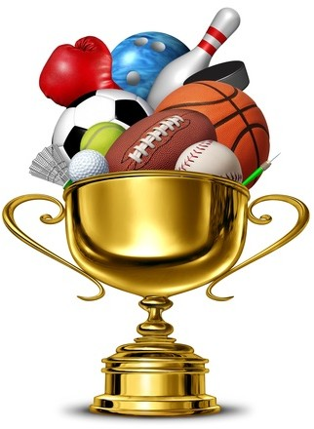

Sports and games

**VOCABULARY DEVELOPMENT**

# 1 Sports Write the correct words under the pictures below.

|  |  |  |  |
| --- | --- | --- | --- |
| athletics | baseball | basketball | cricket |
| football | golf | rugby | table tennis |

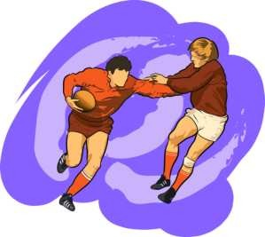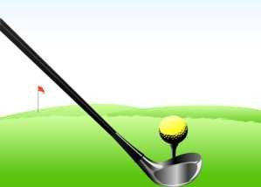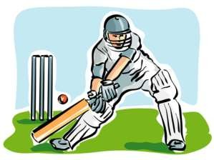

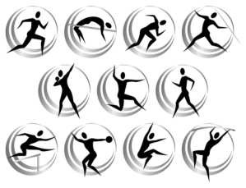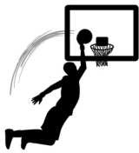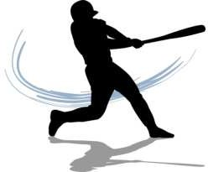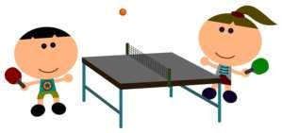

## Which of the above sports are popular in your country? Which are not so popular? What other sports are popular?

**2 Sports, equipment and places**

Look at the words below and complete the table on the next page.

**a bat a club a course a court a racket a piste a ring gloves skis**

|  |  |  |
| --- | --- | --- |
| **Sport** | **EQuipnent** | **Place** |
| football (UK)/ soccer (US) | a ball | a field/pitch |
| tennis |  |  |
| golf |  |  |
| boxing |  |  |
| basketball | a ball |  |
| baseball |  | field |
| skiing |  |  |

# 3 Sporting verbs

## Read the sentences below in pairs. Which sport do you think each spectator is talking about?

1. If you **kick** the ball into the other team's net, you **score** a goal.
2. If you **hit** the ball with your racket and your opponent is unable to return it, you win 15 points.
3. If you **catch** the ball before it hits the ground, the player who **hit** the ball is out.
4. If you **punch** your opponent and he falls down and cannot get up, you win.
5. If you **tackle** the player before he crosses the line, his team do not get any points.
6. If you **miss** the ball three times in a row, you are out!
7. If you **cross** the finish line before everybody else, you win the race.
8. This sport suits players who are tall and can **jump** really high.

# 4 Discuss any of the Questions below.

1. Do you do any sports? Which ones? How often?
2. What sports are popular in your country?
3. Which sports are unpopular in your country?
4. Do you enjoy watching sport?
5. Which is your favourite sport?
6. Do you prefer team sports or individual sports?

**Now label the pictures with the words below.**

board games cards chess dominoes pool video games



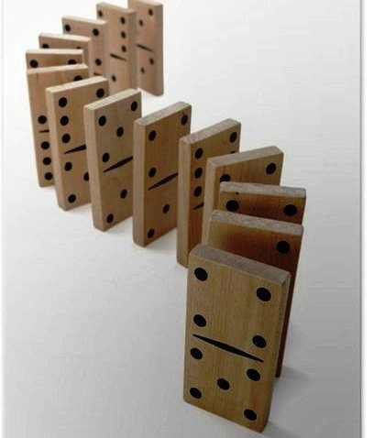





**What other games can you think of?**

**Discuss any of the questions below.**

1. Do you play any games? Which ones? How often?

2. Which games did you play as a child?

3. What games are popular in your country?

4. Do you like playing games