Watch the video https://www.youtube.com/watch?v=0_lrUe7sAAc&t=49s
Study these words:
footsteps: the shape of a foot made by walking or stepping - πατημασιές
cemetery: a place where dead people are buried - νεκροταφείο
stalker: someone who follows someone else continuously - φανατικός θαυμαστής
chase: run after someone – κυνηγάω
convenience store - a small market that carries a limited selection of goods and is open long hours

Match:

- At the beginning of the story Elissa ____ | - When Elissa finally finished her work
- Elissa was walking home ____ | - when she heard footsteps behind her.
- There was no one in the street____ | - to ask for help
- Elissa ran into the cemetery and____ | - was working late at the office
- She went to the convenience store ____ | - hid there.

Answer the following questions in complete sentences about the video. 0:00 – 2:28

What was Elissa doing at the beginning of the story?
Who was on the street when she went out?
Why did Elissa start running?
Where did she go to hide?
What did the click in the convenience shop tell her?

How does the clerk explain the footsteps Elissa heard?

What do you think the clerk thought of Elissa? Why?
Do you think there was really a stalker after Elissa? Explain your answer

- Κάνετε επανάληψη στον Past Continuous από τον οδηγό γραμματικής (στο τέλος του έντυπου)

Write questions in the Past Progressive.
- (Bill /practice) on the guitar when you came home?
- (talk/she) on the phone when you interrupted her?
- (what/discuss/they) when you saw them?
- (what/do/you) yesterday at eight?
- Who/play) football when you got to the park?

Complete the sentences with the past progressive of the verbs in brackets.
a) Helen (work) ___on her computer.
b) Lucy and Tom (have) ___
c) I (read) ___ an article in the newspaper.
d) The children (play) __ snakes and ladders.
e) Paul (chat) ____ on the tablet with a friend.
f) When I came into the living room, the cats (sit) _____ on the table.
g) I could tell by his eyes that he (lie) ____ to me. h)
Helen (listen) ____ to the radio when she heard a strange noise in the garden.
i) I (prepare) ____ dinner yesterday when I noticed that the cooker (work/not)

Answer the questions
What was your mum doing at three o'clock yesterday?
Who were you talking on the phone with last night
What were you doing when the teacher came in?
What was the teacher doing when you walked into the class?
What were the thieves doing when the police saw them?

Αν θέλετε μπορείτε να κάνετε και τις
ΠΡΟΑΙΡΕΤΙΚΑ https://www.ego4u.com/en/cram-up/tests/past-progressive-1

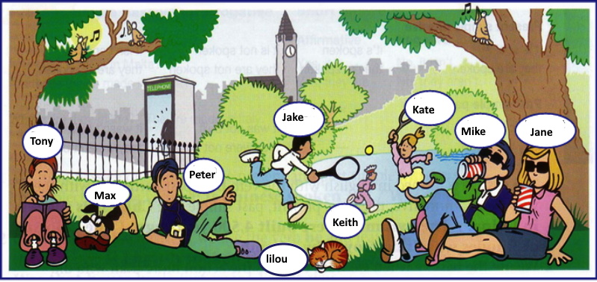
Look at the picture and describe what these were doing

___________________________________________________________________________________________________________________________________________________________________________________________________________________________________________________________________________________________________________________________________________________________________________________________________________________________________________________________________________________________________________________________________________________________________________________________________________________________________________________________________________________________________________________________________________________________________________
PAST CONTINUOUS
Affirmative | Interrogative | Negative
I was talking | Was I talking? | I was not (wasn't) talking
You were talking | Were you talking? | You were not (weren't) talking
He was talking | Was he talking? | He was not (wasn't) talking
She was talking | Was she talking? | She was not (wasn't) talking
It was talking | Was it talking? | It was not (wasn't) talking
We were talking | Were we talking? | We were not (weren't) talking
You were talking | Were you talking? | You were not (weren't) talking
They were talking | Were they talking? | They were not (weren't) talking
Σχηματίζουμε τον Past Continuous με τον αόριστο του ρήματος be ( was, were) και το κύριο ρήμα με την κατάληξη -ing. Jane was talking on the phone for two hours yesterday

Για να σχηματίσουμε τον αρνητικό τύπο βάζουμε το αρνητικό μόριο not μετά το ρήμα be (was, were ) Jane was not talking on the phone for two hours yesterday
Για να σχηματίσουμε τον ερωτηματικό τύπο αντιστρέφουμε το υποκείμενο με το ρήμα be (was, were) Was Jane talking on the phone for two hours yesterday ?

Spelling
- Όταν το ρήμα τελειώνει σε -e φεύγει το e και μετά προσθέτουμε την κατάληξη -ing
have - having make – making write –writing ΕΞΑΙΡΕΣΗ: be = being

- Όταν το ρήμα είναι μονοσύλλαβο και τελειώνει σε σύμφωνο – φωνήεν - σύμφωνο τότε το τελικό σύμφωνο διπλασιάζεται. sit – sitting swim – swimming run running
Προσοχή όταν το ρήμα τελειώνει σε x ή w δεν το διπλασιάζουμε fix = fixing, draw - drawing
όταν το ρήμα τελειώνει σε l διπλασιάζουμε το l travel = travelling

- Όταν το ρήμα τελειώνει σε ie, φεύγει το ie και μετά προσθέτουμε την κατάληξη –ying.
lie – lying die - dying tie – tying vie - vying
O Past Continuous ( Αόριστος Διαρκείας) χρησιμοποιείται για να περιγράψει
- μια πράξη η οποία συνέβαινε συνέχεια (δηλαδή είχε παράταση ) σε καθορισμένο χρονικό σημείο στο παρελθόν, χωρίς όμως να ξέρουμε πότε ακριβώς άρχισε ή πότε τελείωσε.
I was peeling potatoes at the time of the earthquake.
2. για μια πράξη που γινόταν συνέχεια στο παρελθόν και διακόπηκε από μια άλλη.
( Η δεύτερη πράξη εκφράζεται με Simple Past. )
I was talking on the phone, when the bell rang.
3. δύο πράξεις που γινόντουσαν ταυτόχρονα στο παρελθόν. (με το while)
Father was washing the car while mother was baking a cake.
4. για να περιγράψουμε την ατμόσφαιρα(σκηνή) σε μια συγκεκριμένη στιγμή στο παρελθόν. It was a dark winter morning. The snow was coming down hard and the wind was howling. People wrapped in heavy clothes were walking as fast as possible……
5. με το always πράξεις που επαναλαμβανόντουσαν στο παρελθόν και εκφράζουν ενόχληση.
He was always pulling my hair!
Remember you can't use this tense with stative verbs.

