Hello children!
We are in the middle of a revision having to do with emotions. Did you see the film Inside Out (which was mentioned in the previous worksheet)?
Now it’s time to combine emotions, arts and self-realisation!
So, we will colour, draw, answer the questions and finally write down personal statements!
We hope you like it!
We miss you and we think that expressing feelings in different forms is the best way to go through this period!

- Find the words
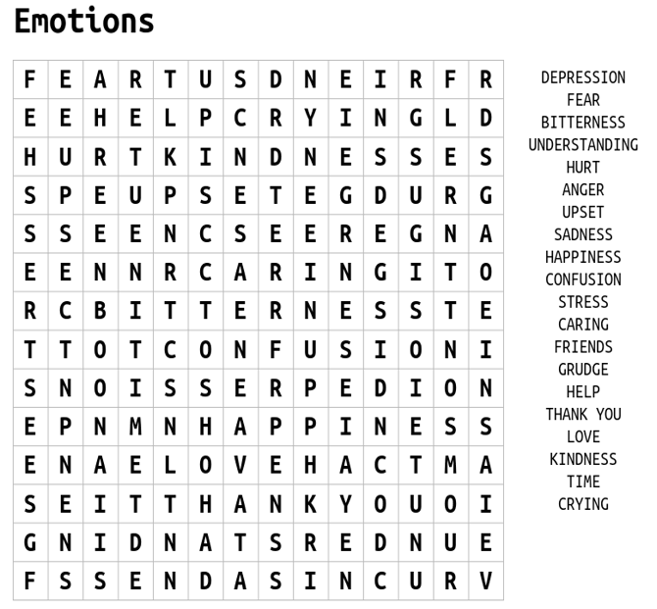

- The Emotion of Line. Try to express the words by drawing lines in the appropriate box. For example, how would you draw fear in a line? Straight, wavy, zig-zag?
ANGER | LOVE  e.g. | PEACE
SURPRISE | SADNESS | FEAR
EXCITED | PAIN | JOY

- How satisfied are you with yourserl? Tick the correct box.
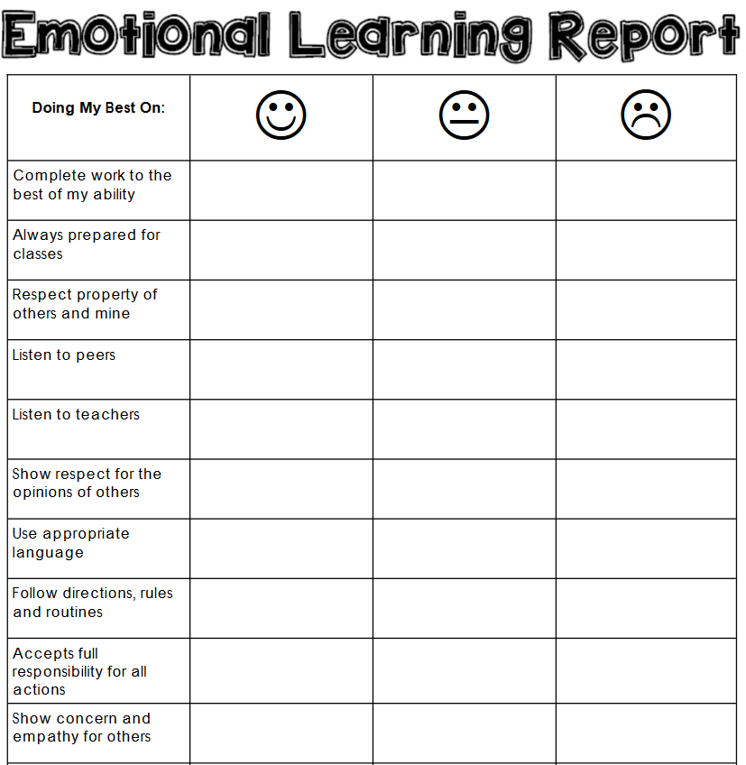

CREATE SPACE FOR JOY
- Fill in the boxes with the appropriate phrases expressing yourself
I FEEL THE MOST JOY WHEN… | I FEEL DISAPPOINTED WHEN…

THIS WEEK I WILL CREATE SPACE FOR JOY BY… | THIS WEEK I WILL GIVE UP…

