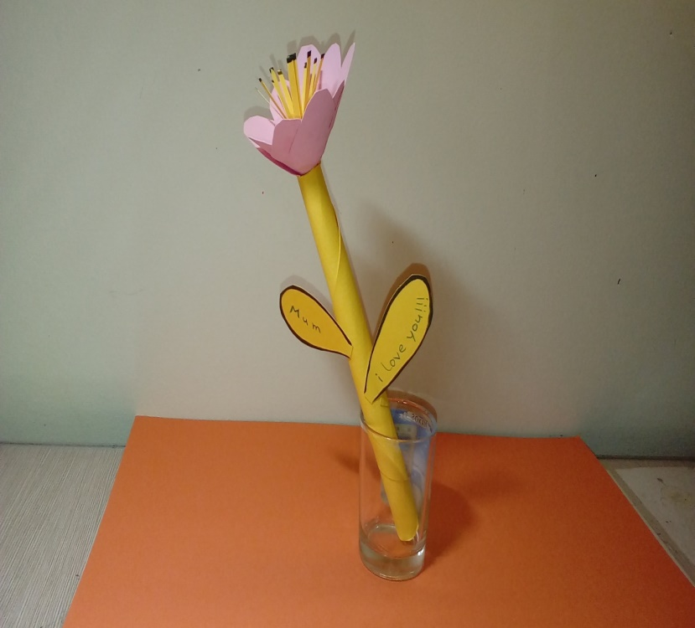
MUM I LOVE YOU VERY MUCH!!!!!!
ΑNDREAS TYRIAKIDIS

