CLASS E1/E2 REVISION 5 Name:

Hello everyone, here we are again! I hope you and your families are all well. Even though I enjoy creating material for you I truly miss our class and each one of you! Hopefully we will see each other soon!
In Unit 2 Lesson 3 we read about customs around the world. Now read about Christmas customs in Australia.

CUSTOMS

In Australia, Christmas comes towards the start of the summer holidays. Children have their summer holidays from late December to early February, so some people might go camping at Christmas.
Because it's so hot at Christmas time in Australia, there are often big bush fires across the country. Volunteer bush fire fighters help to save people and houses. They travel from all over Australia to help in other states.
Australians decorate their houses and gardens with Christmas trees and Christmas lights. Sometimes, they decorate as early as December 1st. People hang wreaths of holly on their doors. Neighbours sometimes have competitions to see who has the best lights. Neighbours often visit each other at night to look at each other’s lights. One street in Sydney raises over $35,000 every year for charity with their street display!
Australians also decorate their houses with Christmas Bush, a native Australian tree. It has small green leaves and cream-coloured flowers. In summer, the flowers turn a deep shiny red over a few weeks (usually by the week of Christmas in Sydney). Poinsettia plants are also popular decorations.
Many cities and towns have Carols by Candlelight. Famous Australian singers lead crowds singing Christmas songs and waving candles, while many more watch it on
television. Many towns and cities have festivals and parades. Many local parks have a fireworks display.
Many towns, cities and schools also hold their own Carols by Candlelight services, with local bands and choirs sometimes helping to perform the Christmas carols and songs, leading big crowds in the singing. Since it is the middle of summer,
Australians change the words in the carols about snow and the cold winter to special Australian words. There are also Australian carols.
When Santa comes to Australia, he sometimes gives the reindeers a rest and might use six kangaroos called “white boomers.” He also often changes his clothes for cooler ones! Children often leave out carrots for Santa's reindeer and some cake and a nice cold beer for Santa (although drinking and driving the sleigh doesn't seem a good idea to me!).
Families give each other presents on Christmas Day. Workplaces and clubs might have a “Kris Kringle.” You get someone’s name and give them a present at the work Christmas party.
The day after Christmas is called Boxing Day. On Boxing Day, most people go and visit their friends and often have barbecues at the beach. Two popular sports also start on Boxing Day: Australia challenges another country to a test cricket match and there is a famous yacht race from Sydney to Hobart in Tasmania

Σημείωση: το όνομα <Kris Kringle> είναι ένα άλλο όνομα για τον <Santa Claus> αυτός που φέρνει τα δώρα δηλαδή.
VOCABULARY:

Comes towards Bush fires Volunteer Wreaths of holly Charity  Street display | Έρχεται προς Φωτιές σε θάμνους Εθελοντές  Στεφάνια από πουρνάρι Φιλανθρωπία  Εκθέτουν τη διακόσμηση του δρόμου

Local bands and choirs Crowds  Barbecues Challenge (es)  Yacht race | Τοπικές μπάντες και χορωδίες Πλήθος  Ψήσιμο στα κάρβουνα Πρόκληση  Αγώνας με σκάφη

Choose the correct answer.
- What can’t you do on Christmas Day in Australia that you might do in England?
  - camping
  - fireworks
  - skiing

- What sometimes makes Christmas in Australia dangerous?
  - bushfires
  - it’s too hot
  - travelling to another state

- What sort of competition can you have with your neighbours?
  - who has the best Christmas lights
  - who has the earliest Christmas decorations outside
  - who raises the most money for charity

- What colour are the flowers on a Christmas Bush at Christmas time?
  - cream-coloured
  - red
  - green

- What can you watch on television?
  - parades
  - famous singers singing carols
  - fireworks

- Why are some Christmas songs different from songs in other countries?
CHOOSE THE WRONG ANSWER.
  - there are original Australian carols written here
  - they change the parts that talk about winter to describe Australia’s summer
  - they aren’t famous singers so they make them easier to sing

- What animals pull Santa’s sleigh in Australia?
  - reindeer
  - kangaroos
  - sometimes reindeer and sometimes kangaroos

- Who do you give a present in a Kris Kringle?
  - your family
  - one colleague
  - all your colleagues

- What sporting event happens the day after Christmas?
  - a cricket match between New South Wales and Tasmania
  - a boat race
  - a boxing match

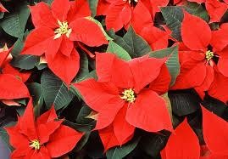
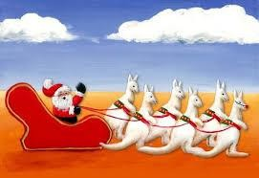
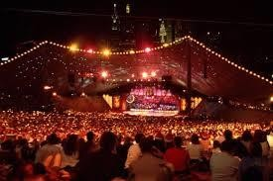
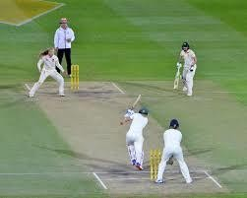
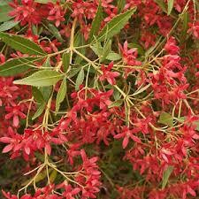
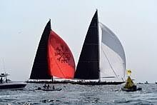
Can you match the words to the pictures?

1. Carols by Candlelight | 2. Christmas bush | 3. poinsettias
4. six white boomers | 5. test cricket match | 6. yacht racing

a) | b)
c) | d)
e) | f)

