**CLASS ΣΤ1/ΣΤ2 REVISION 2**

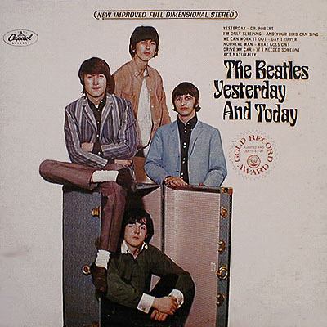

The Beatles Short History and Legacy .

WATCH the video on the uploaded file

Here are words that you will hear and some that you will use to fill in the gaps. Listen to the video as many times as you need to.

* *Liverpool – πολη της Αγγλίας
* *influential- είχαν επιρροή
* *worldwide - παγκοσμίως
* mop-top hair style - τα μαλλιά τους που έμοιαζαν με σφουγγαρίστρα
* *innovation -καινοτομία
* *timing - χρονική στιγμή -συγχρονισμός
* 1st war generation - πρώτη γενιά μετά τον πόλεμο
* *youth culture - η κουλτούρα των εφήβων
* rebel against authoritative culture – ενάντια της αυταρχικής κουλτούρας
* *beatlemania - έκφραση που δηλώνει πόσο φανατικός ήταν o κόσμος με τους Beatles
* *stay on the cutting edge – leading position-βρίσκεται στη πρώτη γραμμή
* pursue an individual career -επιδίωξη ατομικής καριέρας
* *break up – χωρίζω από συνεργασία, από σχέση…
* *shot- πυροβολήθηκε- (shoot)
* *business- επιχειρηματική δραστηριότητα
* *open people’s mind – διεύρυναν την οπτική των ανθρώπων
* women’s liberation –γυναικεία απελευθέρωση
* *revolution- επανάσταση

1. Fill in the sentences with the **\*words** above:
2. They __________ from Liverpool England.
3. They sold more records ________________than any other band.
4. Why were they so successful and __________________?
5. Because of their talent, practice, personality, __________________and timing.
6. Their music rooted in skillful and rock and roll evolved into _________ that’s how they got their name.
7. _________ ____________ was born.
8. ____________________ rolled across the globe.
9. They stayed on the ______________edge.
10. In 1970 the Beatles _________________.
11. In 1980 John Lennon was _____________.
12. The Beatles changed the music ___________ for ever.
13. They ____________people’s mind
14. They brought on a ________________.
15. Listen to the songs and fill in the gaps

Imagine: <https://www.youtube.com/watch?v=VOgFZfRVaww>

Yesterday: <https://www.youtube.com/watch?v=wXTJBr9tt8Q>

