Η ΝΑΥΜΑΧΙΑ ΤΗΣ ΣΑΛΑΜΙΝΑΣ

[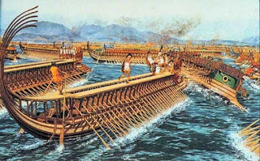](https://4.bp.blogspot.com/-p30x0tow_6c/WbAVUmOpJWI/AAAAAAAABV8/21iILgHUGlYSoc6tFuIOqjXIxTxrjksgACLcBGAs/s1600/naymaxia_ellhnwn.jpg)

1.Γιατί ο Θεμιστοκλής ήθελε να συγκρουστούν οι δύο στόλοι στα στενά της Σαλαμίνας;

­­­­­­­­___________________________________________________________________________­____________________________________________________________________________________________________________________________________________________________________________________________________________________________________________________________________________________________________________

2.Πως νομίζεις πως αισθάνονταν οι Έλληνες μετά τη νίκη τους;

---------------------------------------------------------------------------------------------------------------------------------------------------------------------------------------------------------------------------------------------------------------------------------------------------------------------------------------------------------------------------------------------------------------------------------------------------------------------------------------------------------------------------------------------------------------------------------------------------------------------------------------

3.Τι ήταν οι τριήρεις:

_____________________________________________________________________________________________________________________________________________________________________________________________________________________________________________________________________________________________________________________________________________________________________________________________________________________________________________________________________________________________________________________________________________