**NAME: ……………………………………………………………… DATE: ………………………………………**

***UNIT 1***

1. ***Unscramble the words and match them with the pictures.***
2. **dbkyorea ……………………………………………..**
3. **enrecs ……………………………………………………**
4. **esume ………………………………………………….**
5. **Icnerhmoop …………………………………………….**
6. **tperinr ……………………………………………………….**
7. **wrteo ……………………………………………………………**
8. **srepake …………………………………………………………..**

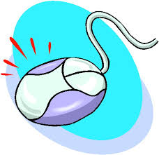

 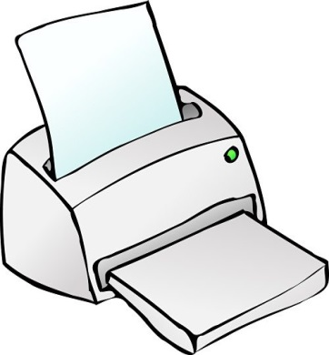

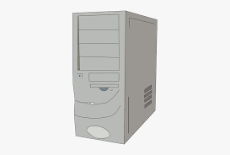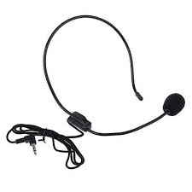

1. ***Match each of the computer parts with the right use.***

|  |  |
| --- | --- |
| 1. **Microphone** | 1. **Where the computer processors, drives and memory are located** |
| 1. **Mouse** | 1. **Where you view words and images** |
| 1. **Keyboard** | 1. **It is used to copy a picture or a document into the computer** |
| 1. **Screen** | 1. **A piece of equipment with keys to type information into the computer** |
| 1. **Printer** | 1. **This sends out sound** |
| 1. **Tower** | 1. **It allows you to move around the computer screen** |
| 1. **Scanner** | 1. **It is used to print documents** |
| 1. **speaker** | 1. **You use this to speak to other people on the web** |

1. ***Match the country with the correct nationality*.**
2. **………England A. Australian**
3. **………Brazil B. Portuguese**
4. **……….Argentina C. German**
5. **…………Germany D. French**
6. **………….Russia E. English**
7. **………….Portugal F. Austrian**
8. **……………Switzerland G. Korean**
9. **………….Turkey H. Dutch**
10. **…………..Japan I. Mexican**
11. **…………….Greece J. Russian**
12. **………………Spain K. Chinese**
13. **……………….France L. Spanish**
14. **…………………Australia M. Canadian**
15. **………………..Italy N. British**
16. **…………………USA O. Japanese**
17. **…………………..Great Britain P. Swiss**
18. **…………………..Holland Q. Greek**
19. **…………………..China R. Italian**
20. **…………………….Mexico S. Argentinian**
21. **…………………….Korea T. American**
22. **………………….Austria U. Brazilian**
23. **…………Canada V. Turkish**
24. **Watch the following videos and then do the exercises ( Simple Present) .**

**( CTRL + κλικ στον σύνδεσμο)**

<https://www.youtube.com/watch?v=mGMpaD8KvyA>

<https://www.youtube.com/watch?v=FWJRwasIWnM>

1. ***Add –s,-es,-ies to the verbs below to form the Present Simple for he, she,it.***
2. **stop………………. 5. mix…………. 9. go………………**
3. **watch………….. 6. tie …………. 10. catch………….**
4. **study…………… 7. dress ……….. 11. enjoy…………..**
5. **do…………………. 8.try …………. 12. lose …………..**
6. ***Complete the sentences with the Simple Present form of the verb in brackets.***
7. **Mum…………………..(wash) the car once a week.**
8. **Children usually………………..(like) ice cream.**
9. **………………you………………..(know)the way to the lake?**
10. **Bob…………………..(study) French on Saturdays.**
11. **Every year Helen………………….(go) to France.**
12. **He…………………..(not visit) his friends every day.**
13. ***Write each sentence in the negative. Then write an affirmative sentence using the words in brackets*.**
14. **eg You need more spelling practice. (reading)**
15. **You don’t need more spelling practice.**
16. **You need more reading practice.**
17. **My Dad reads the newspaper every day. (a book)**
18. **………………………………………………………………………**
19. **………………………………………………………………………**
20. **I study on Saturdays. (Sundays)**
21. **……………………………………………………………………..**
22. **………………………………………………………………………**
23. **Mark goes to karate lessons. (piano)**
24. **…………………………………………………………………….**
25. **…………………………………………………………………….**
26. ***Write questions and answer (short answers) them about yourself*.**
27. **your grandma/often/visit/you? 3. your dad/play/the guitar?**

**Does your grandma often visit you? ……………………………………..**

**Yes, she does/No, she doesn’t ……………………………………..**

1. **you/watch/TV/in the evening? 4. your friends/like/computer games?**

**…………………………………………… …………………………………………………..**

**…………………………………………… …..................................................**