BRAISE BEEF
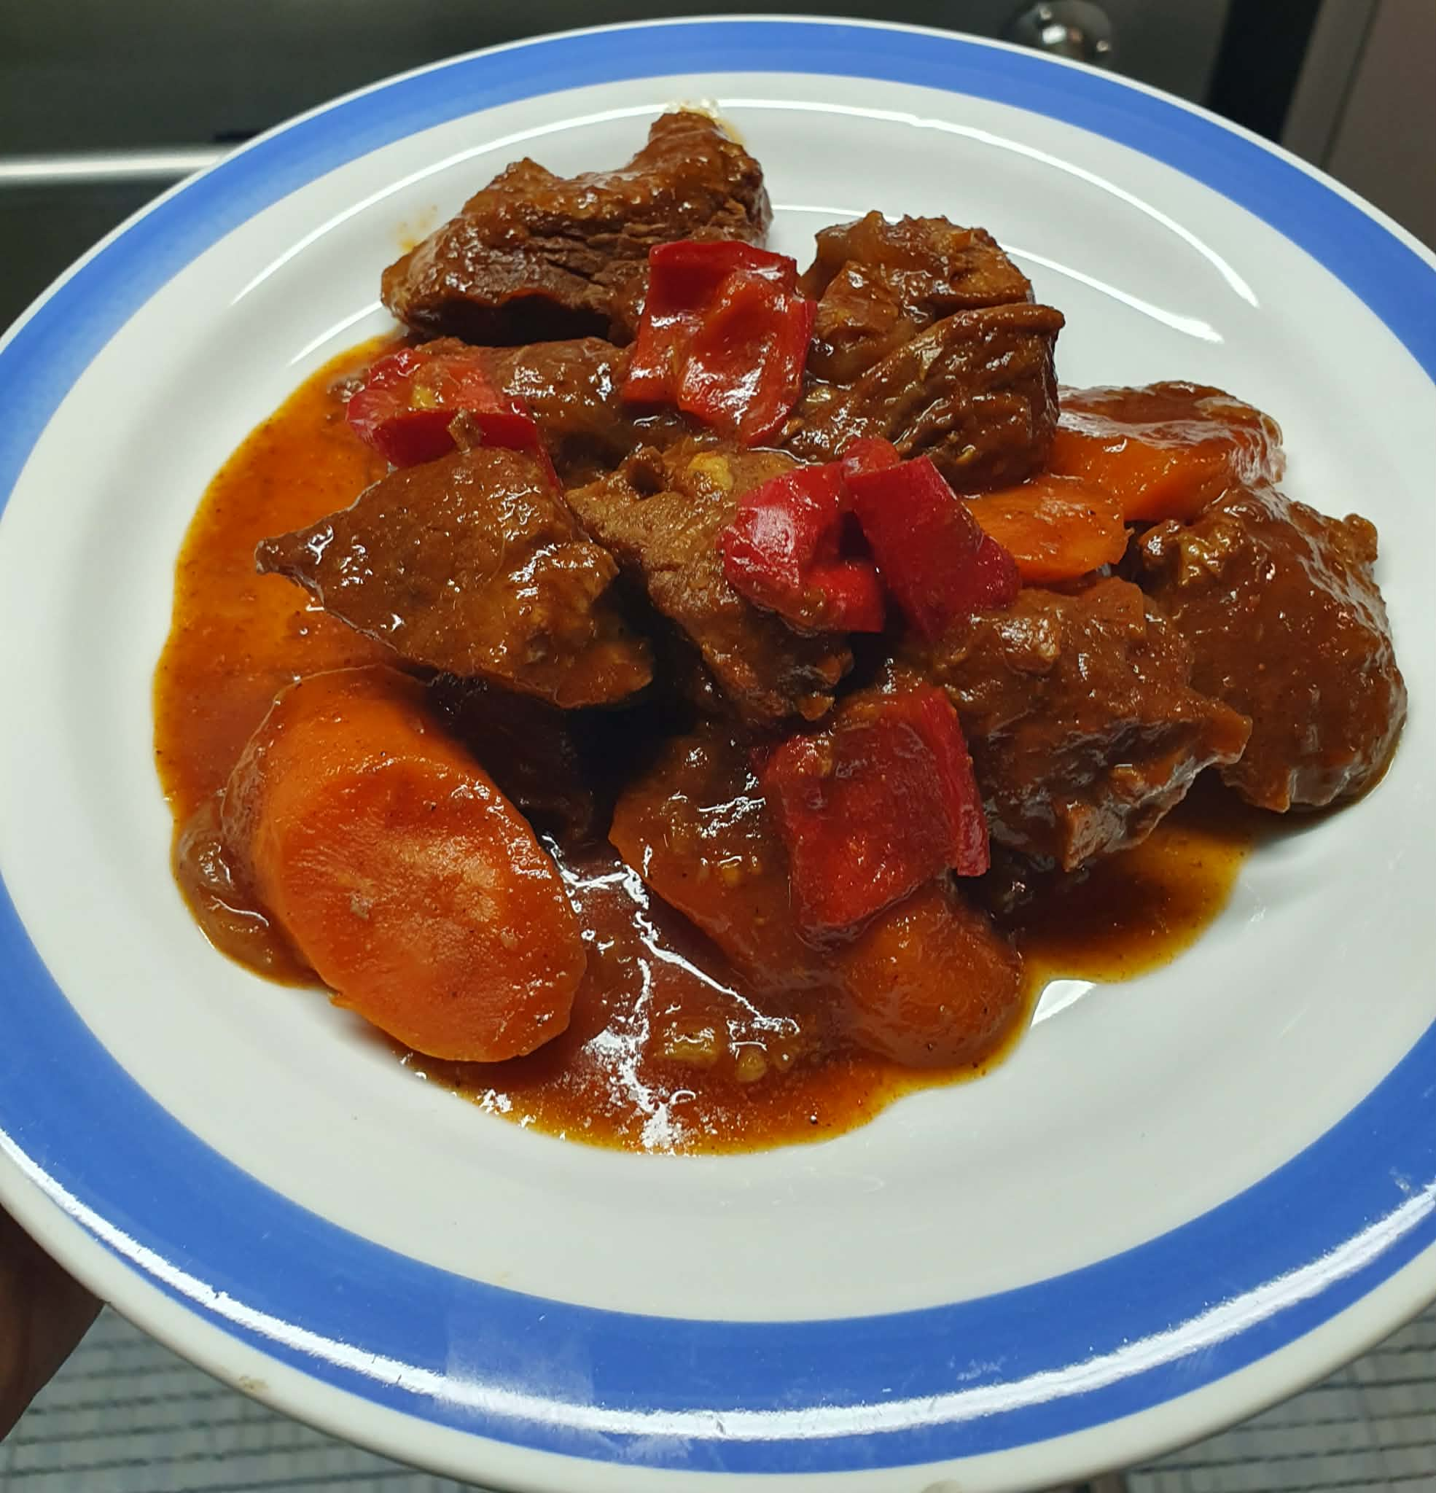

Ingredients:
- 1 Kg beef cubes
- 1 onion
- 4 cloves
- 250ml tomato sauce
- ½ cup dark soy sauce
- ½ cup brown sugar
- 1 tsp black pepper powder
- 2 pcs large carrots
- 2 pcs bell pepper
- Oil for frying
Procedure:
- In a bowl put the beef cubes,tomato sauce,dark soy sauce,brown sugar,black pepper powder. Marinade for 1 hr.
- After 1hr, in a casserole heat the oil saute’ garlic and onion until the aroma cames out then put the beef marinade. Then mix. Cover for 1 hr or until the beef become tender.
- After the beef become tender put the carrots and bell pepper for 5 mins. And its ready.
- Serve with hot rice or roast potatoes/mashed

